Module 7
Mergers
& Acquisitions
A Self-Contained Study Textbook
HEC Paris • EMBA Finance Specialization
Based on the lectures of Prof. Marc Vermeulen
Prepared for Khloud Alghati

Preface
This textbook is designed to be the only resource you need to study the Mergers and Acquisitions module of the EMBA Finance Specialization. The course is a full-day program that focuses on how to execute an M&A transaction, drawing on the practitioner experience of Prof. Marc Vermeulen, who spent thirty-eight years at Paribas / BNP Paribas in investment banking before joining HEC. This book reorganises the in-class material into a chapter structure, expands the bullet-point logic of the slides into prose explanations, walks through the Smith & Wesson case study in full detail, and adds end-of-chapter recaps and self-test questions.
M&A is sometimes thought of as a single decision: do we buy this company at this price? In practice it is a long sequence of decisions: How do we run the sale process? What kind of deal — cash or shares? What's in the price and what's outside it? When does signing become closing, and what risks live in that gap? If the target is listed, what does the regulator require? How do we finance the cash payment? And the moment we close, how do we keep the value we just paid for?
The book is organised around that sequence. Chapter 1 sets the scene: definitions, market size, drivers. Chapter 2 covers the selling process — bilateral vs. auction, key players, and the typical timetable. Chapter 3 covers deal structuring: cash deals versus share deals (mergers), exchange ratios, EPS impact, and synergies. The Smith & Wesson case study runs through the chapter as the worked numerical example. Chapter 4 covers execution mechanics: the EV-to-Equity bridge, locked-box vs completion accounts, due diligence, the SPA. Chapter 5 covers public M&A: regulatory thresholds, offer types, friendly vs hostile dynamics, takeover defences. Chapter 6 covers financing and post-merger integration.
How to use this book
Read each chapter linearly — chapters depend on earlier definitions.
Do the worked Smith & Wesson questions in Chapter 3 with paper and a calculator.
Pause at each Worth Memorizing callout to commit the formula or principle to memory.
Attempt the end-of-chapter self-test questions before reading the solutions.
The exam is multiple choice, jointly with the other Week 2 courses, so emphasise definitions, frameworks and the mechanical formulas (EPS accretion, ND/EBITDA computations).

Contents
1. Introduction — definition, market, rationale — What is M&A, market size by region, recent recovery drivers, strategic rationales.
2. The selling process — Bilateral negotiations, auctions, timetable, key advisor roles.
3. Deal structuring — Cash versus share deals, exchange ratios, EPS accretion, synergies, Smith & Wesson worked case.
4. Execution main drivers — EV-Equity bridge, locked box vs. completion accounts, due diligence, SPA.
5. Public M&A — Regulatory thresholds, OPA / OPE / mixed offers, friendly vs. hostile, defence tactics.
6. Financing and post-merger integration — Bridge loans, refinancing, the Air Liquide-Airgas case, PMI risks.
7. Self-test questions and solutions — Multiple-choice and short-answer practice.
Glossary — Quick-reference definitions.

Chapter 0 — Primer for Non-Finance Readers
Who this chapter is for
Read this first if you've never worked on an M&A transaction or studied corporate finance formally.
We define the vocabulary used in the rest of the textbook in plain language and explain the basic mechanics of how a deal works from start to finish.
Once you've read this, the technical chapters will feel like extensions of common-sense ideas rather than a foreign language.

0.1 What an M&A transaction actually is
Mergers and Acquisitions (M&A) is the business of buying, selling, and combining companies. "Mergers" historically meant two companies of similar size joining as equals; "acquisitions" meant one company buying another. In modern practice the distinction has blurred — almost every M&A transaction is technically an acquisition, just with different consideration mixes and political framings.
Three things make a deal an M&A transaction (rather than a portfolio investment or a block trade):
- Control transfer — the buyer ends up controlling the target, either through majority ownership, a controlling stake, or contractual rights.
- Negotiation — there is a back-and-forth between buyer and seller. Quietly accumulating shares on the open market isn't M&A; signing a definitive agreement is.
- Documentation — the terms are captured in legally binding contracts, principally the Share Purchase Agreement (SPA).

0.2 Why companies do M&A
Motivations cluster into a few patterns. Behind every deal there's usually a story that sounds something like one of these:
- Buy growth instead of building it. Faster than organic expansion. Especially attractive when the target has scarce capabilities or market access.
- Acquire a specific capability. Technology, talent, customer relationships, regulatory approvals.
- Achieve scale economics. Consolidate two firms' operations to lower unit costs.
- Enter new geographies or product lines. Buy your way into markets that would take years to build organically.
- Defensive consolidation. Threatened by a larger rival; combine to compete more effectively.
- Restructure or divest. Sell a non-core unit so management can focus on the core business.
- Financial engineering. LBO funds buy companies to install new leverage and management, aiming for high returns on equity invested.

0.3 The basic vocabulary

Buyer-side and seller-side
- The buyer (or acquirer) is the firm purchasing the target.
- The seller is the firm or shareholder group that owns the target.
- "Sell-side" advisors work for the seller; "buy-side" advisors work for the buyer. In an auction, both sides have multiple advisors.

Enterprise value vs Equity value
These two numbers measure different things and you must keep them straight.
- Enterprise Value (EV) — the total value of the business itself, regardless of how it's financed. Equal to equity value plus net debt plus a few other claims. EV is the price the business as a whole is being valued at.
- Equity Value (Market Cap) — the value of the shareholders' claim only. For a listed company, equal to share price × shares outstanding. For a private company, the residual after net debt and other senior claims are taken out of EV.
$Equity Value = Enterprise Value - Net debt - Other senior claims$
In an M&A deal, the parties typically agree on the EV first (it's the cleanest measure of what the business is worth), then walk through the "EV-to-Equity bridge" to figure out how much actually goes to the seller. Chapter 4 walks through this bridge in detail.
In plain language
Enterprise Value is what you'd pay if you wanted the whole business, debt and all.
Equity Value is what you'd pay if you only wanted the shareholders out (and were taking the business with its existing debt).
Net debt is the difference between them: gross debt minus cash on hand.

Cash deal vs Share deal
Two main ways to pay for a target:
- Cash deal — the buyer pays cash. Target shareholders exit completely; they have no ongoing relationship with the buyer. Buyer typically uses some combination of its own cash, new debt, or recent equity issuance.
- Share deal (merger) — the buyer pays in its own newly issued shares. Target shareholders become shareholders of the combined entity. No cash leaves the buyer.
Each has different implications for the buyer's balance sheet, leverage, dilution, and tax treatment. Cash deals consume cash and add leverage; share deals dilute existing shareholders but preserve balance sheet flexibility. The choice is one of the central strategic decisions in deal structuring.

Friendly vs Hostile
A friendly deal is one the target's board recommends to its shareholders. A hostile deal is one launched without the board's support — typically through a direct tender offer to shareholders, or by accumulating shares quietly and then announcing.
Hostile deals are politically harder, attract more press attention, often pay higher premiums (because the bidder has to overcome resistance), and run a higher risk of failing. Most hostile bids end up either failing or being negotiated into a friendly deal at a higher price.

Premium
In any deal involving a listed company, the buyer almost always offers MORE than the pre-announcement share price. The difference (in percent) is the premium. Average European premium is around 30% over the pre-announcement 3-month average price. The premium pays for: (a) the control rights the buyer gets, (b) the synergies the buyer expects to realize, (c) the cost of overcoming any resistance.

Synergies
The value the combination creates over and above the two firms apart. Two categories:
- Revenue synergies — selling more by combining product lines, customer bases, or geographies. Harder to predict, slower to realise.
- Cost synergies — eliminating duplicate functions, consolidating supply chains, better procurement. Easier to predict, faster to realise.
The cardinal pricing principle: the present value of all future synergies must equal or exceed the premium paid. If not, the buyer destroys value — and the market punishes the buyer's share price immediately on announcement.

0.4 The deal lifecycle from start to finish
A typical M&A transaction takes 4-12 months from initial discussion to closing. The phases follow a standard pattern:

Phase 1 — Strategic decision (target identification)
Buyer-side: the strategic team identifies acquisition opportunities. Sell-side: the company decides to sell (often after an unsolicited approach or strategic review).

Phase 2 — Approach and NDA
Buyer makes initial contact (often via an investment banker). If the seller is interested, both sides sign a Non-Disclosure Agreement (NDA), then exchange initial information.

Phase 3 — Non-Binding Offer (NBO) / Letter of Intent (LOI)
Buyer submits an indicative offer based on limited information. Typically structured around a valuation range. Not yet legally binding. If seller likes the offer, the buyer is invited into deeper due diligence.

Phase 4 — Due diligence
The deep-dive investigation phase. Buyer and its advisors investigate everything: financial accounts, contracts, legal disputes, IT systems, employee matters, intellectual property, environmental liabilities. Lasts weeks to months. Several streams happen in parallel: financial DD (Big Four firms), legal DD (law firms), strategic DD (Bain, Mercer, OC&C), industrial DD (specialised engineers).

Phase 5 — Binding Offer (BO) and SPA negotiation
Buyer submits a final, binding offer based on what due diligence revealed. The parties negotiate the Share Purchase Agreement (SPA), the master legal document. Topics include final price, EV-to-Equity bridge items, representations and warranties, indemnities, conditions to closing.

Phase 6 — Signing
Both parties execute the SPA. The deal is now legally committed (subject to closing conditions). Public announcement usually happens here.

Phase 7 — Conditions and regulatory clearances
Between signing and closing, certain things must happen: antitrust approvals (US and EU, plus potentially China, UK, etc.), regulatory clearances (CFIUS in the US for sensitive sectors, FDI screening in Europe), financing draw-downs, sometimes shareholder votes.

Phase 8 — Closing
Money changes hands; shares are transferred; control passes. The deal is now "closed" or "consummated."

Phase 9 — Post-Merger Integration (PMI)
The hard part. Combining systems, cultures, organisations, products, brands. Typically takes 1-3 years. Where most deals deliver less than their announced synergies.

0.5 The cast of characters
Large deals can involve 50+ people on each side, drawn from a stable cast:
- Buyer's leadership — CEO, CFO, head of strategy, divisional heads.
- Seller's leadership — same roles, plus the controlling shareholder(s) if it's a private company.
- Investment banks — provide deal advisory. On the sell-side they run the sale process; on the buy-side they help with valuation, negotiation, and financing structure. Universal banks (BNP Paribas, JPMorgan, Goldman) provide both advisory and financing. M&A boutiques (Lazard, Rothschild, Centerview) advise without lending.
- Law firms — draft and negotiate the SPA, conduct legal due diligence, advise on regulatory and tax matters.
- Big Four accountants — financial due diligence, vendor due diligence (VDD), valuation, tax advice. Sometimes also do integration consulting.
- Strategy consultants — strategic due diligence, market analysis, business plan validation, post-merger integration planning.
- Specialised advisors — environmental engineers, HR consultants, IT specialists, real estate appraisers.
- Financing banks — provide acquisition financing (separate from advisory).
- Regulators — antitrust authorities, sectoral regulators, sometimes governments.

0.6 Public vs Private deals
If the target is privately held, the deal is private M&A and the negotiation can stay confidential until closing. If the target is publicly listed, the deal is public M&A and the regulatory environment is far more constrained — disclosure thresholds, mandatory bid rules, formal offer documents, anti-takeover defences. We cover the public M&A specifics in Chapter 5.

0.7 Key valuation concepts you'll see

Discounted Cash Flow (DCF)
The most theoretically rigorous valuation method. Project the target's free cash flows for 5-10 years, then estimate a terminal value beyond. Discount everything back to today at a cost-of-capital rate. The sum is the enterprise value.

Comparable Company Analysis ("Comps")
Look at the multiples (EV/EBITDA, P/E) at which similar listed companies trade. Apply those multiples to the target. The most common multiple in M&A is EV/EBITDA — divide enterprise value by EBITDA to get how many years of EBITDA the market is paying.

Precedent Transactions
Look at the multiples paid in recent comparable M&A deals. Apply to the target. Tends to give higher numbers than Comps because it includes the M&A premium.

Leveraged Buyout (LBO) Analysis
For PE-style deals: model the future cash flows, assume the deal is financed mostly with debt, and compute what equity return the buyer would achieve at exit. Reverse-engineers the price the buyer can pay.

0.8 EPS accretion / dilution — a quick concept
Earnings Per Share (EPS) = Net Income / Shares Outstanding. After an acquisition, EPS will change. A deal is accretive if post-deal EPS is higher than pre-deal EPS, and dilutive if lower. Companies often present accretion as evidence the deal is good — but it's not the same as creating value (a deal can be accretive on paper while destroying real value, and vice versa). The basic mechanics:
- Cash deal — the buyer adds the target's earnings to its own (plus or minus synergies) but also adds interest expense from any new debt. Whether EPS rises depends on whether the new earnings outweigh the new interest cost (after tax).
- Share deal — the buyer adds the target's earnings but also issues new shares. Whether EPS rises depends on whether the new earnings divided by the new total shares is more or less than the original EPS. The shortcut: a share deal is accretive when the buyer's P/E exceeds the target's P/E (premium-adjusted).

0.9 How to read the rest of this textbook
- Chapter 1 sets the scene with definitions, geography, and rationales. Quick read.
- Chapter 2 (Selling process) explains bilateral vs auction. Pay attention to the auction timetable in Section 2.2 — it appears on the exam.
- Chapter 3 (Deal structuring) is the meatiest analytical chapter. The Smith & Wesson case at Section 3.8 ties everything together — work through the numbers yourself.
- Chapter 4 (Execution) covers the EV-Equity bridge, locked box vs completion accounts, and the SPA. This is what M&A professionals do most of.
- Chapter 5 (Public M&A) covers the regulated environment for listed-company deals. Note the regulatory thresholds and the offer types (OPA, OPE, mixed).
- Chapter 6 (Financing and PMI) connects deal structure to the practical realities of paying for the deal and capturing the synergies after closing.
The big picture
M&A is a structured, regulated process — not a one-day decision.
The choice between cash and share deals has big consequences for shareholding, leverage, and tax.
The price you pay must be supported by the present value of synergies — otherwise you destroy value.
Most M&A failures happen in post-merger integration, not in the deal negotiation. Plan for it from day one.
Public M&A is far more constrained than private M&A — regulators, disclosure thresholds, defences.

Quick check
- In your own words, why is Enterprise Value usually different from Equity Value?
- Explain why a share-based merger between a high-P/E acquirer and a low-P/E target is typically EPS-accretive.
- Name three of the four phases of a typical M&A deal where due diligence is most concentrated.
- If a buyer pays a 30% premium for a listed target, what minimum amount of synergies (in present-value terms) must materialise for the deal to break even?

Chapter 1 — Introduction
Learning objectives
Define an M&A transaction and distinguish it from related transactions such as block trades.
Quantify the global M&A market and its geographic distribution.
Identify the macro and micro drivers of M&A activity.
Explain why 2025-26 showed renewed activity after a quieter period.

1.1 What is an M&A transaction?
Three features together define an M&A transaction. First, the deal involves the acquisition (or disposal, or merger) of a controlling position in a company or set of assets — or at minimum an influential stake. Second, it is the product of a negotiation, either with one identified counterparty or with "the market" through an organised process. Third, it is captured in structured, documented agreements that the parties execute.
The negotiation element matters because it distinguishes M&A from other transactions that may look similar at first glance. Block trades of listed shares — including the so-called Accelerated Book-Built (ABB) sales — can move large stakes in listed companies without any direct contact between the parties. Even when sizable, an ABB is not an M&A transaction in this technical sense.
Boundary cases
If a private equity fund buys 30% of a listed firm and signs a shareholders' agreement giving it board representation and control rights, that is M&A.
If the same fund quietly accumulates 5% through open-market purchases without negotiation, that is not M&A — it is portfolio investment.
If two firms merge through a stock-for-stock exchange offer with a negotiated exchange ratio, that is M&A.

1.2 Market size and geography
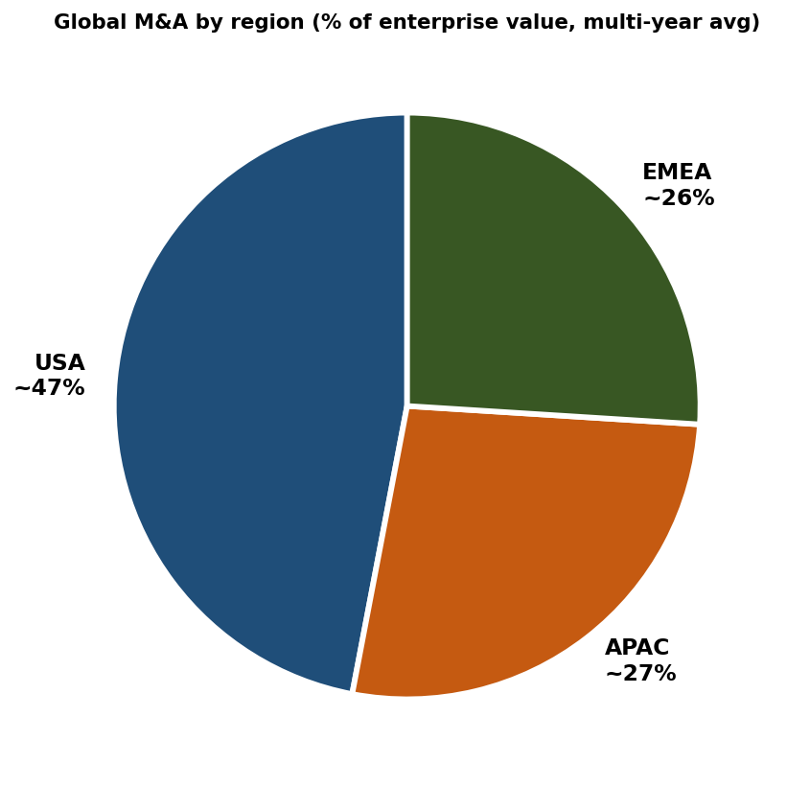
Figure 1.1 — Global M&A by region (% of enterprise value).
M&A is a large and persistent activity in the global economy. Recent annual volumes run into the trillions of dollars in enterprise value, with the United States the largest single market by some margin. Approximate regional shares (by EV, multi-year average):
- United States: roughly 47% of global deal volume.
- Asia-Pacific: roughly 27%.
- Europe, Middle East and Africa: roughly 26%.
These shares move with macro conditions, regulatory shifts and the cyclicality of large-deal flow, but the dominance of the US has been stable across most of the past two decades.

1.3 Drivers of the 2025-26 recovery
Deal activity is highly cyclical, and the 2025-26 period is characterised as a recovery from a quieter phase. Four drivers stand out:
- Carry-over from low prior-year deal flow. When activity has been depressed, both sellers and buyers accumulate plans that eventually need to be executed; the pipeline rebuilds quickly when conditions allow.
- Favourable financial environment. Bullish equity markets raise valuations and confidence, while accessible financing eases deal funding.
- Pickup in private equity transactions, especially leveraged buyouts. PE funds with dry powder must deploy capital within their fund lives, and easier financing conditions reopen the LBO playbook.
- Resurgence of jumbo deals. Large strategic transactions tend to cluster — once one mega-deal lands, others often follow as competitors respond.

1.4 Macro and micro drivers of M&A more broadly
Beyond the cyclical drivers above, M&A activity is shaped by a stable set of long-running forces. The macro drivers operate at the level of whole economies; the micro drivers explain why an individual firm pursues a specific deal.

Macroeconomic drivers
- Technological change — new technologies create both threats and opportunities that force consolidation or repositioning.
- Internationalization and globalization — firms expand across borders to access markets and resources.
- Deregulation — sector-specific liberalisation often triggers waves of consolidation.
- Stock market pressure — high valuations make share-based acquisitions attractive.
- Healthy financial markets and low interest rates — both ease the cost of financing.
- Specific financial schemes — leveraged buyouts (LBOs), Special Purpose Acquisition Companies (SPACs) and similar vehicles enable M&A that would not otherwise occur.

Microeconomic drivers
- Economies of scale and unit-cost reduction.
- Gaining market share — adding new countries, new product lines, new customer segments.
- Pursuing industry leadership.
- Saving time relative to organic build — though you pay a "goodwill" premium for the head start.
- Strategic focus or deleveraging — disposing of non-core operations.
- Managerial disruption — death, departure or weakness of senior management can force restructuring.

1.5 M&A in the strategic-transactions landscape
M&A is one tool in the broader toolkit of strategic financial transactions, which also includes capital markets (IPOs, follow-on offerings, debt issuance), restructurings (spin-offs, equity carve-outs), and joint ventures. Each tool has its own time horizon, regulatory profile and economic logic. M&A is distinct in that it transfers control: after the transaction completes, the target's decisions are made under a new ownership.
Worth memorizing
M&A = controlling stake (or influential), negotiated, documented. ABBs are not M&A.
Geography: USA ~47%, APAC ~27%, EMEA ~26% of global volume.
2025-26 recovery: carry-over flow, bullish markets, PE pickup, jumbo deals.
Macro drivers: tech change, globalisation, deregulation, market pressure, rates, structured vehicles.
Micro drivers: scale, share, leadership, time, focus, managerial disruption.

1.6 Chapter recap
The remainder of this textbook is concerned with how M&A is actually executed, given that the strategic and economic motives are well understood. The next chapter therefore turns to the first practical question facing a seller: what kind of process should I run?

Quick check
- Why is an ABB not considered an M&A transaction?
- List four macroeconomic drivers that have supported M&A activity recently.
- How does the role of LBO financing illustrate the link between financial markets and M&A volume?

Chapter 2 — The Selling Process
Learning objectives
Compare bilateral and auction processes on speed, confidentiality, price and execution risk.
Memorise the standard auction timetable and document sequence.
Identify the key advisor roles on both sides of an M&A transaction.
Estimate how many parties and people are involved in a large deal.

2.1 Two dominant process types
When a seller decides to dispose of a business, the first strategic choice is how to run the sale. Two archetypes dominate: a bilateral private negotiation with one identified buyer, and an organised auction with many invited bidders. Each has its trade-offs.

Bilateral (one-on-one) negotiation
Two parties — the seller and one potential buyer — engage directly. The typical sequence:
- Non-disclosure agreement (NDA) — protects information shared during diligence.
- Memorandum of Understanding (MOU) or Term Sheet — fixes the broad commercial terms in principle.
- Detailed negotiation — fleshes out the final agreement.
- Legal steps — drafting, regulatory clearances if required.
- Signing — both parties bound.
- Closing — money and shares actually change hands.
Why pick this route? The pros are confidentiality and speed. The negotiations stay private; competitors do not learn the firm is for sale; the executives can stay focused on the business. The cons are obvious in hindsight: the seller does not know whether it found the best buyer at the best price. The deal is the deal; there is no counter-offer to keep the buyer disciplined.

Auctions
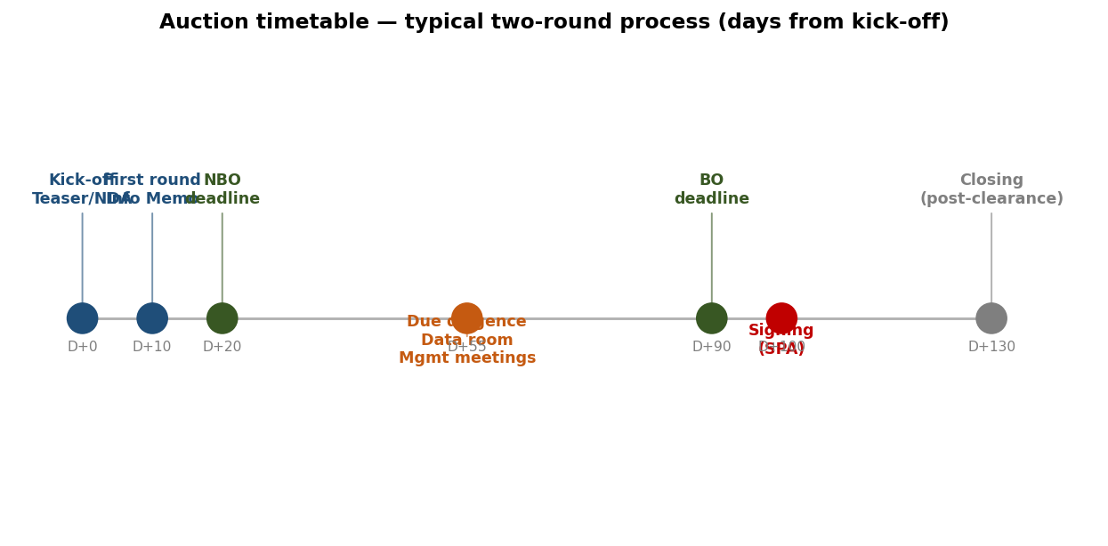
Figure 2.1 — Typical two-round auction timetable: kick-off to closing in ~130 days.
Auctions reverse the trade-off. The seller approaches many potential buyers, runs a structured process to keep them moving in parallel, and uses competition to drive price discovery. Auctions are common for mid-cap and large deals, especially when the asset is well-known and likely to attract multiple credible buyers.
A typical two-round auction follows a timetable like this, with D defined as the day of kick-off:
Day | Event
D = 0 | Kick-off: teaser circulated; NDAs signed.
D+1 to D+19 | First round: interested parties receive Information Memorandum, submit Non-Binding Offers (NBO).
D+20 | NBO deadline: seller selects a shortlist of 3-6 buyers.
D+21 to D+89 | Second round: shortlisted buyers conduct full due diligence, access data room, meet management, visit sites.
D+90 | Binding Offer (BO) deadline: buyers submit final binding bids with mark-ups to the draft Share Purchase Agreement.
~D+100 | Signing of the SPA with the winning bidder.
D+100+ | Closing: regulatory approvals secured, money and shares change hands.

This timetable is indicative. Sellers customise it to their own objectives: an accelerated auction can compress the timetable substantially, while complex carve-outs can extend it for many months. Sellers sometimes accept a pre-emptive bid before the formal process completes, particularly if a buyer offers terms that meaningfully exceed expectations.

2.2 The document trail in an auction
Several documents punctuate the auction process, each serving a specific function:
- Vendor due diligence (VDD). A pre-emptive due-diligence report commissioned by the seller. Speeds up the buyer's own work and signals professionalism.
- Teaser. A short anonymised description of the opportunity, used to gauge buyer interest before NDAs are signed.
- Non-disclosure agreement (NDA). Required for any party that wishes to receive confidential information.
- Information Memorandum (Info Memo). Detailed sales document, typically 60-100 pages, covering business overview, financials, market, growth thesis, governance.
- Non-Binding Offer (NBO) — also known as Letter of Intent (LOI). First-round submission of indicative price and structure, conditional on diligence.
- Data room. Online repository of confidential information available to shortlisted bidders. Contains contracts, audited accounts, customer data, legal records.
- Management meetings and site visits. Structured opportunities for buyers to test the business and assess management.
- Binding Offer (BO). Final firm bid, including a mark-up of the seller's draft Share Purchase Agreement.
- Share Purchase Agreement (SPA). The legal contract executed at signing.

2.3 Trade-offs between the two process types
Dimension | Bilateral | Auction
Speed | Faster | Slower (60-100 days)
Confidentiality | Easier to keep | Harder to maintain
Price discovery | Limited | Strong (competition)
Execution certainty | High (one negotiation) | Lower (more failure points)
Buyer fit | Risk of suboptimal match | Better selection across many bidders
Best for | Niche assets, sensitive carve-outs | Mid- to large-cap, well-known assets

2.4 Key players
M&A deals attract a small army of advisors. The two camps face each other with very few neutral parties; the main exceptions are listed-company transactions in which independent experts and regulatory bodies (anti-trust authorities, foreign-investment review boards, sectoral regulators) play formal roles.

Financial advisors
- Universal banks (BNP Paribas, JPMorgan, Goldman Sachs, etc.) provide both advisory and financing.
- M&A "pure-play" firms (Lazard, Rothschild, Centerview, Evercore) advise without lending capital.
- Boutiques cover specific industries or geographies with deep relationships.
There is typically at least one financial advisor on the sell side; multiple advisors often appear on the buy side. On large deals, both sides may employ several advisors in parallel — for example, one bulge-bracket bank for global execution and a domestic boutique for local intelligence. In listed-company takeover bids, financial advisors are effectively compulsory.

Legal advisors
Legal teams sit on both sides and dominate document drafting (the SPA, ancillary agreements, regulatory filings). Their role is structural — they translate commercial deal terms into binding contracts and identify the legal risks the financial advisors might miss.

Other advisors
- Auditors — preparing VDDs, performing buy-side financial due diligence, validating completion accounts.
- Strategy consultants — typically Bain, McKinsey, BCG, OC&C, Mercer or Roland Berger; produce or test the business plan and the market thesis.
- Specialised technical advisors — real estate, labour and social law, environmental, ESG, IT.
- Management advisors — particularly important in LBOs, where the buyer must align with operational leadership.
- Fairness opinion providers — independent valuers, common in listed-company transactions.
- Communication agencies — managing internal and external messaging around the deal.
- Financing banks — separate from advisory banks, providing the loans and debt issues that fund a cash deal.
Scale of a large deal
On a multibillion-dollar transaction, each side can easily involve up to 10 different advisory firms.
The total number of professionals directly involved in execution can reach 50 per side.
That excludes the buyer's and seller's internal teams — finance, legal, strategy, HR, IT, communications.

2.5 Chapter recap
The choice between a bilateral negotiation and an auction is essentially a trade-off between confidentiality and speed, on one hand, and competition-driven price discovery on the other. Sellers tailor the process to their priorities. Whichever route they take, the deal-execution machinery is the same: a sequence of structured documents (Teaser → NDA → Info Memo → NBO → DD → BO → SPA → Signing → Closing), supported by a network of financial, legal and technical advisors.

Quick check
- If a seller's overriding priority is price, would you recommend a bilateral or auction process? Why?
- What document defines the formal start of the second round in an auction?
- Why are fairness-opinion providers more common in listed-company deals than in private-company deals?

Chapter 3 — Deal Structuring
Learning objectives
Distinguish the four payment / substance combinations that structure M&A.
Quantify the impact of cash vs share consideration on the acquirer's market cap, shareholding, and net debt.
Apply the EPS-accretion rules for both cash and share deals.
Compute the post-deal structure of Smith & Wesson in both cash and share scenarios.
Explain why the PV of synergies must equal or exceed the premium paid.

3.1 The vocabulary trap: "merger" and "acquisition"
M&A practitioners use "merger" and "acquisition" in technical senses that conflict with everyday usage. To stay precise:
- Acquisition — buying up to 100% of the shares of a company, or of a defined set of assets, typically with cash.
- Merger — has different meanings to different audiences. A journalist may call any combination of two firms a merger. A lawyer reserves the term for a legal absorption of one entity by another. An M&A finance practitioner uses "merger" specifically for a combination paid in shares of the buyer — whether or not a legal merger follows.
The most useful taxonomy uses two dimensions: the substance of what is being acquired (shares of the target or specific assets) and the form of payment (cash or shares of the buyer). This produces a 2-by-2 grid:
 | Substance: shares of target | Substance: assets
Payment: cash | Acquisition (shares of target) | Asset purchase (acquisition of assets)
Payment: shares of buyer | Merger (share deal) | Asset contribution

Cash deals (acquisitions) and share deals (mergers) are the most common patterns. Mergers may also include a cash component — "mixed" deals. The technicality of whether the target entity is subsequently legally merged into the buyer is mostly tax and legal; the economic substance is identical.

3.2 Cash deal: nature and features
In a cash acquisition, the buyer pays cash to the target's shareholders in exchange for shares (up to 100%) of the target — or, alternatively, in exchange for specific assets. The target becomes a subsidiary, or its assets are absorbed into the buyer's operations.
- Price is usually easy to define: a single number, or a number per share.
- The payment is cash — funded from the buyer's existing balance sheet, from debt, or from a capital raise.
- Tax: usually a taxable event for the seller, who receives liquid proceeds and (in most jurisdictions) realises any embedded capital gain.
- Typical use case: small to mid-cap transactions, including add-on acquisitions and "build-up" programmes in private equity.

3.3 Share deal (merger): nature and features
In a share deal, the seller contributes the target to the buyer in exchange for newly issued shares of the buyer. The target becomes a wholly-owned subsidiary; whether it is subsequently legally merged into the buyer's main entity depends on tax and legal considerations.
- Price is not a fixed amount — the consideration is defined by an exchange ratio ("X shares of A for Y shares of B"), so it moves with the buyer's share price.
- From an economic standpoint, a merger is an aggregation of the substance of both firms. It is symmetrical for the shareholders of both companies: whether A absorbs B or B absorbs A, the outcome is the same in theory (in practice, who issues the shares affects tax, legal mechanics, and psychology).
- Tax: typically no immediate liability for the seller — no cash changes hands, so no realisation event.
- Typical use case: jumbo deals (large cross-border combinations of listed firms), and public M&A where the acquirer wants to preserve cash and balance-sheet capacity.

3.4 Exchange ratio in share deals
In a share deal, the headline question is not the per-share price of the target — it is the exchange ratio. A is not buying B at €100 per B-share; A is issuing X new A-shares for every Y B-shares (the ratio X:Y). This number depends both on the stand-alone valuations of the two firms and on how the parties allocate the value created by synergies.
Any cash component in the deal partially restores the importance of stand-alone valuations, because the cash portion does pin a numerical price on the target. Pure exchange offers are unusual at the high-end; in practice, even "mergers" often have at least some cash.

3.5 Impact of deal type on the acquirer
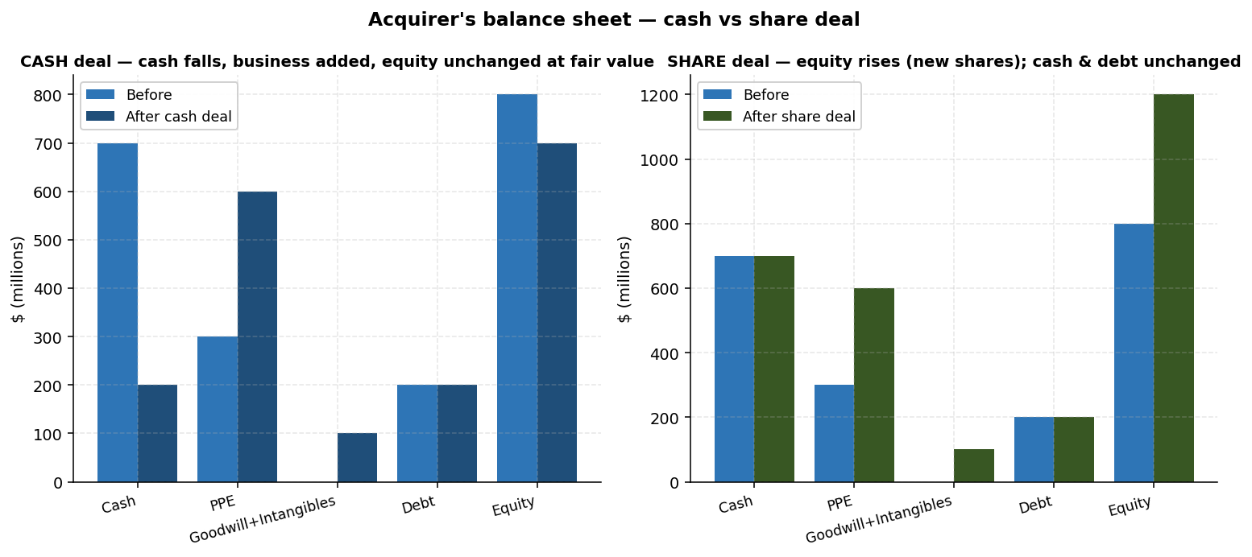
Figure 3.1 — Acquirer's balance sheet impact: cash deal swaps cash for the business (equity unchanged); share deal grows market cap by the target's size.
The accounting and structural consequences of the two routes differ substantially. The key variables are the acquirer's market cap, the composition of its shareholder base, and its net debt.

Market capitalisation
Cash deal. Assuming the buyer pays the fair market value of the target and we set aside synergies for a moment, the buyer's equity value is unchanged. It has swapped cash on the balance sheet for an operating business of equal market value, funded by debt or cash. Equity holders' wealth is the same.
Share deal. The buyer's market cap rises by the target's pre-deal market cap, because new shares are issued in exchange for the target equity. Combined market cap = market cap of acquirer + market cap of target (again, ignoring synergies).

Shareholding structure
Cash deal. The acquirer's share capital is unaffected; the existing shareholders retain their economic and voting positions.
Share deal. New shares are issued to the target's shareholders, who become shareholders of the combined entity. A new investor group joins, and the relative weight of the original groups becomes a key negotiation item.

Net debt
Cash deal. The acquirer's net debt rises by (a) the target's pre-existing net debt that is taken on, plus (b) the cash spent on the acquisition. The combined leverage ratio (Net Debt / EBITDA) can shift dramatically.
Share deal. Because no cash is spent, the combined net debt is simply the sum of the two pre-deal net debts. Leverage is preserved.
Worth memorizing — cash vs share at a glance
Cash: acquirer market cap unchanged; shareholding unchanged; net debt rises.
Share: acquirer market cap = sum of two; new shareholders join; net debt unchanged from sum.
Cash deal favours acquirers who can comfortably absorb new debt; share deals favour acquirers with high P/E multiples whose currency is valuable.

3.6 EPS accretion / dilution
The earnings-per-share impact of a deal is a popular short-hand for whether the deal looks accretive to shareholders. The rules differ between cash and share deals.

Cash acquisitions
A cash acquisition is EPS-accretive (other things equal) when the inverse of the target's price-to-earnings ratio — adjusted for the premium paid — exceeds the after-tax cost of the new debt used to fund the deal.
$Accretive if \frac{1}{P/E_{T}} > k_{d} (1 - t)$
Where PE_T is the premium-adjusted price-to-earnings ratio of the target, k_d is the cost of debt, and t is the tax rate. Intuitively, the new earnings (the target's contribution) must exceed the new interest expense — otherwise net income falls and EPS dilutes.

Share-based mergers
In a share deal, accretion turns on the relative P/E ratios. The post-merger P/E equals the weighted average of the pre-merger P/Es of acquirer and target, weighted by their respective net incomes. A deal is accretive when the acquirer's P/E exceeds the target's premium-adjusted P/E.
$Accretive if P/E_{acquirer} > P/E_{target}$
The intuition: if the acquirer's earnings are valued more dearly by the market than the target's, exchanging acquirer shares for target shares brings in earnings that are "cheap" relative to the acquirer's currency, lifting per-share earnings.
A practical corollary: acquirers with high P/E ratios are mechanically EPS-friendlier acquirers, at least for communication purposes. This explains why high-growth firms find it easier to use stock as a deal currency than low-growth firms.

3.7 Synergies — the analytical heart of pricing
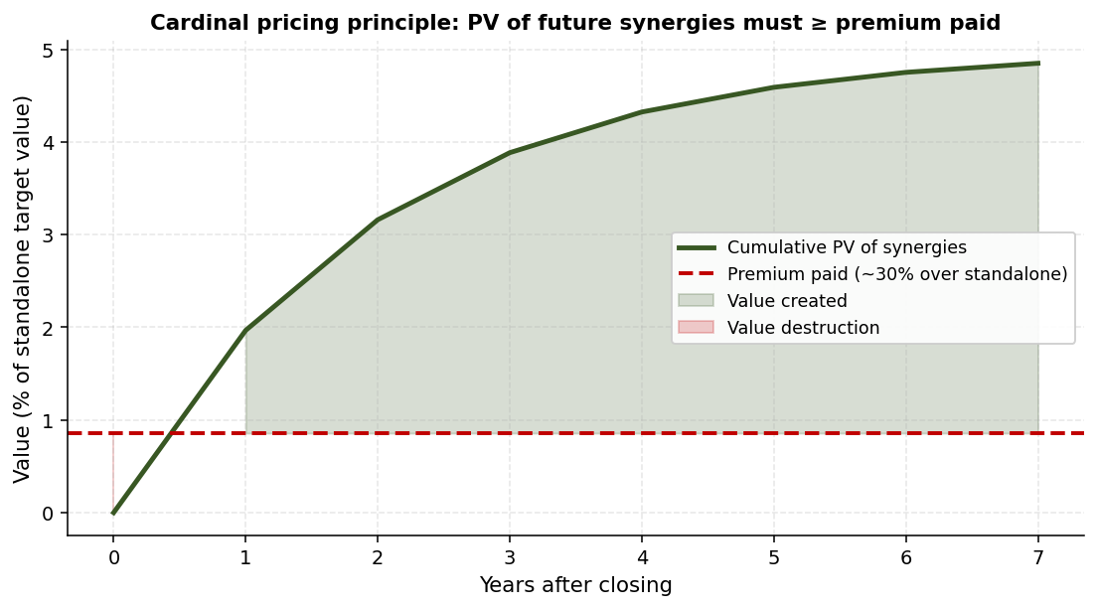
Figure 3.2 — The cardinal pricing principle: PV of future synergies must equal or exceed the premium paid.
Pricing an M&A transaction is not about the target's stand-alone valuation; it is about what the target is worth in the hands of the buyer. The difference between those two numbers is the synergies — the value the combination creates over and above the value of the two firms apart.
Two broad categories of synergy are usually distinguished:
- Revenue synergies — cross-selling, pricing power, expanded distribution. Generally harder to estimate and slower to materialise.
- Cost synergies — duplicate role elimination, procurement economies, shared infrastructure. Typically easier to quantify and capture more quickly.
For each synergy, both magnitude and timing matter. A €500M synergy realised in year 1 is worth far more than the same synergy realised gradually over five years.

The cardinal pricing principle
$PV(synergies) ≥ Premium paid$
Why must this hold? Because if it does not, the acquirer has paid more for the target than the target is worth in the acquirer's hands — by definition, value destruction. The market reads the price as soon as it is announced and revalues the acquirer's shares accordingly. An immediate stock-price decline for the acquirer is a public confession that the synergies are insufficient.
In Europe, the three-year average M&A premium runs around 30%. This is the bogey synergies must clear. Realised synergies that fall short produce the wave of post-merger value destructions that fill business-school case studies.

Sharing synergies
A second-order question is how the buyer and seller share the synergies. Synergies belong, in principle, to the combination — but the seller has bargaining power and will demand a share of the value the buyer will create. The split is one of the central tactical decisions in deal pricing. In a share deal, it translates directly into the exchange ratio; in a cash deal, it determines the premium.

3.8 Smith & Wesson — a worked case study
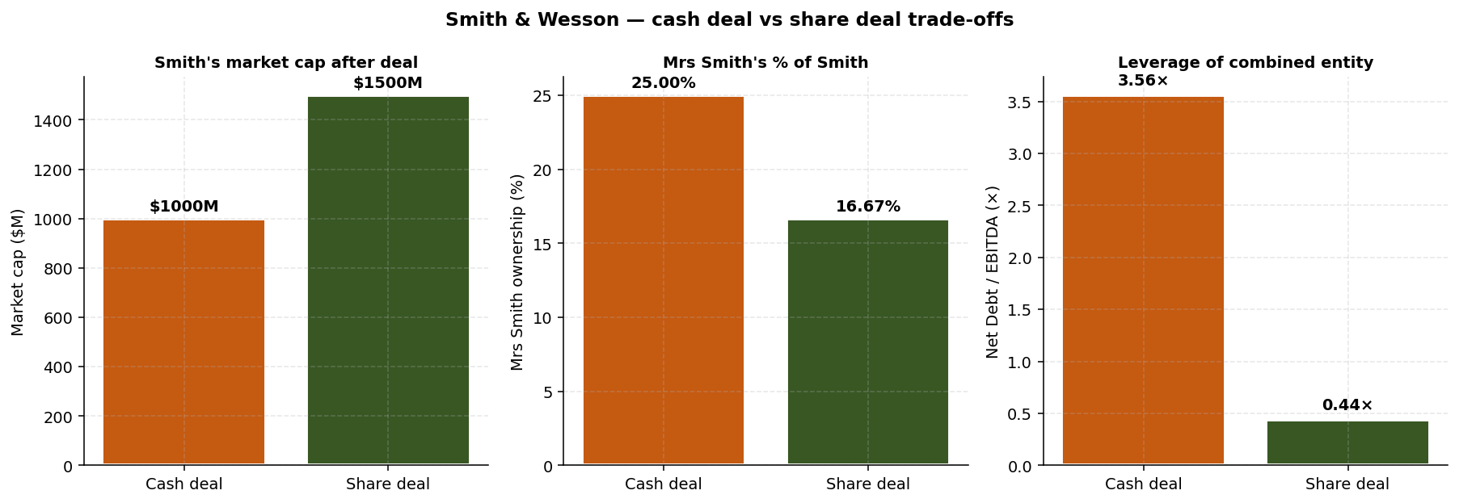
Figure 3.3 — Smith & Wesson: cash vs share deal trade-offs across market cap, control, and leverage.
The Smith & Wesson case in the course brings every concept above together in a single numerical example. Mrs Smith, CEO of Smith & Co., holds 25% of Smith. She wants to combine her company with Wesson, which is 50% owned by Mr Wesson. The new entity will be renamed Smith & Wesson. The question: should the deal be structured as a cash acquisition or as a share-based merger?

Pre-deal facts
Item ($M unless stated) | SMITH | WESSON
Share price ($) | 10 | 50
Shares outstanding (M) | 100 | 10
Market capitalisation | 1,000 | 500
Net financial debt | (10) | 80
Enterprise Value | 990 | 580
EBITDA | 90 | 70
Net income | 50 | 40
EPS ($) | 0.50 | 4.00
P/E | 20× | 12.5×

Assume the deal is executed at the current market prices of the two firms (no premium, no synergies modelled — we are running the structural mechanics).

Question 1 — Combined market cap
Cash deal. Smith uses $500M of cash to acquire 100% of Wesson. Smith's equity value is unchanged at $1,000M — it swapped $500M of cash for a $500M business. Mrs Smith's economic stake (and voting position) is also unchanged.
Share deal. Smith issues new shares to buy Wesson at fair value. The new shares = $500M / $10 = 50 million new Smith shares. Combined market cap = $1,000M + $500M = $1,500M. Total share count = 100M + 50M = 150M.

Question 2 — Mrs Smith's shareholding
Cash deal. Mrs Smith continues to own 25M shares out of 100M outstanding = 25% (unchanged).
Share deal. Mrs Smith continues to own 25M shares out of a now-larger 150M outstanding = 25 / 150 = 16.67%. She has been diluted by the deal.

Question 3 — Post-deal leverage
Cash deal. Combined net debt = −10 + 80 + 500 (cash spent) = $570M. Combined EBITDA = 90 + 70 = $160M. Net Debt / EBITDA = 570 / 160 = 3.56× — a substantial leverage burden for the combined firm.
Share deal. Combined net debt = −10 + 80 = $70M (no cash spent). Net Debt / EBITDA = 70 / 160 = 0.44× — extremely clean balance sheet.

Trade-off and recommendation
The two routes hand Mrs Smith very different trade-offs. The cash deal preserves her 25% controlling stake but loads the combined entity with leverage of 3.56× EBITDA, raising the risk profile of her position. The share deal dilutes her to 16.67% but leaves a near-debt-free balance sheet with substantial capacity for future M&A or returns to shareholders.
Important auxiliary point: a share-based purchase of Wesson is EPS-accretive for Smith. Smith trades at 20× P/E, Wesson at 12.5×. By the share-deal accretion rule (PE_acquirer > PE_target), the deal is mechanically accretive — Smith is exchanging "expensive" shares for "cheap" earnings.
In practice, the recommendation depends on what Mrs Smith values most. If retaining control is paramount and the combined firm can support the leverage, cash is justifiable. If long-run flexibility and balance-sheet strength matter more than the control margin, the share deal dominates. The case is a clean illustration that there is no universally correct structure — only structures that fit specific objectives.
Worth memorizing — Smith & Wesson numbers
Smith: $1bn cap, ND = −$10M, P/E 20×, EBITDA $90M.
Wesson: $500M cap, ND = $80M, P/E 12.5×, EBITDA $70M.
Cash deal: Smith cap unchanged $1bn, Mrs Smith 25%, ND/EBITDA = 3.56×.
Share deal: combined cap $1.5bn, Mrs Smith 16.67%, ND/EBITDA = 0.44×.
Share deal is EPS-accretive because PE_S (20×) > PE_W (12.5×).

3.9 Chapter recap
The structural choice between cash and share is the single most consequential decision in deal design. Cash deals preserve shareholding but consume cash and worsen leverage; share deals preserve leverage but dilute shareholders. The choice depends on the acquirer's currency (P/E), balance sheet, control preferences, and the target's tax considerations. The synergy principle disciplines pricing: PV of synergies must clear the premium, or the acquirer's stock will pay the bill.

Quick check
- A buyer with a 25× P/E acquires a target with a 30× P/E in a pure share deal. Is the deal accretive? Why?
- Why does a cash deal usually raise an acquirer's net debt by more than the target's stand-alone net debt?
- In Smith & Wesson, what happens to Mrs Smith's voting weight if Smith issues only half the new shares as cash and the other half as Smith shares?

Chapter 4 — Execution Main Drivers
Learning objectives
Define enterprise value and equity value, and walk through the bridge between them.
Identify the standard bridge items and explain why each is negotiated.
Compare locked-box and completion-accounts mechanisms.
List the main due-diligence types and what each covers.
Describe the structure and purpose of an SPA.

4.1 Two views of execution
Once price is agreed in principle, the execution phase is about translating that headline price into a binding contract that captures exactly what each side gives and receives. Practitioners describe this as a sequence: a preliminary EV is set after the first round of analysis; due diligence in the second round refines that EV and identifies the items that must be subtracted to reach the equity value the seller actually pockets.
The EV-to-Equity "bridge" is therefore the central artifact of execution. Every line item in the bridge moves the final cheque the buyer writes, and each is negotiated separately. A good deal team in the second round refines the EV, builds the bridge, and provisionally agrees post-closing adjustment mechanisms for items that cannot be locked at signing.

4.2 Enterprise value vs equity value
Enterprise value (EV) is what one is paying for the entire business, regardless of how it is financed. Equity value is what is paid to the equity holders specifically — after the buyer has taken responsibility for the firm's debts and other obligations.
$Equity value = Enterprise value - Bridge items$
In an M&A transaction, the bridge items go beyond the simple "net debt" of a textbook EV calculation. They include every non-equity claim on the firm's enterprise value, from financial debt to pension obligations to off-balance-sheet commitments. Each line is fought over.

4.3 Bridge items
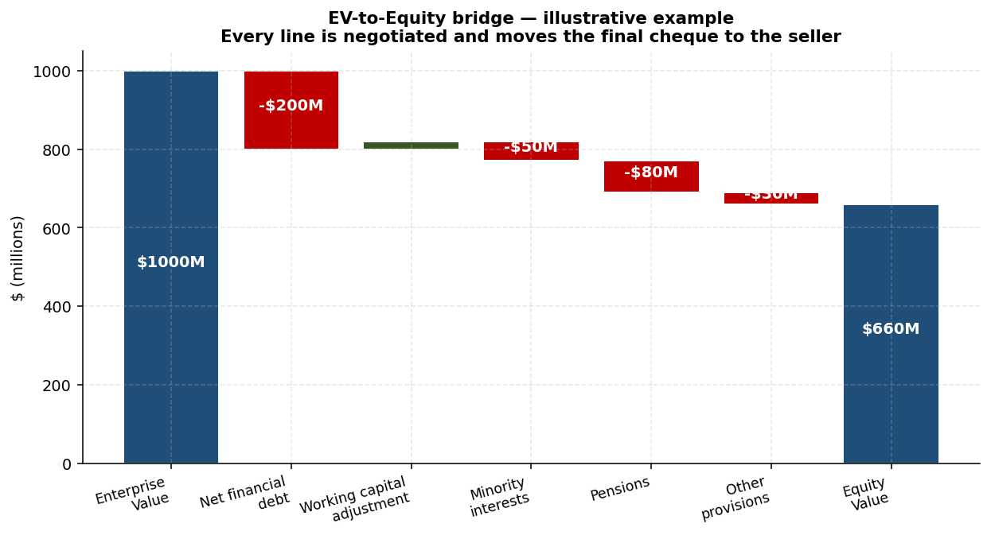
Figure 4.1 — EV-to-Equity bridge: every line is negotiated and moves the final equity value.

Net financial debt
Gross financial debt minus cash. Gross financial debt includes all financial debt items regardless of maturity, plus leasing liabilities (a common point of dispute). Cash and equivalents include cash, bank balances, and liquid placements at market value — with careful attention to "trapped" cash (cash held in subsidiaries where extraction is restricted by regulation, tax, or minority shareholders).

Working capital adjustment
Working capital fluctuates seasonally, and the level at closing affects how much cash effectively transfers with the business. Two main approaches: a yearly-average adjustment (compare actual working capital at closing to the annual average) or a "normative" adjustment (compare to a level both parties agree as normal for the business). The reference date and methodology are negotiation items; the direct impact on the equity value is dollar-for-dollar.

Minority interests
If the target has non-wholly-owned subsidiaries, the minority shareholders own part of those subsidiaries' equity. Because EV is a global concept (it captures the value of all of the business, including the minority share), the minority interest must be subtracted in the bridge to reach the equity value belonging to the controlling shareholders.

Off-balance-sheet commitments
Pledges granted, guarantees received or granted, put options outstanding, and similar contingent obligations or rights. These are not in the audited accounts as liabilities, but they can convert into cash flows under specific scenarios.

Pensions and other employee benefits
Pension liabilities are usually the most complex bridge item. Verifying the active and retiree populations, the actuarial assumptions (discount rate, longevity, inflation), and the present value calculation requires specialist work — typically by a pensions consultant. Relevant provisions, including any incremental funding the parties agree to make, are incorporated in the bridge.

Other provisions
Tax disputes pending with authorities, restructuring costs already committed, decommissioning or environmental-restoration liabilities. Each must be analysed as a potential future cash outflow and either provided for at fair estimate or surfaced as a separate bridge item.

Real estate and miscellaneous
Real estate held but not used in operations may be valued separately and added or subtracted. Numerous smaller items round out the bridge — surplus assets, non-recurring items, advisor success fees. Every line is negotiated.
Why every item matters
A €50M difference in the pension assumption is a €50M difference in the cheque.
Sellers push for low pension liabilities and low working-capital adjustments.
Buyers push the opposite direction on each.
Strong vendor due diligence reduces disputes by establishing a defensible baseline upfront.

4.4 Signing vs closing — locked box vs completion accounts
Signing and closing rarely coincide. Regulatory clearances, financing draw-downs, employee notification processes — all take time. The gap between signing and closing creates a problem: which version of the target's accounts are the parties pricing? Two mechanisms address this:

Locked box
The acquisition price is "frozen" — locked in a box — at signing, based on the most recent set of available audited accounts. There is no post-closing adjustment. Between the lock-box date and closing, the seller bears the risk and reward of any value change, subject to a "prudent manner" clause that prevents the seller from extracting value during this interim period.
- Advantages: speed and certainty for both parties.
- Risks: any deterioration in the business between the lock-box date and closing belongs to the seller in theory, but the buyer must trust the audited accounts.
- Recent trend: locked box has become increasingly popular in Europe.

Completion accounts
The parties agree to update the price based on accounts as of (or close to) the closing date. The mechanism requires a target balance sheet at signing (with provisional values), audited closing-date accounts, and a process for resolving disputes over adjustments — typically with reference to a defined accounting standard or an independent expert. Adjustments can be made before closing or post-closing.
- Advantages: better information; price reflects the actual business at closing.
- Risks: dispute risk, delay, accounting-policy disagreements.
- Use: still systematic in the United States.

4.5 Worked example — EV-Equity bridge in practice
Consider an illustrative deal signing in late April with closing scheduled for end-September. The parties agree at signing:
- Enterprise Value = $650M (per negotiation).
- Adjusted net financial debt (31 December audited) = $335M.
- Value of minority interests = $40M (20% of an Italian subsidiary, etc.).
- Cost of decommissioning = $25M (agreed per negotiation).
- Pensions liability = $30M.
- Working-capital adjustment = $5M.
Bridge sum = 335 + 40 + 25 + 30 + 5 = $435M. Equity value at signing = 650 − 435 = $215M.
Now suppose the parties chose completion accounts. At closing on 30 September, audited interim accounts show:
- Adjusted net debt has fallen by $20M (more cash, less trapped cash).
- Working-capital is $10M above the agreed reference.
Final equity value = 215 + 20 + 10 = $245M. The payment at closing is based on the signing equity value, with the final adjustment booked when September accounts are available, typically by year-end.

4.6 Other negotiation tools
Beyond the bridge, several contractual mechanisms shape the economics:
- Vendor loan — a portion of the price deferred, financed by the seller. A trade-off between price and financing: a higher headline price for a vendor loan with attractive terms can be worth less than a lower price paid fully in cash.
- Earn-out — part of the price contingent on post-closing performance (see Chapter 6 of the Intangibles textbook for full mechanics).
- Prudent manner clause — binds the seller to operate the business normally during the signing-closing gap; preserves enterprise value.
- Material Adverse Change (MAC) clause — allows the buyer to walk away if a defined event materially harms the business between signing and closing. Borrowed from capital markets, not specific to M&A.
- Exclusivity — the seller agrees not to negotiate with other potential buyers for a defined period.
- Reps & warranties — the seller's statements about the business and the contractual remedies if those statements prove false.
- ESG commitments — increasingly written into agreements, particularly in regulated sectors.
- Shareholders' agreement — when the buyer is not acquiring 100%, governs the ongoing relationship between the buyer and any remaining shareholders.

4.7 Due diligence
Due diligence — the systematic verification of the seller's claims — is the costliest single workstream in a typical deal. Several types run in parallel.

Strategic due diligence
Performed by Bain, Mercer, OC&C, Roland Berger or similar strategy consultancies. Tests the top line of the business plan: market size, growth, competitive dynamics, positioning. The output is a view on whether the volume and margin assumptions are credible.

Financial due diligence
Performed by Big Four firms (PwC, EY, Deloitte, KPMG) or specialised independents such as 8Advisory. Covers profitability history, "quality of earnings" (separating recurring from one-off items), current trading, cash flow, working capital dynamics, business-plan review, financial-debt detail, EV-Equity bridge analysis.

Legal due diligence
Performed by the buyer's legal advisors. Covers contracts (commercial, supply, employment), litigation (pending and threatened), patents and other IP, tax history and disputes. Identifies legal risks that must be reflected in price or reps & warranties.

Specialised due diligences
- Industrial — fixed assets, premises, future CAPX needs.
- HR — social conditions, labour relations, litigation.
- Environmental — pollution risks, soil investigations.
- ESG — increasingly important across all transactions.

4.8 The Share Purchase Agreement (SPA)
The SPA is the master document that captures everything the parties have agreed. Typical structure:
- The price and all its components (base price, bridge items, adjustments).
- The mechanics of the transaction (signing, closing conditions, deferred payments).
- Representations of the seller (statements about the business).
- Warranties granted by the seller (with remedies if reps prove false).

Indemnification structure
Reps & warranties protect the buyer against asset shortfalls and misleading representations. Several parameters shape the protection:
- Ceilings (caps) — the maximum exposure of the seller under the warranty package.
- Triggering thresholds ("basket" or "deductible") — claims below this level are not reimbursable.
- Franchise — the threshold below which no claim is paid; once crossed, payment is from the first euro (or only above the threshold, depending on drafting).
- Duration — usually the legal statute of limitations for tax and social claims, with other claims (commercial, environmental) often capped at up to four years.
- R&W insurance — a growing market in which the buyer purchases insurance against breaches of seller warranties, often replacing seller-funded escrow arrangements.
The negotiated balance among these parameters connects directly to the price of the deal. Tighter warranties for the buyer mean a higher price (the seller is taking more risk); looser warranties mean a lower price.
Worth memorizing
Bridge items: net financial debt, working-capital adjustment, minorities, off-BS commitments, pensions, other provisions, real estate.
Locked box: price frozen at signing (EU default). Completion accounts: price adjusted at closing (US default).
Due diligence types: strategic (top-line), financial (quality of earnings, bridge), legal (contracts, litigation, IP), specialised (HR, environment, ESG).
SPA contains: price, mechanics, reps, warranties, indemnification.
Caps + thresholds + franchise + duration = the seller's exposure profile.

4.9 Chapter recap
Execution turns a handshake into a binding contract. The EV-to-Equity bridge identifies every non-equity claim that must be subtracted from the headline price. Locked-box and completion-accounts mechanisms resolve the signing-closing timing gap differently. Due diligence — strategic, financial, legal and specialised — generates the information that price adjustments and warranties depend on. The SPA captures all of it. Each clause is a slice of value; each is negotiated; each can be the line that drags the deal across the finish line or kills it.

Quick check
- Why are pensions usually the most complex single item in an EV-Equity bridge?
- Under what circumstances is a locked-box mechanism preferable to completion accounts?
- Explain the role of "trapped cash" in defining net financial debt.

Chapter 5 — Public M&A
Learning objectives
Explain why M&A on listed companies is regulated more heavily than private-company M&A.
List the regulatory disclosure thresholds and the trigger for a mandatory bid.
Compare cash offers (OPA), share offers (OPE) and mixed offers.
Distinguish friendly and hostile takeover dynamics.
Identify common takeover defences and the underlying motive of buying time.

5.1 Why listed-company M&A is different
Acquiring control of a listed company by quietly buying shares on the open market is essentially impossible in practice. The volumes required would move the price; the discretion would be impossible to maintain; and almost every developed market imposes regulatory constraints aimed precisely at preventing this kind of stealth acquisition.
The motive for those regulations is the protection of minority shareholders. Anyone holding shares of a listed firm has a right to know when control is shifting, on what terms, and to receive a fair opportunity to exit. The regulations therefore impose transparency requirements (disclosure thresholds) and protection requirements (mandatory bid rules).

5.2 Regulatory disclosure thresholds
In most jurisdictions, an investor crossing certain ownership thresholds must publicly disclose its position within a defined period. The thresholds vary, but several countries share broadly similar rules.
- France — 5%, 10%, 15%, 20%, 25%, 30%, 33.3%, 50%, 66.6%, 90%, 95%.
- United Kingdom — 3% and each multiple of 1% above.
Crossing a threshold — in either direction — triggers a filing with the market regulator. Failure to disclose carries penalties that range from fines to forced divestiture.

5.3 Mandatory bid
Most jurisdictions impose a mandatory bid obligation: when an investor's holding crosses a defined threshold (often 30%), the investor must offer to acquire the remaining shares from all other shareholders at the highest price it has paid in a defined preceding period.
The rule serves two purposes. First, it prevents creeping control changes that bypass the protections of an organised takeover. Second, it gives minority shareholders a real exit option, at a price aligned with what the controlling investor was prepared to pay.
The United States is a notable exception: there is no general mandatory-bid rule. Other rules (the Williams Act and SEC regulation) shape US takeover practice, but the mandatory-bid mechanism is a European invention.

5.4 Offer types
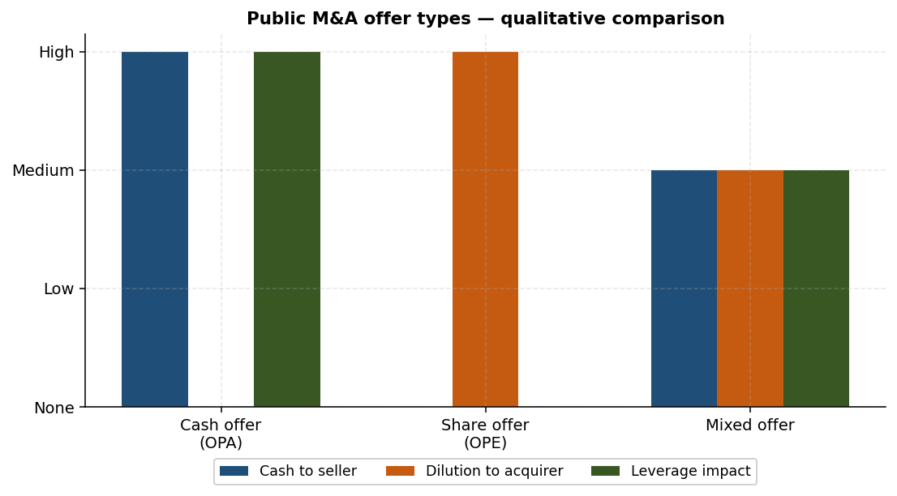
Figure 5.1 — Public M&A offer types compared on three dimensions.

Cash offers (OPA in French — Offre Publique d'Achat)
The bidder offers cash for each target share. Example: €100 per share. From the bidder's perspective, this is an acquisition. From the target shareholder's perspective, it is a cash exit — no further exposure to the buyer or the combined entity.
- Pros for the bidder: avoids dilution, retains existing shareholder structure.
- Cons for the bidder: consumes cash or requires new debt; deteriorates leverage.

Share offers (OPE — Offre Publique d'Échange)
The bidder offers its own shares in exchange for the target's shares. Example: 1 share of the bidder for each target share (a "1-for-1" exchange ratio). The target's shareholders become shareholders of the combined entity.
- Pros for the bidder: preserves cash and debt capacity.
- Cons for the bidder: dilutes existing shareholders.
- Spirit: this is a merger — the two shareholder groups are joining forces, sharing the future.

Mixed offers
A combination of cash and shares. Example: "4-for-5" plus €20 in cash per target share. Mixed offers reflect a compromise: target shareholders receive some immediate liquidity while also participating in the upside of the combined entity. They are common in deals that are large enough to strain a pure-cash bidder but small enough that pure dilution is not desired either.

"Mix and match" structures
In some transactions the target's shareholders are offered a choice between cash and shares, subject to an overall cash-share split (mix and match). Worldline's 2020 offer for Ingenico illustrates the pattern: an €8 billion deal in which holders could elect cash or stock within an overall framework.

5.5 Valuation and premium in public offers
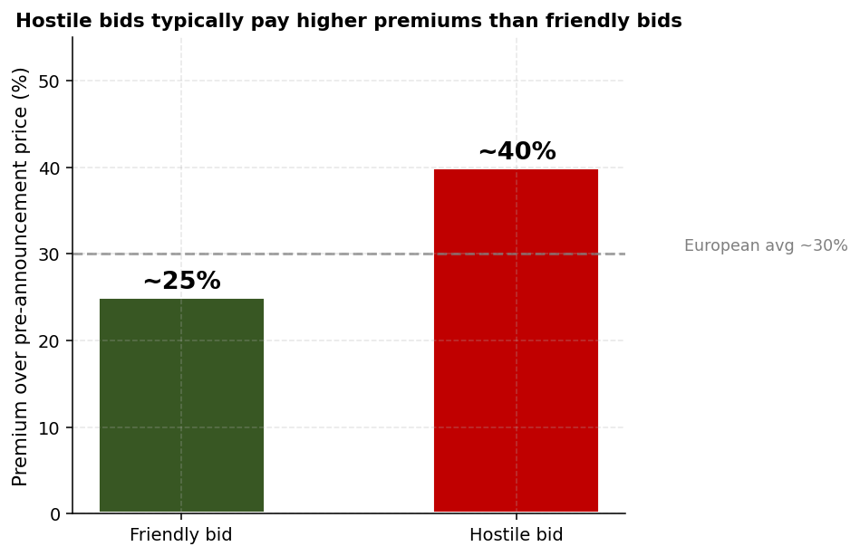
Figure 5.2 — Hostile bids typically pay higher premiums than friendly bids.
Pricing a public M&A bid involves the same fundamentals as a private transaction — stand-alone valuation, synergy assessment, premium — but with the added discipline of a live market price. In a cash offer, valuation is expressed in absolute terms (price per share). In a share offer, it is expressed in relative terms (exchange ratio).
Premiums tend to be larger in public deals than in private ones. The average three-year premium in Europe runs around 30% over the pre-announcement share price. The premium discipline applies: PV of synergies must clear the premium, or the acquirer's stock will fall on the announcement.
The sharing of synergies surfaces explicitly in the exchange-ratio negotiation. If A and B merge, the relative weight of the two shareholder groups in the combined firm is a function of both stand-alone valuations and synergy attribution. Practitioners debate fiercely how much of the synergy belongs to the merger as a whole (split 50/50) versus how much belongs to the buyer alone (which would justify a lower exchange ratio for the target).

5.6 Mechanics of a takeover bid
Public bids are run on a calendar set by the market regulator. After the bidder seeks initial clearance from the regulator and publishes the offer document, the offer period opens. During this window, target shareholders tender their shares; the bidder watches the market constantly, since the price of both the bidder and the target moves with new information; rebound events such as price increases by the bidder or counter-bids by rival suitors can dramatically reshape the dynamic.

5.7 Friendly vs hostile dynamics
Dimension | Friendly | Hostile
Preparation period | Several months of joint work | Shorter — the bidder cannot collaborate with the target
Offer period | Standard | Often longer, as the target resists
Post-merger integration | Often slower, more thoughtful | Can be very quick — the buyer dominates
Premium paid | Standard | Usually higher
3rd-party interference | Less common | More common (white knights, regulators)
Political acceptability | Politically straightforward | Politically uncomfortable in many jurisdictions
Cultural fit | Often a delicate mixture | Buyer dominates

A common pattern is for a hostile bid to be transformed into a friendly deal during negotiation — the bidder raises the price, the target's board recommends acceptance, and the transaction becomes officially "agreed." The political optics of an agreed deal are far better than those of a contested one.

5.8 Takeover defences
When a target board does not want to be acquired, it can deploy a variety of defensive tools. None is a guaranteed shield — the strongest defence in the long run is to remain well-managed — but each can buy time or improve terms.
- Caring for shareholders — special dividends or buybacks that immediately return value, raising the bar the bidder must clear.
- Communication campaign — making the case to shareholders that the bid undervalues the company.
- White knight — inviting an alternative friendly bidder whose offer is more attractive.
- Opportunistic capital increase — issuing new shares to dilute the hostile bidder and bring in friendly investors.
- Pacman defence — counter-bidding for the hostile bidder, turning the tables (rarely successful but spectacular when it works).
- Poison pill — automatic dilution triggered when a hostile bidder crosses a threshold. Common in the US, less so in Europe.
- Government protection — particularly in strategic or sensitive sectors, regulators or governments may block foreign acquisitions on national-interest grounds.
- Legal action — litigation to slow the bidder down.
The hidden objective
Most takeover defences are not designed to stop the bid outright — they are designed to buy time.
Time lets the target's board solicit better offers, brief shareholders, or persuade the bidder to raise the price.
Even when defences fail, they often improve the eventual deal terms.
The best long-run defence: stay well-managed enough that a justified takeover premium is hard to write.

5.9 Chapter recap
Public M&A operates in a regulated arena designed to protect minority shareholders. Disclosure thresholds, mandatory-bid rules, and the formal calendar of an offer are constraints the bidder must navigate. Within those constraints, the bidder chooses between cash, share or mixed offers — each with different consequences for dilution, leverage, and the spirit of the combination. Hostile bids attract higher premiums but face stronger defences. Practitioners track the live share prices of both firms throughout the process; market signals reshape strategy in real time.

Quick check
- Why does the United States not have a general mandatory-bid rule?
- Walk through what happens, mechanically, if a French shareholder crosses 30% by buying shares on the open market.
- Why are share offers (OPE) called "merger spirit" while cash offers (OPA) are called "acquisition spirit"?

Chapter 6 — Financing and Post-Merger Integration
Learning objectives
State and apply the two golden financing rules.
Identify the main financing options for an M&A transaction.
Walk through a bridge-loan refinancing using the Air Liquide / Airgas case.
List the principal risks of post-merger integration and the patterns that lead to value destruction.

6.1 The two golden rules
Two principles, both deceptively simple, anchor M&A financing.

Separate financing from the M&A investment decision
The economic logic of an acquisition (does it create value?) is distinct from the financing logic (how should we pay for it?). Mixing the two leads to bad decisions. A deal that destroys value is not rescued by clever financing; a value-creating deal is not killed by being financed with debt rather than equity, as long as the firm can sustain the resulting leverage.
In practice, the two decisions are made by different teams: the deal team focuses on the target's value and synergies; the treasury team focuses on the financing structure. They communicate, but neither dictates to the other.

Secure financing before announcing
A deal announced without committed financing is a deal at risk of public failure. Markets and the target's board will react badly to any uncertainty about the bidder's ability to fund the cash component. Bridge loans, underwritten by relationship banks, exist precisely to remove this uncertainty: the bank commits to fund the deal at signing, then helps refinance over the following months.

6.2 Key financial drivers of the financing decision

Combined debt leverage
The most-watched metric is Net Financial Debt / EBITDA on a pro-forma combined basis. Rating agencies and bank covenants set thresholds; the buyer's existing investment grade rating may be at risk if leverage rises too far. The Smith & Wesson cash case (Chapter 3) shows the mechanic: from −0.1× to 3.6× — a transformational change.

EPS impact
Even after rejecting EPS as a serious measure of value, practitioners watch it carefully because the market and management often anchor on it. A deal that is EPS-dilutive demands an articulate communication story — the buyer must explain why long-run value creation justifies short-run EPS pressure.

6.3 Financing options

Equity and equity-linked
- Capital increase — issuing new shares to existing shareholders (rights issue) or to the public (follow-on offering). The cleanest equity financing.
- Equity-linked instruments — convertible bonds and similar securities that count as debt initially but convert to equity over time. Useful when the buyer is reluctant to dilute today but accepts dilution if the share price rises.

Debt (recourse)
- Bank loans — bilateral or syndicated. Faster to execute than bonds and more flexible on covenants.
- Bonds — public market debt, usually cheaper than bank loans for investment-grade issuers, available in multiple currencies.

Structured (non-recourse)
- Corporate acquisition financing — facilities structured around the acquired business's cash flows.
- LBO financing — a private-equity acquisition vehicle takes on substantial debt, with the target's cash flows as the source of repayment. The acquired company carries the leverage; the equity sponsor invests only equity into the holding vehicle.

M&A-specific instruments
- Bridge loans — short-term loans (often 12-24 months) provided by relationship banks specifically to secure the cash payment at closing. Always intended to be refinanced over time with cheaper long-term capital.
- Vendor loans — the seller defers part of the price, effectively lending to the buyer. Useful when the buyer wants to limit its day-one debt and the seller is willing to take some risk.

6.4 Worked example — Air Liquide and Airgas
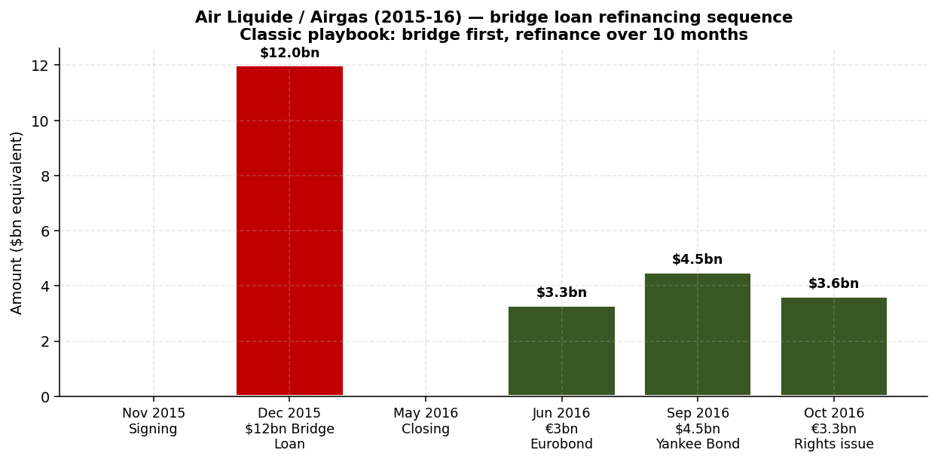
Figure 6.1 — Air Liquide / Airgas (2015-16): $12bn bridge loan refinanced over 10 months.
Air Liquide's 2015-16 acquisition of Airgas is a textbook example of the bridge-loan playbook. The deal was a $13.4 billion all-cash acquisition aimed at strengthening Air Liquide's leadership in industrial gases (already #1 in North America, Europe, MEA and APAC).

Timeline
Date | Event
17 November 2015 | Signing announced — agreement with Airgas board for the $13.4 billion cash deal.
December 2015 | Bridge loan of $12 billion provided by two relationship banks.
23 May 2016 | Closing of the acquisition.
June 2016 | First tranche of refinancing — €3 billion Eurobond issued.
September 2016 | Second tranche — $4.5 billion Yankee bond issued (USD-denominated debt sold to US investors by a non-US issuer).
October 2016 | Third tranche — €3.3 billion rights issue (capital increase).

The total refinancing was spread over roughly ten months. The bridge loan absorbed all of the funding pressure at closing; the bond issues and rights issue progressively replaced bank debt with cheaper, longer-dated and more diversified capital. By the end, Air Liquide had moved from a $12 billion bridge with two banks to a balanced mix of bonds (in two currencies) and fresh equity.
This sequencing — bridge first, refinance later — is the standard template for large strategic cash deals. The bridge buys certainty of close; the subsequent refinancing optimises cost of capital.

6.5 Post-Merger Integration (PMI)
Closing is not the end of the deal; it is the start of the harder part. Capturing the synergies that justified the premium requires sustained operational work, often over years. Different buyer types weigh PMI differently.
- Private equity funds — focus is largely on IRR and the money-on-money multiple at exit. PMI is operational but does not require cultural integration with another corporate.
- Trade buyers (corporates acquiring other corporates) — face the full integration challenge: products, systems, cultures, brands, employees. Tracking synergies is hard, especially in mergers of equals where the target perimeter blurs into the combined entity.
PMI practice remains empirical, with limited harmonisation or standardisation across firms. Each buyer develops its own playbook; consultants compete on the strength of theirs.

6.6 PMI risks
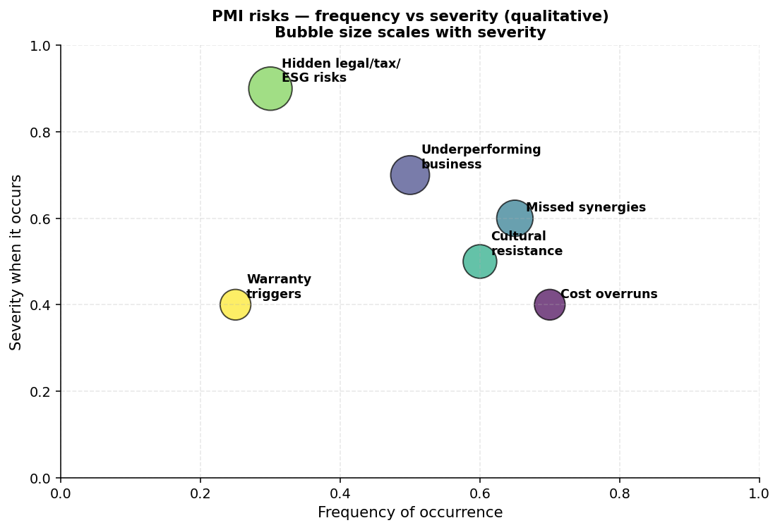
Figure 6.2 — PMI risks plotted by frequency and severity. Hidden legal/tax/ESG risks are the most severe even though less frequent.
Several patterns recur in deals that fail to deliver the value originally promised:
- Higher acquisition cost than anticipated. Adjustments at closing or post-closing tip the price higher than the headline.
- Warranty triggers. Asset shortfalls or liabilities not flagged in due diligence force the seller to pay claims or the buyer to absorb the loss.
- Underestimated legal, tax, litigation, social, environmental or political risks. Famous examples include Bayer's acquisition of Monsanto (subsequent glyphosate litigation) and Holcim's merger with Lafarge (post-merger discoveries of payments in conflict zones).
- Underperforming business. The acquired business misses its plan, regardless of integration efforts.
- Low level of integration / cultural resistance. The two organisations remain effectively separate, capturing few of the expected synergies.
- Inability to deliver promised synergies. The plan was right in principle but execution falls short — most often a mix of process complexity, talent attrition, and timing.
Worth memorizing
Two golden rules: separate financing from investment; secure financing.
Bridge loan: short-term bank facility that secures the closing payment and is refinanced over 6-18 months.
Air Liquide / Airgas: $12bn bridge → €3bn Eurobond → $4.5bn Yankee bond → €3.3bn rights issue, over 10 months.
PMI risks: cost overrun, warranty triggers, hidden legal/social/environmental risks (Bayer-Monsanto, Holcim-Lafarge), underperformance, cultural friction, missed synergies.

6.7 Chapter recap
Financing decisions follow the two golden rules: keep them separate from the investment decision, and secure them before announcement. A typical large cash deal is funded with a bridge loan at closing and refinanced over the following months via a combination of bonds, bank debt, and (sometimes) a capital increase. Post-merger integration is where the value originally paid for must be captured — or destroyed. The common failure modes are familiar: cost overruns, hidden risks, talent flight, cultural resistance, and synergies that look easier on a deck than on a Monday morning.

Quick check
- Why is it dangerous to announce a $5 billion cash deal without committed financing?
- Explain the strategic logic of the Air Liquide bridge-loan refinancing sequence.
- List three risks in PMI that typically explain why acquirer share prices decline two years after an apparently successful close.

Chapter 7 — Self-Test

Section A — Multiple choice
Q1. In an M&A context, an Accelerated Book Build (ABB) is best characterized as:
A. A type of M&A auction process
B. A block trade of listed shares, not an M&A transaction
C. A specific financing tool for a cash acquisition
D. A regulatory clearance procedure
Q2. In a cash acquisition at fair market value, the acquirer's market capitalization is most likely to:
A. Increase by the target's market cap
B. Decrease by the cash spent
C. Remain unchanged
D. Become zero
Q3. A share-based merger is EPS-accretive when:
A. The acquirer has higher revenue than the target
B. The acquirer's P/E exceeds the target's P/E (premium-adjusted)
C. The combined entity has higher EBITDA
D. The exchange ratio is exactly 1:1
Q4. The cardinal pricing principle in M&A is that:
A. The acquirer should never pay more than book value
B. The seller should always be paid in cash
C. PV of future synergies must equal or exceed the premium paid
D. The exchange ratio must be 1:1
Q5. In the Smith & Wesson case, the cash deal results in a combined Net Debt / EBITDA ratio of approximately:
A. 0.44×
B. 1.78×
C. 3.56×
D. 5.00×
Q6. Which of the following is NOT usually a line item in the EV-to-Equity bridge?
A. Net financial debt
B. Working-capital adjustment
C. Pensions
D. Future R&D budget
Q7. The mandatory tender offer threshold in France is approximately:
A. 10%
B. 20%
C. 30%
D. 50%
Q8. Locked box and completion accounts differ primarily in:
A. The legal form of the transaction (asset purchase vs share purchase)
B. Whether the price is fixed at signing or adjusted at closing
C. Whether the deal is cross-border or domestic
D. Whether the consideration is cash or shares
Q9. Air Liquide funded its $13.4 billion acquisition of Airgas (2015-16) primarily by:
A. A leveraged buyout structure
B. A bridge loan refinanced via bonds and a rights issue
C. Vendor financing from Airgas shareholders
D. An all-equity offering
Q10. The classic objective shared by most takeover defences is:
A. To block the takeover permanently
B. To increase the acquirer's leverage to unacceptable levels
C. To buy time — to improve terms, find alternatives, or persuade shareholders
D. To trigger anti-trust intervention

Section B — Short answer
S1. Smith & Wesson revisited. Assume Smith now offers Wesson a mixed consideration: 50% cash (financed with debt) and 50% Smith shares. Compute the combined market cap, Mrs Smith's resulting % ownership, and combined Net Debt / EBITDA.
S2. Explain three reasons a hostile bid is likely to pay a higher premium than a friendly bid for the same target. Use specific dimensions from the friendly-vs-hostile table.
S3. An acquirer agrees to pay €1 billion for a target. The bridge items are: net financial debt €200M, pensions €80M, minorities €50M, working-capital adjustment +€20M (in seller's favour), decommissioning obligations €30M. Compute the equity value transferring to the seller.

Section A — Solutions
Q1: B
An ABB is a sale of a block of listed shares with no contact between parties — it does not involve negotiation, so it is not an M&A transaction in the technical sense.
Q2: C
At fair market value, the acquirer swaps cash for an operating business of equal value. Equity value is preserved; only the balance-sheet composition shifts (cash down, business up, or net debt up).
Q3: B
Post-merger P/E is the weighted average of the two pre-merger P/Es. If the acquirer's P/E is higher, the deal is accretive.
Q4: C
If PV(synergies) < premium, the acquirer has paid more than the target is worth in its hands. The market re-rates the acquirer's stock downward immediately.
Q5: C
Combined ND = (−10) + 80 + 500 (cash spent) = 570. EBITDA = 90 + 70 = 160. Ratio = 570/160 = 3.56×.
Q6: D
Future R&D budget is an operating item that affects the target's standalone valuation, not an EV-to-Equity bridge item.
Q7: C
France's mandatory bid threshold is 30%. Crossing it forces the acquirer to bid for the remaining shares.
Q8: B
Locked box freezes price at signing; completion accounts adjust at closing based on updated accounts.
Q9: B
Bridge loan from two banks, refinanced over 10 months by a Eurobond, a Yankee bond, and a rights issue.
Q10: C
Defences rarely block bids permanently. They buy time to improve terms, find white knights, or persuade shareholders.

Section B — Solutions
S1. Half-cash, half-share mix. Smith spends $250M cash on half the consideration. New shares = $250M / $10 = 25 million new Smith shares. Combined market cap = $1,000M + $250M (new shares issued) = $1,250M. Total shares outstanding = 100M + 25M = 125M. Mrs Smith owns 25M / 125M = 20%. Combined net debt = (−10) + 80 + 250 (cash spent) = $320M. Combined EBITDA = $160M. ND / EBITDA = 320 / 160 = 2.0×. The mixed structure splits the trade-off — Mrs Smith dilutes less than in a pure share deal but more than in a pure cash deal, and the leverage settles between the two extremes.
S2. Three reasons: (a) Preparation period is shorter in a hostile bid — the bidder cannot work jointly with the target's board to optimise the structure, so it must price to clear scepticism. (b) Hostile bids attract third-party interference — a white knight or competing bidder can drive the price up. (c) Cultural and political optics are worse in hostile bids; the bidder must offer a meaningfully attractive price to overcome resistance from target shareholders, regulators and other stakeholders.
S3. Bridge sum = 200 (net debt) + 80 (pensions) + 50 (minorities) − 20 (working-cap adjustment, in seller's favour, so we subtract from the bridge) + 30 (decommissioning) = €340M. Equity value = €1,000M − €340M = €660M. Note the sign: a working-capital adjustment in the seller's favour reduces the bridge (the buyer effectively gives back), so the equity value rises by that amount.

Glossary
ABB (Accelerated Book Build). A rapid block sale of shares in a listed company, typically without buyer-seller negotiation. Not an M&A transaction.
Auction. A structured sale process inviting multiple bidders, usually in two rounds (NBO → BO).
Binding Offer (BO). Final firm bid from a buyer at the end of an auction's second round, including a marked-up SPA.
Bridge loan. Short-term bank loan extended to secure the closing payment of an acquisition; refinanced later.
Completion accounts. Mechanism where the acquisition price is adjusted at or after closing based on closing-date accounts.
Due diligence (DD). Verification of the seller's claims by the buyer, covering strategic, financial, legal, and specialised areas.
Earn-out. Contingent post-closing payment from buyer to seller based on a performance milestone.
Enterprise Value (EV). Total value of the business — equity value plus net debt and other claims.
EV-to-Equity bridge. Adjustments to EV that yield the equity value paid to shareholders: net debt, pensions, minorities, working capital, etc.
Exchange ratio. In a share deal, the number of acquirer shares issued for each target share (X:Y).
Friendly bid. A takeover bid recommended by the target's board.
Hostile bid. A takeover bid not recommended by the target's board, often opposed by takeover defences.
Information Memorandum. Detailed sales document prepared by the seller and shared with prospective buyers in an auction.
LBO (Leveraged Buyout). Acquisition structure where the buyer (often a PE fund) finances the deal with substantial debt secured against the target's assets and cash flows.
Locked box. Mechanism where the acquisition price is fixed at signing based on most recent accounts; no closing adjustment.
MAC (Material Adverse Change). Clause permitting the buyer to walk away if a defined material event harms the target between signing and closing.
Mandatory bid. Regulatory obligation to extend a bid to all shareholders once a holder crosses a defined threshold (e.g. 30% in France).
NBO (Non-Binding Offer). First-round indicative bid from a buyer, conditional on due diligence.
OPA (Offre Publique d'Achat). Cash offer for a listed company's shares.
OPE (Offre Publique d'Échange). Share offer for a listed company's shares.
Pacman defence. Takeover defence where the target counter-bids for the hostile acquirer.
PMI (Post-Merger Integration). Process of combining two firms after closing — operations, systems, brands, cultures, and capturing synergies.
Poison pill. Defensive shareholder-rights plan that automatically dilutes a hostile bidder crossing a threshold.
Premium. Difference between the offer price and the pre-announcement share price, expressed as a percentage.
Prudent manner clause. SPA clause obliging the seller to operate the business normally between signing and closing.
Reps & warranties. Statements made by the seller in the SPA and the contractual remedies if they prove false.
SPA (Share Purchase Agreement). Master contract documenting an M&A transaction's price, mechanics, reps, warranties, and remedies.
Synergies. Value the combination creates over and above the value of the two firms apart — revenue, cost, financial.
VDD (Vendor Due Diligence). Pre-emptive DD report commissioned by the seller for the auction process.
Vendor loan. Part of the acquisition price deferred and financed by the seller.
White knight. Alternative friendly bidder invited by a target board to defeat a hostile bid.

End of textbook.

