Module 6
Valuing
Intangible Assets
A Self-Contained Study Textbook
HEC Paris • EMBA Finance Specialization
Based on the lectures of Prof. Guillaume Vuillemey
Prepared for Khloud Alghati

Preface
This textbook is designed to be the single resource you use to prepare for the Valuing Intangible Assets module of the EMBA Finance Specialization. It reorganizes the in-class material into a self-contained chapter structure, expands compressed slide bullets into full prose explanations, walks through the numerical examples in detail, and adds end-of-chapter recaps and self-test questions so you can study without flipping back to the slides.
The course examines a paradox of the modern economy: many of the world's most valuable firms hold the bulk of their value in assets you cannot find on their balance sheet. Patents, software code, customer lists, brand equity, organizational know-how, the loyalty of skilled employees — none of these survive the standard accountant's tests for what counts as an "asset." Yet they drive profits, justify equity valuations, and increasingly determine which firms thrive and which fade.
Once you accept that the balance sheet is silent on these crucial assets, several questions follow. How should we report them in accounts (Chapter 2)? How should we adjust the accounting to make ROIC, EBITDA, and book equity more meaningful (Chapter 3)? How should an intangible-intensive firm finance itself, given that its main assets cannot be pledged to lenders (Chapters 4-5)? And when such a firm changes hands, what contractual structures retain the value that walks out the door at 6 p.m. with its employees (Chapter 6)?
How to use this book
Read each chapter once carefully, working through the boxed examples with paper and pencil.
Pause at each Worth Memorizing callout and write down the formula or fact.
Attempt the end-of-chapter Self-Test before moving on.
When you finish, use the Glossary at the end as a quick checker.
The exam is multiple choice, jointly with the other Week 2 courses, so focus on definitions, formula application, and intuition — not on rote memorization of slide numbers.

Contents
Preface
1. The Rise of Intangibles — Why this matters; how big the gap is between accounting value and economic value.
2. Accounting for Intangibles — First principles, IAS 38, goodwill, purchase price allocation.
3. Capitalizing Intangibles in Practice — The capitalization formula, ROIC adjustments, the BioTechCo example.
4. Financing Intangible-Heavy Firms — Why cash matters, the capital-structure checklist, target leverage.
5. Collateralizing and Reselling Intangibles — NOLV, asset-backed loans, venture debt, bankruptcy.
6. Corporate Deals with Intangibles — Dual-class shares, earn-outs, contingent value rights (CVRs).
7. Self-Test Questions and Solutions — Multiple-choice and short-answer practice across all six chapters.
Glossary — Quick-reference definitions.

Chapter 0 — Primer for Non-Finance Readers
Who this chapter is for
Read this first if you don't have a formal finance or accounting background.
We define the basic accounting and corporate finance vocabulary used in the rest of the textbook in everyday language.
Most of this material would be familiar to an MBA finance graduate; for an EMBA executive coming from operations, engineering, sales, or general management, the precise meanings matter.

0.1 Why "intangibles" matters as a business topic
Walk into any modern company and ask: where does the value come from? In most industries today, the answer is not the buildings or the machinery. It's the brand, the technology, the customer relationships, the trained workforce, the regulatory approvals. These are intangible assets — they have no physical form, but they generate most of the cash flow.
Accounting, the rule-bound system for measuring business activity, was designed in an era of factories and warehouses. It handles physical assets very well: a building is on the balance sheet at its purchase cost minus depreciation. But intangibles confuse the rules: a company can spend ten years developing a drug, accumulating massive future value, and report none of it as an asset. This mismatch — between what the accounts say a company owns and what it actually owns — is the central topic of this module.

0.2 The three primary financial statements
Before we discuss intangibles, you need to know where the numbers live. Every company produces three financial statements every quarter or year, and you should know the role of each.

The balance sheet
A snapshot of what the company owns and owes at a single point in time. It has three sections that always satisfy:
$Assets = Liabilities + Equity$
- Assets — things the company owns that have future economic value (cash, receivables, inventory, property, equipment, recognised intangibles).
- Liabilities — amounts the company owes (debt, accounts payable, accrued expenses).
- Equity — what's left for shareholders after liabilities are paid: book equity. Equal to assets minus liabilities.
The intangibles problem appears here. Many real assets (brands, customer lists, in-house technology) never make it onto the balance sheet, so the equity number understates what shareholders actually own.

The income statement
A film of what happened over a period (quarter or year). Starts with revenue, subtracts costs, ends with net income. Standard form:
- Revenue — total sales.
- Cost of Goods Sold (COGS) — direct costs of making what you sold.
- Gross Profit = Revenue − COGS.
- Operating Expenses (R&D, marketing, general administration) — the running costs of the business.
- EBITDA = Earnings Before Interest, Taxes, Depreciation and Amortization. A common proxy for cash operating profit.
- EBIT = EBITDA − Depreciation and Amortization.
- Net Income = EBIT − Interest − Taxes. What's left for shareholders.
The intangibles problem also appears here. R&D and brand-building expenses are charged in full to the period they occur (as operating expenses). If you spent €200M on R&D this year, your income statement shows €200M of cost — even though much of that R&D will generate cash flows for the next ten years. Profits look artificially low.

The cash flow statement
Tracks actual cash movements over the same period as the income statement. Has three sections: cash from operations, cash from investing (capex, acquisitions), cash from financing (issuing/repaying debt, dividends, share buybacks).

0.3 OPEX, CAPX, and the line between them
The most important distinction in accounting for our purposes is between operating expenses (OPEX) and capital expenditures (CAPX). In plain terms:
- OPEX — costs whose benefits are consumed during the current period. Salaries, rent, electricity. These hit this year's income statement and disappear.
- CAPX — costs that create long-lived assets. Building a factory, buying a machine. These don't hit this year's income statement directly; instead, the asset appears on the balance sheet at cost, and a portion of the cost (depreciation) is charged to income each year over the asset's useful life.
The OPEX/CAPX distinction is the rule that creates the intangibles problem. Most intangible spending — R&D, brand-building, training, software development — has the economics of CAPX (long-lived benefits) but is treated by accountants as OPEX (because the benefits are uncertain). Once you see this, you see the entire module's puzzle.

0.4 Goodwill
When one company buys another, the buyer must allocate the purchase price across the target's assets. After assigning fair values to all identifiable assets (factories, inventory, identifiable intangibles like patents), there is often a residual — extra money paid that can't be tied to any specific asset. That residual is called goodwill, and it sits on the buyer's balance sheet.
Goodwill captures everything the acquirer paid for that the accounting rules cannot specifically name: expected synergies, brand value not on the target's books, the assembled workforce, customer relationships. In intangible-heavy acquisitions, goodwill can be the biggest single line item on the new combined balance sheet (Amazon-Whole Foods: 70% of the price went to goodwill).
In plain language
Goodwill is the part of the price you paid for things you can't put a specific name on.
It's a measure of how intangible the target's value was.
Later, if the deal disappoints, goodwill gets written down ("impaired"). Big impairments signal that the deal went bad.

0.5 Why financing decisions matter for intangible firms
This module spends a lot of time on capital structure — the mix of debt versus equity a firm uses to fund itself. A few definitions:
- Debt — money the firm has borrowed. Must be paid back with interest. Interest is tax-deductible. Default = bankruptcy.
- Equity — money raised by selling ownership stakes (shares). No fixed repayment. Shareholders bear the residual risk and receive whatever's left after debt is paid.
- Leverage — the ratio of debt to total capital, or sometimes debt to EBITDA. Higher leverage = more risk and (typically) higher expected return on equity.
Firms generally want to lower their cost of capital, and debt looks cheap (interest is tax-deductible, debt investors demand lower returns than equity investors). So why don't firms just lever up to the moon? Because debt also brings risks — bankruptcy if cash flows disappoint, restrictive covenants, agency conflicts. Finding the right mix is the capital structure decision.
Why is this relevant for intangible firms? Because intangibles don't make good collateral. A bank can repossess a factory, but it can't repossess a brand or a research team. Without collateral, intangible-heavy firms can't borrow as easily, and the cost of debt is higher. This pushes them toward equity financing and cash hoarding. We spend Chapter 4 unpacking exactly why.

0.6 Useful key ratios
The textbook will reference several financial ratios. Brief definitions:
Ratio | Formula | What it tells you
ROIC | (1−t) × EBIT / Invested Capital | Returns earned on the capital deployed in the business. Higher is better.
ROE | Net Income / Book Equity | Returns earned for shareholders on their book stake.
ROA | Net Income / Total Assets | Returns generated per dollar of assets.
Net Debt / EBITDA | (Debt − Cash) / EBITDA | Leverage. <2× is conservative, >5× is aggressive.
Market-to-book (M/B) | Market cap / Book equity | How much more the market thinks the firm is worth than the accountants say.
P/E ratio | Market cap / Net Income | How many years of current earnings the market is paying for. High P/E = growth expectations or expensive stock.

In intangible-heavy firms, all these ratios are distorted by the accounting rules. ROIC looks misleadingly high (the asset base is too small because intangibles are missing). M/B looks high (the market knows about the missing assets even when the accountants don't). Chapter 3 of this textbook walks you through adjusting these ratios to be more economically meaningful.

0.7 Deal structures you'll encounter
Chapter 6 of this textbook covers contractual structures used in deals involving intangibles. Brief overview:

Dual-class shares
A capital structure where some shares carry more votes than others. Founders typically hold the high-vote class, allowing them to maintain control even while owning a minority economic stake. Common in tech IPOs (Facebook 10:1, AirBnB 20:1).

Earn-outs
In an M&A deal, part of the purchase price is paid only if the target hits specific milestones (e.g., EBITDA target three years out). Lets buyers and sellers bridge disagreements about future value.

Contingent Value Rights (CVRs)
Publicly-traded earn-outs. The right to a future payment if specified events occur (e.g., FDA approval of a drug). Used in pharma M&A and other deals where outcomes depend on specific future events.

Convertible securities
Debt or preferred stock that can convert into common shares under specified conditions. Lets a company raise capital without immediately diluting equity, while giving investors upside if the company succeeds.

0.8 How to read the rest of this textbook
- Read Chapter 1 (Rise of Intangibles) carefully. It motivates everything that follows. The Apple example, the M/B sector data, and the HEC valuation puzzle should land as memorable.
- Chapter 2 (Accounting) is the rule book. Don't memorize the rules; understand why prudence usually beats matching for intangibles.
- Chapter 3 (Capitalizing in practice) has the most arithmetic. Take it slowly. The BioTechCo example is the key worked exercise — make sure you can follow the ROIC calculation before and after the adjustment.
- Chapters 4-5 (Financing) connect the accounting picture to the capital structure decisions of real firms. The capital-structure checklist for tech firms is the most exam-relevant framework.
- Chapter 6 (Deal structures) covers the contract designs used in intangible-heavy M&A. The CVR types and dual-class share design are the key memorables.
The big picture
Intangibles are big and growing — they often drive most of corporate value.
Accounting treats intangibles strangely — internally generated ones are expensed, not capitalized.
This distorts financial metrics — ROIC looks higher than it should, book equity looks smaller, earnings look depressed.
Financing intangible-heavy firms is harder — intangibles aren't good collateral, so firms hold cash and avoid debt.
Deals involving intangibles need richer structures — dual-class shares, earn-outs, CVRs all exist to manage the specific risks of intangible-heavy targets.

Quick check
- In your own words, why is R&D treated as an operating expense rather than a capital expenditure?
- If a firm has high market-to-book ratio, what does that tell you about its asset mix?
- Why might an intangible-heavy firm hold a lot of cash?

Chapter 1 — The Rise of Intangibles
Learning objectives
Define what an intangible asset is and give six concrete examples.
Quantify the growing gap between intangible and tangible investment over the past three decades.
Explain why the standard balance sheet understates the value of intangible-intensive firms.
Use the market-to-book ratio to identify sectors that rely on intangibles.

1.1 An opening puzzle: valuing HEC Paris
Imagine you have been asked to value HEC Paris as part of a deal. Strange? Not really. Until 2016, HEC was owned by the Paris Chamber of Commerce (CCIP); since then, it has been an autonomous entity with several equity holders, including the CCIP. Any time a new equity holder buys in, somebody has to put a number on the school. So how much should a 1% stake of HEC cost?
A natural place to begin is the balance sheet. Pull the published accounts and you find something curious. The largest line is buildings — tangible assets account for roughly two thirds of the balance sheet. Receivables come next at about a fifth. Intangibles? About 1%. If you saw that distribution without a name attached, you might guess you were looking at a real-estate company.
But people do not come to HEC primarily to enjoy the buildings. They come for the degree, the network, the brand. So almost all of the value at HEC — the part that earns the tuition revenue, that supports the alumni network, that justifies the price — sits in assets that the accountants leave blank: the HEC name, the alumni network, the human capital of faculty and students. None of these survive the standard tests of "asset" in financial accounting, yet none can be ignored in the valuation.
This is the puzzle that drives the entire module. Many of the most consequential corporate transactions today share this feature: the value being traded does not match the value reported on the balance sheet. To make sound decisions, the finance professional must learn to see what the accountants cannot record.

1.2 What is an intangible?
An intangible asset is an asset that has no physical, tangible existence — yet can have immense value. Six common categories:
- Research and development (R&D).
- Know-how and trade secrets.
- Software, data, customer lists.
- Design, brands, reputation.
- Organizational and supply-chain skills.
- Top human capital — skills, training, and team chemistry.
Some industries depend heavily on intangibles: pharmaceuticals (patents and FDA-approved compounds), technology (software, data, network effects), financial services (algorithms, client relationships, regulatory licenses), consumer goods (brands), and so on.

1.3 How big has intangible investment become?
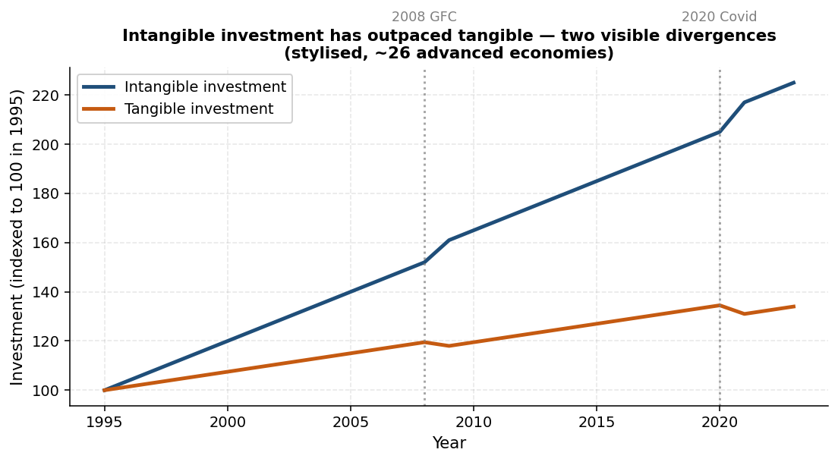
Figure 1.1 — Intangible vs tangible investment, indexed to 100 in 1995. Two visible accelerations: 2008 GFC and 2020 Covid.
If you index global intangible investment to 100 in 1995, two divergences leap out of the data. The first appeared around the 2008 global financial crisis: tangible investment plateaued while intangible investment kept climbing. The second came after Covid-19: tangibles slumped, intangibles accelerated again. Looking at compound annual growth rates for 2013-2023, intangible investment outpaced tangible investment in every major economy.
Concentration of value confirms the picture. Of the ten most valuable firms in the world in May 2025, nine were technology companies (or technology-adjacent platforms) whose value depends mostly on intangibles. The tenth was financial — software and data also drive much of its value.

1.4 Apple as a worked example
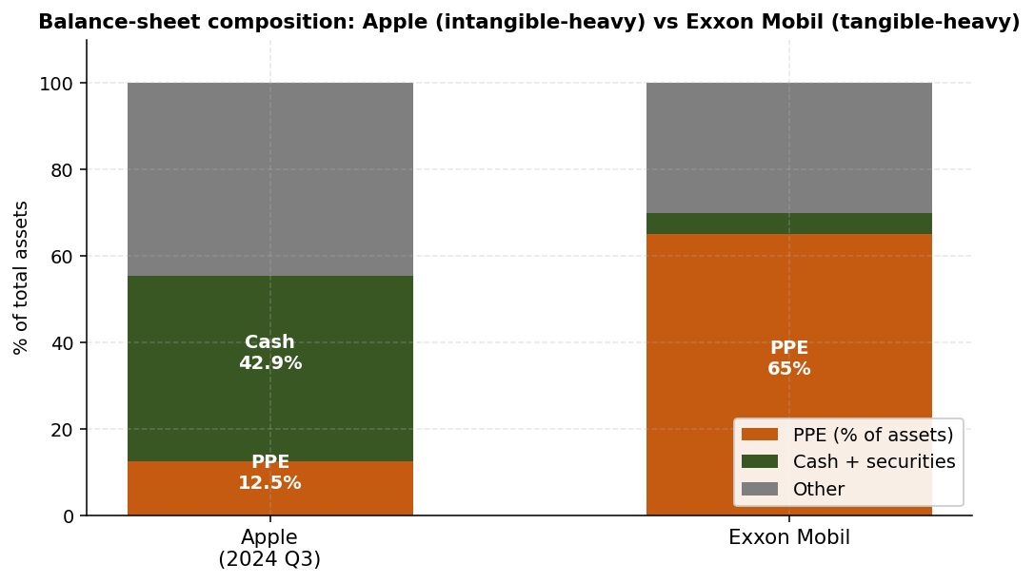
Figure 1.2 — Balance-sheet composition: Apple (intangible-heavy) vs Exxon Mobil (tangible-heavy).
Examine Apple's third-quarter 2024 balance sheet. Property, plant and equipment is about 12.5% of total assets. Compare that to a traditional industrial firm such as Exxon Mobil, where PPE is about 65% of assets. The difference is striking and it is not because Apple has small physical operations — Apple just earns most of its value from things that do not show up as physical capital.
Does Apple's brand appear anywhere on the balance sheet? It does not. Yet according to Interbrand's 2024 ranking, the Apple brand alone is worth about $488.9 billion. If that estimate is correct, the brand by itself represents:
- About 134% of Apple's total reported assets.
- About 235% of its assets net of cash and securities.
In other words, the most valuable thing Apple owns is more than twice the size of everything Apple has officially recorded as an asset. The balance sheet is not wrong in any narrow technical sense — it follows the rules — but the rules systematically hide where the value really is.

1.5 Market-to-book by sector
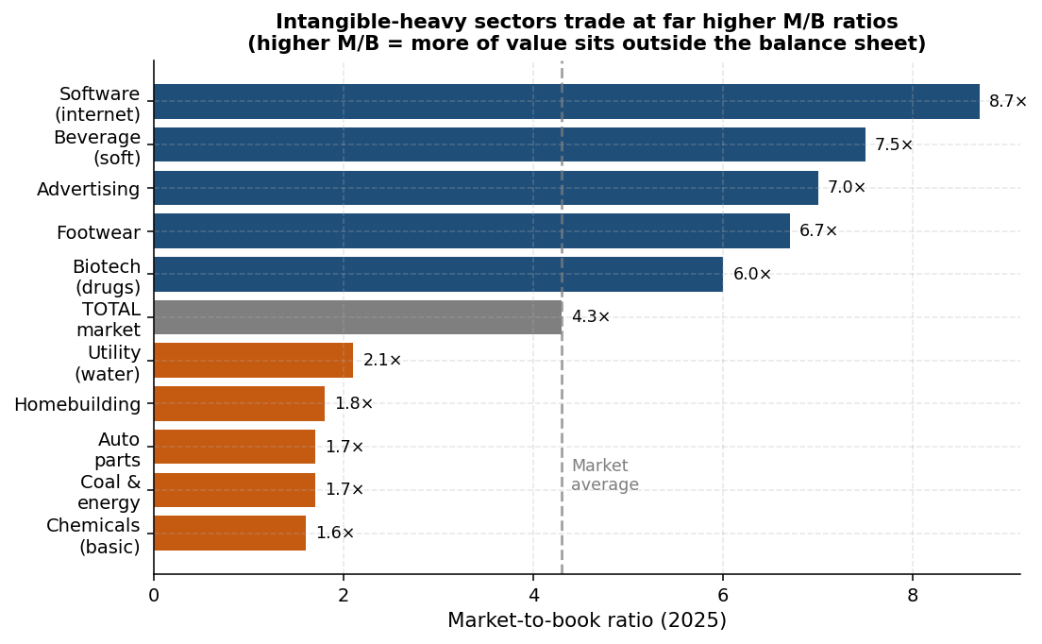
Figure 1.3 — Market-to-book ratios by sector (2025). Intangible-heavy sectors trade well above the market average of 4.3×.
A clean diagnostic for intangible intensity is the market-to-book (M/B) ratio. The total US equity market trades at about 4.3× book. Drill in by sector and the spread is informative.
Sector (selected high) | M/B (2025)
Software (Internet) | 8.7×
Beverage (soft) | 7.5×
Advertising | 7.0×
Footwear | 6.7×
Drugs (biotechnology) | 6.0×
Sector (selected low) | M/B (2025)
Utility (water) | 2.1×
Homebuilding | 1.8×
Auto parts | 1.7×
Chemical (basic) | 1.6×
Coal & related energy | 1.7×

The high-M/B sectors are exactly the brand-, biotech-, and software-intensive ones. The low-M/B sectors are the tangible-asset-intensive ones, where the balance sheet tells a fuller story of what the firm owns. The pattern is simple: for firms with high intangibles, a lower fraction of the firm's value shows up in the balance sheet.
Worth memorizing
Intangibles = assets without physical substance: R&D, software, brands, data, customer lists, organizational know-how, human capital.
Past 30 years: intangible investment has grown much faster than tangible — two visible accelerations (2008 GFC and 2020 Covid).
Apple: PPE ≈ 12.5% of assets; brand alone ≈ 134% of total assets.
Market-to-book ratios across sectors track intangible intensity (software ≈ 8.7×, auto parts ≈ 1.7×).

1.6 Chapter recap
The opening lesson of the module is that financial accounting reflects the world of mostly tangible assets in which it was designed. As the economy has shifted toward intangibles, accounting reports have become less informative about what firms actually own. The next chapter examines how accountants handle intangibles today — and why the answer is often "they do not."

Quick check
- Name three reasons the HEC balance sheet would not have helped a 2016 buyer evaluate a 1% stake in the school.
- Why is Apple's market-to-book ratio so high? Phrase your answer in one sentence.
- If two firms in the same industry both report identical book equity but Firm A trades at 5× book and Firm B at 1.5× book, what is the most likely qualitative difference between them?

Chapter 2 — Accounting for Intangibles
Learning objectives
Distinguish operating expenses (OPEX) from capital expenses (CAPX) under standard accounting.
State the IAS 38 definition of an intangible and explain why most internally generated intangibles are expensed.
List four direct consequences of expensing intangibles for reported financial metrics.
Define goodwill and explain how it is created via the purchase price allocation (PPA).

2.1 First principles: OPEX versus CAPX
Accounting starts from a clean partition. Operating expenses (OPEX) create benefits only in the year they are incurred — salaries, rent, utilities. They reduce the current year's net income and never become balance-sheet assets. Capital expenses (CAPX) create benefits over many years — buying a machine, building a factory. They are not charged to the current income statement; instead, they enter the balance sheet as property, plant and equipment (PPE), and a slice of their cost is depreciated each year over the asset's useful life.
This dichotomy reflects a world in which most assets were physical. A milling machine is easy: it has a sticker price, a useful life, and a market in which you could resell it. The benefit profile is multi-year, so capitalize. A salary is easy too: the benefit is the work this employee did this month, so expense.
Intangibles break this clean partition. R&D spending today may yield zero benefit this year and a blockbuster drug eight years from now. Brand-name advertising builds equity that may persist for decades. Training a new hire may pay off across her entire career at the firm. By the strict matching principle, all of these look like CAPX. Yet the benefits are also deeply uncertain — and that is what tilts the accountants toward calling them expenses.

2.2 IAS 38 and the prudence principle
The International Accounting Standard (IAS) 38 defines an intangible asset as "an identifiable non-monetary asset without physical substance." To qualify as an asset at all, the resource must be controlled by the enterprise as a result of a past event, and future economic benefits must be expected. Both conditions can be hard to meet for internally generated intangibles.
This is where the conflict of accounting principles bites. Two principles pull in opposite directions:
- Matching principle — costs that create multi-year benefits should be recognized over those years, so the income statement reflects only the period's true cost. This argues for capitalization.
- Prudence (conservatism) principle — when future benefits are uncertain, do not anticipate them in the accounts. This argues for expensing.
For intangibles, prudence almost always wins. Under US GAAP, internally generated intangibles are not capitalized; only acquired intangibles can sometimes be. Under IFRS, the rule is similar — but development costs (the later, more determinate stage of an R&D project) can sometimes be capitalized, while research costs (the earlier, more speculative stage) cannot.

2.3 Consequences of expensing intangibles
Calling something an expense rather than an asset has four mechanical consequences. For firms with high intangible investment, these effects are large enough to distort comparisons across firms or across sectors.
- Reported CAPX is smaller than the firm's real investment, because the intangible spending was sent to the income statement rather than to the balance sheet.
- Book equity and total assets are understated — the firm has been building a valuable asset, but the asset is invisible on the balance sheet.
- Earnings (EBITDA, net income, etc.) are understated, because the full intangible spend hits the current income statement instead of being amortized over future years.
- Taxes are lower than they would be if the spending were capitalized, because the deduction is taken sooner. This is a real cash benefit to the firm — and worth keeping in mind when you later try to "undo" the expensing for analysis.
Common pitfall
Beware comparing ROIC, ROE or EBITDA margins across firms with different intangible intensities. The intangible-heavy firm typically reports lower assets and higher margins, both of which inflate ROIC.
Comparing a software firm's ROIC to a steel firm's ROIC without adjusting intangibles can be deeply misleading.

2.4 Useful life and amortization, when capitalized
When an intangible does make it onto the balance sheet (typically, intangibles acquired in a deal), the next question is: how should it be depreciated? Two cases:
- Finite useful life — for example, a patent with a 15-year remaining life. Amortize over that life, conduct periodic impairment tests, and write down if the asset becomes impaired. Under IFRS, additional impairments are possible; reversals are limited.
- Indefinite useful life — for example, a trademark or renewable license. No amortization, but an annual impairment test is mandatory. Under IFRS, a previous impairment can sometimes be reversed if conditions improve.
Note the word "indefinite," not "infinite." The asset is not assumed to last forever. The accountant simply does not have a defensible basis to pick a useful life, so amortization is replaced by the impairment regime.

2.5 Goodwill and the purchase price allocation
The most important way an intangible asset reaches a balance sheet is through an acquisition. When Buyer pays Target shareholders, accounting requires Buyer to allocate the purchase price among the assets it has acquired. This is the purchase price allocation (PPA), and it is usually performed by a consulting firm at closing.
Take a stylized example. Buyer pays $30 billion for Target. Target's book assets net of liabilities equal $8 billion. A fair-value assessment of Target's identifiable assets (including identifiable intangibles such as patents, registered trademarks, customer contracts) gives $24 billion. The difference between what Buyer paid and what it can identify is goodwill:
$Goodwill = Purchase Price - Fair Value of Identifiable Net Assets$
$Goodwill = \$30bn - \$24bn = \$6bn$
Goodwill captures everything the acquirer paid for that the accountants could not specifically name: expected synergies, brand value that did not meet the recognition criteria, the assembled workforce, and so on. In Amazon's 2017 acquisition of Whole Foods, roughly 70% of the $13.7 billion price ended up as goodwill — the value of Whole Foods was vastly more about brand, store locations, organic supply chains and shopper loyalty than about the tangible inventory on the shelves.

2.6 The "goodwill checklist"
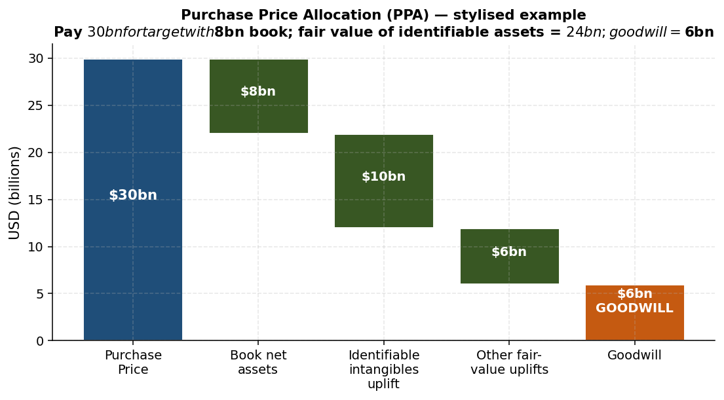
Figure 2.1 — Purchase Price Allocation (PPA) waterfall: how the price paid is allocated to identifiable assets, leaving the residual as goodwill.
Goodwill, then, is the residual where unrecognizable value goes to rest. Is having a lot of it good or bad? The honest answer is: it depends. The following two columns capture the debate.
Goodwill is good when… | Goodwill is bad when…
It captures internally generated value the accounting rules cannot recognize separately. | It signals an overpaid acquisition — managers used the firm's cash flows to dilute equity.
Lack of subsequent impairment is a positive signal that management captured the value it paid for. | Subsequent impairments mean the acquisition's synergies never materialized — a bad signal for investors.
Some debt contracts accept goodwill as security (rare). | Goodwill cannot generally be used as collateral in a loan.

Worth memorizing
Goodwill = price paid minus fair value of identifiable net assets.
Goodwill checklist: assess it positively if no impairment follows, negatively if impairments do follow.
The cleaner metric to judge an acquisition is the subsequent return on invested capital (ROIC), not the size of the goodwill line.

2.7 Chapter recap
Accountants reflect intangibles imperfectly because two of their fundamental principles, matching and prudence, give different answers and prudence usually wins. As a result, internally generated intangibles are expensed; acquired intangibles are sometimes capitalized and the residual that cannot be named is parked in goodwill. For users of financial statements, this means that ROIC, ROE, book equity, and earnings are systematically distorted for intangible-heavy firms — distortions you must learn to undo.

Quick check
- Why does the prudence principle usually override the matching principle for R&D?
- Under US GAAP, why are research costs in a pharmaceutical lab expensed even though they may produce a blockbuster drug?
- Define goodwill in one sentence and describe how it is created in an acquisition.

Chapter 3 — Capitalizing Intangibles in Practice
Learning objectives
Apply the capitalization formula for intangible expenses given an amortizable life.
Compute adjusted EBITDA and adjusted book equity for an intangible-heavy firm.
Explain why capitalizing intangibles typically reduces reported ROIC, and what determines the size of the effect.
Articulate two reasons to capitalize that go beyond compliance with accounting standards.

3.1 Why bother undoing the accounting?
If the accountants are going to expense an R&D budget regardless of what we think, why should an analyst recompute the numbers? Two answers:
- To represent historical investment more accurately. When intangible spend is expensed, the firm's true historical investment in productive assets is hidden. ROIC can look misleadingly high (the asset base in the denominator is too small). For intangible-heavy firms, this can systematically overstate operating performance.
- To prevent manipulation of short-term earnings. A firm under pressure to hit a quarterly target can simply cut R&D — and reported earnings will climb. Capitalizing intangibles spreads the spend over multiple years and makes such tactics more visible.

3.2 The capitalization formula
Suppose a firm has invested in an intangible category — say R&D — and we believe the typical asset has an amortizable life of n years. We want to estimate what the capitalized value of those past R&D expenditures would be at the end of year t.
The idea is that R&D from year t is still 100% "on the books" (it has not yet been amortized at all). R&D from year t−1 has been amortized for one year, so n−1 of its n years of useful life remain — meaning (n−1)/n of the value remains. R&D from year t−2 has (n−2)/n remaining, and so on. The capitalized value is the sum of these layered remaining values:
$Capitalized intangible{}_{t} = Σ_{k=-(n-1)}^{0} Int.Expense{}_{t+k} · \frac{n+k}{n}$
To make this concrete, assume n = 3. The end-of-year-t capitalized value of the past three years' R&D spending is:
- 100% of year t's expense (k = 0: (3+0)/3 = 1).
- 2/3 of year t−1's expense (k = −1: (3−1)/3 = 2/3).
- 1/3 of year t−2's expense (k = −2: (3−2)/3 = 1/3).
Year t−3's expense has been fully amortized, so it no longer appears on the balance sheet.

3.3 Adjusted EBITDA and adjusted book equity
Once the intangible asset is on the balance sheet, two more adjustments naturally follow:
$Adjusted Book Equity = Book Equity + Capitalized Intangibles$
The intuition is simple: the firm has been building a real asset, but the asset never made it to the balance sheet. Recognizing it raises both total assets and (by accounting identity) book equity by the same amount.
$Adjusted EBITDA = EBITDA + Investment - Amortization$
The intuition: the firm's reported EBITDA is depressed by the full intangible spend in the current year. Add it back, then subtract the more economically sensible figure — annual amortization of the capitalized base. The difference is the adjustment.
Common pitfall — taxes
Do not subtract taxes when adjusting EBITDA for intangibles.
The intangible spend was tax-deductible when expensed, so the firm has already received its tax benefit. Capitalizing the expense for analytic purposes does not change the firm's actual tax bill.
When comparing ROIC, use the same post-tax convention before and after the adjustment.

3.4 The BioTechCo example
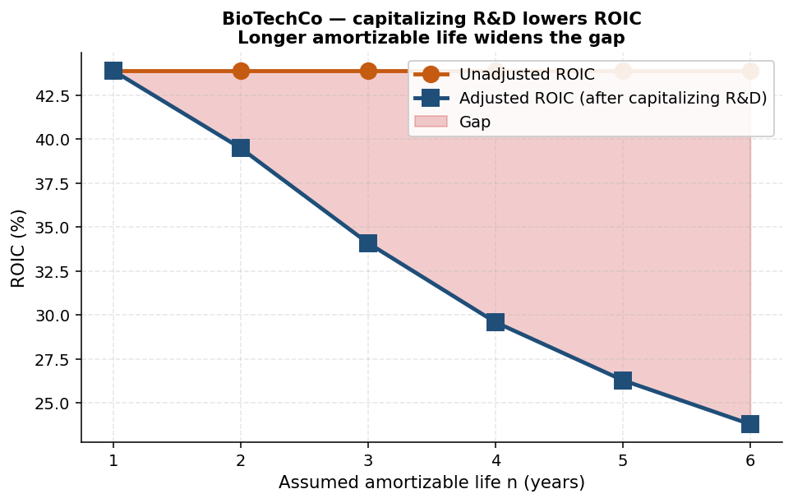
Figure 3.1 — BioTechCo example: capitalizing R&D lowers ROIC; longer amortizable life widens the gap.
Consider a stylized firm, BioTechCo, that invests heavily in R&D. The relevant data for 2024 (in million USD):
Item (2024) | Value ($M)
Sales | 874.4
EBIT | 153.6
Net income | 121.4
PPE | 262.3
Accounts receivable | 26.2
Inventories | 35.0
Accounts payable | 43.7
Book equity | 250.5
Tax rate | 20%
R&D expense (years 2021-2024) | 210.1; 217.8; 224.9; 231.2

Assume the amortizable life of R&D is n = 4 years. Apply the capitalization formula at end-of-2024:
$Capitalized R\backslash \&D = \frac{1}{4}(210.1) + \frac{2}{4}(217.8) + \frac{3}{4}(224.9) + \frac{4}{4}(231.2) = 561.3$
Now compute ROIC = (1 − t) × EBIT / Invested Capital, where Invested Capital = PPE + Net Working Capital (NWC), and NWC = AR + Inventories − AP.

Before capitalizing R&D:
- EBIT = 153.6.
- Invested Capital = 262.3 + 26.2 + 35.0 − 43.7 = 279.8.
- (1 − 0.20) × 153.6 / 279.8 ≈ 43.9%.

After capitalizing R&D (n = 4):
- Adjusted EBIT = 153.6 + 231.2 (the year's intangible spend, added back) − 0.25 × 543.9 (the year's amortization, where 543.9 was the capitalized base at the start of the year) ≈ 248.8.
- Adjusted Invested Capital = 279.8 + 561.3 = 841.1.
- (1 − 0.20) × 248.8 / 841.1 ≈ 29.6%.
The headline ROIC for BioTechCo drops from 43.9% to 29.6% — a major change. Both numerator and denominator rose, but the denominator grew faster, so the ratio fell. The intuition: the firm has been building a much larger productive asset base than the accounts suggested; once we recognize it, the same operating income now sits on top of a bigger capital stock.

3.5 Will capitalizing always reduce ROIC?
Usually yes, but not always. The direction depends on whether the numerator or denominator grows faster, which in turn depends on the structure of the firm's intangible spend. Some empirical regularities:
- Longer amortizable life → wider ROIC gap. As n rises, the capitalized base grows larger relative to the annual flow, and the denominator effect dominates.
- Stable intangible spend (R&D roughly constant year on year) → "steady-state" effect; investment ≈ amortization, so adjusted EBIT ≈ reported EBIT, but IC grows substantially.
- Growing intangible spend → adjusted EBIT can rise meaningfully (investment > amortization), partially offsetting the IC effect.
- Fixed-cost R&D programmes behave differently from variable R&D programmes — fixed-cost programmes look more capital-intensive when capitalized.

3.6 Other performance metrics
The same logic — bigger denominator and revised numerator — flows through every accounting metric that mixes equity, assets or operating income. Examples:
- ROE = Net Income / Book Equity. With BioTechCo, the unadjusted ROE is 48.5%; with capitalized R&D, the adjusted ROE drops to 18.1% (adjusted NI ≈ 197.6, adjusted book equity ≈ 250.5 + 561.3).
- ROA — similar pattern.
- Pre-tax return on assets — similar.
- NOPLAT (Net Operating Profit Less Adjusted Taxes) — adjusted upward by the intangible flow.
Worth memorizing
Formula: capitalized intangible at end of year t = sum over k = −(n−1) to 0 of Int.Expense(t+k) × (n+k)/n.
Adjusted EBITDA = EBITDA + intangible spend − amortization of capitalized base.
Adjusted Book Equity = Book Equity + Capitalized Intangibles.
Capitalizing usually lowers ROIC because IC grows faster than EBIT.
Capitalizing is tax-neutral — the firm already deducted the spend.

3.7 Chapter recap
Capitalizing intangibles is not a regulatory compliance exercise — it is an analytic adjustment that lets you compare firms whose accounting differs from their underlying economic reality. The formula is mechanical; once you have it, the rest follows. The most important effects to internalize are the directional one (ROIC usually falls when you capitalize) and the magnitude one (the gap widens with longer amortizable lives).

Quick check
- If a firm spent €200M on R&D in year t and you assume n = 5, what fraction contributes to the capitalized base at end of year t+3?
- Why does capitalizing R&D usually decrease ROIC?
- Why is the tax bill unaffected by your decision to capitalize R&D for analytical purposes?

Chapter 4 — Financing Intangible-Heavy Firms
Learning objectives
Explain why intangible assets are hard to use as collateral.
Apply the capital-structure checklist to a tech firm and reach the conclusion of low or negative target leverage.
Describe how the US corporate sector has shifted from net borrower to net lender, and why.
Identify when cash hoarding is rational versus when it is excessive.

4.1 Why intangibles are hard to collateralize
Lending is built on the implicit ability to seize collateral if the borrower defaults. That works for tangibles: a mortgage is secured by the house, a vehicle loan by the vehicle. But intangibles fail the collateral test on three fronts.
- Lack of physical substance. There is nothing physical to seize. Employee training, organizational culture, in-house tooling — none of these can be carted off in a truck.
- Asymmetric information. The lender often cannot evaluate the intangible's worth as well as the borrower can. What is a patent on a specific algorithm really worth? Only the developer can credibly answer.
- Value drops outside the business model. A customer list is valuable to a competitor running an identical pricing model — but worthless to a buyer in a different industry. The same is true of brands tied to a specific positioning.
These three frictions push intangible-heavy firms away from debt. But firms still need a buffer against shocks. Two partial solutions have emerged:
- Cash and equivalents — replace debt-financed buffers with self-financed ones. Set a negative net-debt target.
- Specialized markets for intangibles — venture debt with warrant kickers, patent-trading platforms, and asset-backed loans against the few intangibles that do retain value in distress.

4.2 Apple as a case study of the cash buffer
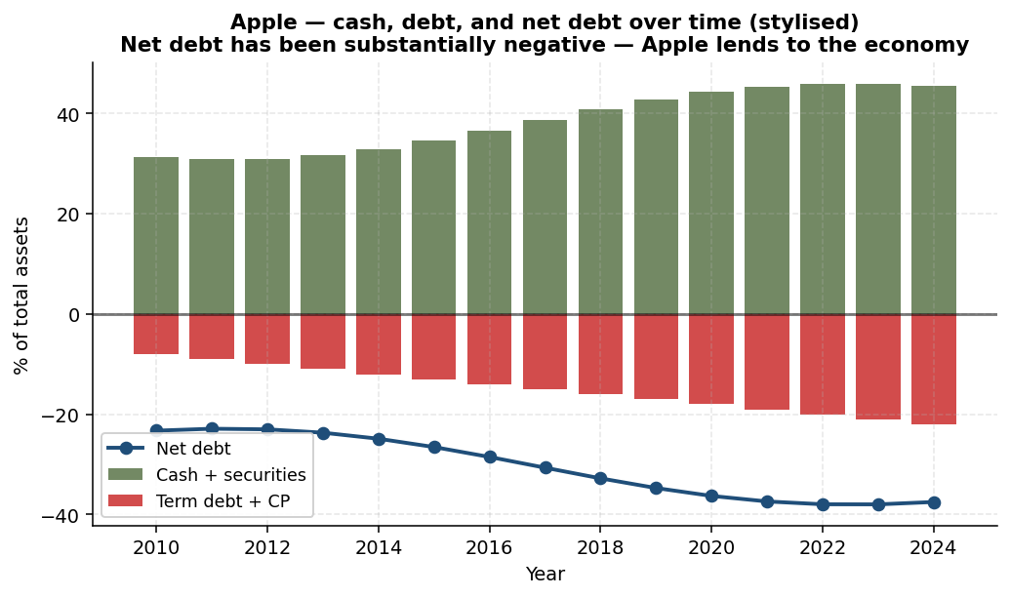
Figure 4.1 — Apple's cash, debt and net debt position over time (stylised).
Apple's fiscal-year 2024 balance sheet illustrates the cash strategy. Add up Apple's cash, short-term marketable securities, and long-term marketable securities, and you get about $156.6 billion — roughly 42.9% of total assets. Apple does carry debt: term debt of about $96.6 billion, plus $9.9 billion of commercial paper. But on a net basis:
$Net debt = 96.6 + 9.9 - 156.6 = -50.1 bn ≈ -13.5\% of assets$
In other words, Apple is more of a creditor than a debtor. The company is, in effect, one of the largest private bond investors in the world.

4.3 Firms as net lenders to the economy
Define net lending for a firm as profits minus dividends minus investment. A firm with negative net lending is borrowing from the economy on net; a firm with positive net lending is lending to the economy on net. The traditional textbook picture is clear: firms raise capital, invest in PPE or R&D, and return capital later. Corporates are net borrowers.
Over the past two to three decades, the actual data turned the textbook picture on its head. The aggregate US corporate sector has shifted from net borrower to net lender. The shift is not because dividends rose (they did, but the bigger driver is something else); it is because firms have accumulated growing piles of cash and marketable securities.
Why? Because intangible-heavy firms are not safe candidates for traditional leverage, and yet they face cyclical demand and competitive shocks. Their solution is to self-insure with cash and short-duration securities. The Apple case generalizes: tech-heavy aggregates show much greater cash accumulation than other sectors, and the same is true of younger firms.

4.4 The capital-structure checklist
To make the argument more rigorous, run through the standard capital-structure checklist firm by firm. For each dimension, assess strength as weak / medium / strong. The dimensions split into pros and cons of debt.

Pros of debt
- Interest tax shield. Strong if EBT is consistently high — interest reduces taxes. Weak if cash flows are cyclical, since tax-loss carryforwards (TLCF) make the deduction less valuable in bad years.
- Discipline. Strong if there are real concerns about management misusing free cash — debt service forces discipline. Weak if those concerns are minimal.

Cons of debt
- Risk of financial distress. Strong if cash flows are highly cyclical or the unlevered beta of the industry is well above 1.
- Investment. Strong if cutting investment to repay debt would seriously damage the franchise.
- Rivals. Strong if competition is a structural threat — rivals can exploit a distressed firm's distraction.
- Customers and suppliers. Strong if either group would walk away from a distressed firm (think long-cycle products, where buyers need confidence in long-term support).
- Assets. Strong if assets are easily pledged as collateral (favourable for debt). Weak if they cannot be (the intangibles case).
- Employees. Strong if hard-to-replace, high-human-capital staff would leave at the first whiff of trouble.

Applying the checklist to a tech firm
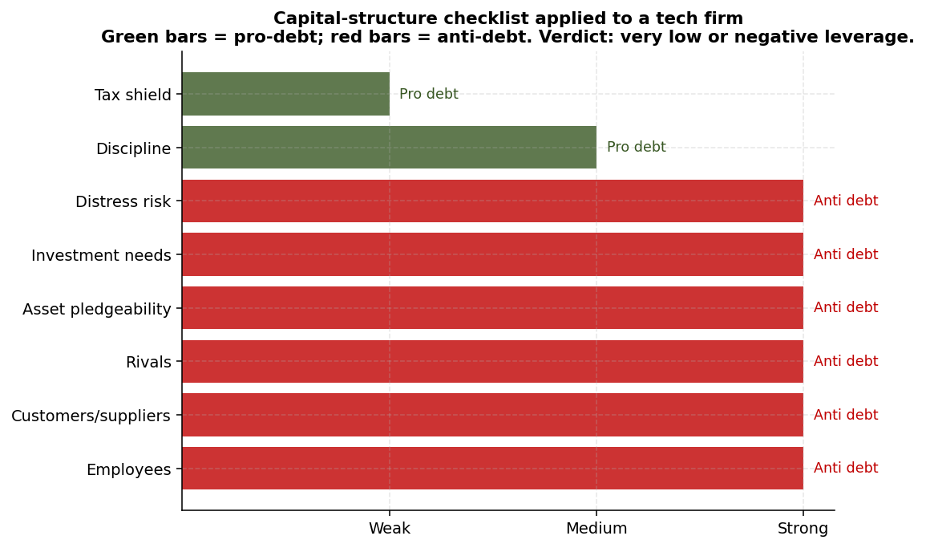
Figure 4.2 — Capital-structure checklist verdict for a tech firm: 6 of 8 factors point against debt.
For an intangible-heavy tech firm, the columns line up like this:
Dimension | Verdict | Why
Interest tax shield | Weak | Highly cyclical earnings; losses produce TLCF that delays the tax benefit.
Discipline | Medium | Useful only in boom periods when investors worry about over-investment.
Distress risk | Strong (con) | Cyclical cash flows + technology obsolescence risk + intense competition.
Investment | Strong (con) | Inflexible R&D, CAPX, and M&A needs; cuts would damage long-term value.
Assets (pledgeability) | Strong (con) | Intangibles cannot easily be pledged or valued in liquidation.
Rivals | Strong (con) | Highly competitive sectors; distress invites attack.
Customers & suppliers | Strong (con) | Often need to be confident for the long run — distress fears destroy demand.
Employees | Strong (con) | Human-capital intensive; bankruptcy concerns trigger talent flight.

The checklist points unambiguously toward low, or even negative, target leverage — coupled with a substantial cash buffer.

4.5 Cyclicality and "why now?"
The capital-structure-checklist argument is consistent with the aggregate data and the cross-section. It is especially compelling for firms whose business is highly cyclical and where major shocks are likely. Apple's behaviour during the Covid crisis is a striking example: the firm let its current marketable securities run down meaningfully, drawing on its buffer at exactly the moment when other firms struggled to borrow.

4.6 Critique: are firms hoarding too much?
Not everyone is convinced. Activist investors have argued that firms such as Apple hold too much cash — that the right move is to return it to shareholders through dividends or buybacks rather than warehouse it on the balance sheet. The famous case is Carl Icahn's open letters to Apple's management. The debate is genuinely contested, and the answer depends on how cyclical you think the business is, how likely you think future shocks are, and whether you trust management to redeploy the cash productively.
Worth memorizing
Intangibles fail three collateral tests: no physical substance, asymmetric information, value tied to business model.
Apple FY24: cash + securities ≈ 43% of assets; net debt ≈ −13.5%.
Aggregate US corporate sector has shifted from net borrower to net lender, driven by intangible-heavy firms.
Capital-structure checklist for tech firms points to low / negative target leverage.

4.7 Chapter recap
Financing decisions for intangible-heavy firms cannot rely on the standard tradeoffs that work for tangible-asset firms. The collateral problem and the cyclicality of cash flows together push toward larger cash buffers, lower debt, and a structural reliance on self-financing. The empirical record matches the theory — at the firm level (Apple), the sectoral level (tech aggregates) and the macroeconomic level (US corporates as net lenders).

Quick check
- Name the three frictions that make intangibles hard to collateralize.
- If Apple's cash flows became dramatically less cyclical overnight, would your view of its target leverage change? Why?
- Walk through the capital-structure checklist for a chocolate manufacturer with strong brand assets but stable revenues — does the conclusion match the tech case?

Chapter 5 — Collateralizing and Reselling Intangibles
Learning objectives
Compute a stylized borrowing base using the S&P rules of thumb.
Explain the three NOLV approaches and identify which is most common for trademarks.
Describe the structure of venture debt and why warrants are essential.
Read a bankruptcy trademark multiple table and explain the heterogeneity.

5.1 When can intangibles serve as collateral?
The previous chapter argued that intangibles are usually unsuitable as collateral. "Usually" is not "always." Two specific channels can work:
- Asset-backed bank loans — usually syndicated, where the borrowing base is the discounted value of pledgeable assets.
- Venture (VC) debt — specialised lenders to high-growth startups, accepting equity-like upside via warrants to compensate for downside risk.
The two cases differ. In a bank loan, the binding question is the liquidation value of the intangible if the borrower defaults — what could a court-appointed administrator realize in a sale? In a VC debt deal, the contract is more sophisticated: the lender relies partly on the equity investor's willingness to keep funding, partly on the realisable value of intellectual property, and partly on warrants that pay off if the firm succeeds.

5.2 Bank loans: borrowing-base mechanics
Syndicated bank loans frequently require a borrowing base — a number that caps how much the firm can draw under the facility. The borrowing base is a weighted sum of the firm's assets, with each asset class haircut according to its liquidity and realizability.
Standard & Poor's rule-of-thumb haircuts for ordinary asset types:
- Inventories: about 50% of book value.
- Accounts receivable: about 80% of book value.
- Real estate: 60% to 85% of fair market value.
And intangibles? Since the mid-1990s, some companies have raised debt against carefully selected intangibles. The borrowing base for an intangible is more bespoke and depends on a credible estimate of the asset's net orderly liquidation value (NOLV).

5.3 Net Orderly Liquidation Value (NOLV)
NOLV is the estimated net proceeds from selling an asset in an orderly manner, after subtracting commissions, legal fees and other transaction costs. "Orderly" matters — a fire sale would generate far less. Three valuation approaches:
- Market-based. Look for actual prices paid for similar assets in similar circumstances. Cleanest when comparables exist.
- Cost-based. Estimate the cost to replicate the intangible from scratch. Useful for relatively undifferentiated intangibles (e.g., generic software components).
- Income-based. Compute the present value of the incremental earnings or royalties an owner could extract. The most common version is the relief-from-royalty method: estimate what a buyer would pay in royalties to commercialize the trademark, and take the PV of those royalty streams.

5.4 Sales multiples in bankruptcy
How much do trademarks actually fetch in Chapter 11 bankruptcies in the US? The historical record shows wide dispersion. A few illustrative cases:
Brand | Industry | Buyer | Sales base ($M) | Multiple of sales
CompUSA | Electronics | Systemax | 3,670 | 0.01×
Danskin | Apparel | Iconix | 300 | 0.23×
Fanny Farmer | Food | Alpine Confections | 107 | 0.20×

The spread between 0.01× and 0.23× sales is enormous. Several factors explain it:
- Trademark strength — does the brand still resonate with consumers?
- Trademark relevance — retail brands carry more weight than wholesale brands.
- Cost structure of the industry — high sales do not imply realizable profits.
- Timing — a firm-specific bankruptcy in a buoyant industry will fetch more than a bankruptcy filed during a sector-wide downturn (other potential acquirers face their own constraints).

5.5 Venture debt
Venture debt is the principal way intangible-heavy startups access borrowed money before they are profitable. The structure has several distinctive features:
- Short-term loan with a relatively high interest rate.
- Warrants for company stock attached to the loan — equity-like upside that compensates the lender for the high failure rate.
- Senior secured debt, with a blanket lien on the company's assets.
- Repayment expected from one of two sources: a future equity round, or — as a backup — the sale of intellectual property (patents, trademarks, copyrights) if a secondary market for those exists.
The lender's underwriting therefore depends heavily on two things: the quality and engagement of the firm's equity investors (will they keep funding it?), and the redeployability of the firm's IP (would another firm pay for the patents in a wind-down?). The latter has become more important as patent-trading markets have grown.

5.6 Evidence on venture debt
Recent academic work by Hochberg, Serrano and Ziedonis (2018) and Serrano and Ziedonis (2024) finds:
- Over 35% of VC-backed startups obtain patent-backed loans before exit.
- Thicker patent-trading markets are associated with higher rates of startup lending.
- The effect is especially strong for startups whose patents are more redeployable (i.e., useful to multiple potential acquirers).
- In some cases, when a firm fails, the patent's prior owner transfers to a new business — supporting the idea that intangibles can be reallocated in distress.
Worth memorizing
NOLV approaches: market-based, cost-based, income-based. Income-based via relief-from-royalty is the most common for trademarks.
S&P haircuts: inventories ~50%, receivables ~80%, real estate ~60-85%.
Bankruptcy trademark multiples vary dramatically (CompUSA 0.01× sales vs Danskin 0.23×).
VC debt = high interest + warrants + senior secured + repayment via future round or IP sale.
Patent-backed loans are used by more than a third of VC-backed startups pre-exit.

5.7 Chapter recap
Even though intangibles are usually bad collateral, specialized markets and contracts can extract some value from them. Bank loans use NOLV-based haircuts; venture debt combines warrants with senior secured claims. The empirical record on bankruptcy multiples is volatile, but the underlying logic is straightforward: assets that are redeployable to multiple potential buyers, in active sectors, with strong brands, command higher prices.

Quick check
- A firm has $200M of inventories, $150M of receivables, $300M of real estate and $400M of intangibles. Estimate a borrowing base using S&P rules of thumb, ignoring the intangibles entirely.
- Why is the relief-from-royalty approach considered an income-based method?
- What two factors explain why VC debt deals always include warrants?

Chapter 6 — Corporate Deals with Intangibles
Learning objectives
Explain why deal designs for intangible-heavy targets must align with the employees who carry the value.
Compare dual-class share structures and identify their pros and cons.
Describe the mechanics of an earn-out and explain what makes a milestone manipulation-proof.
Compare price-protection CVRs and event-driven CVRs.

6.1 Why deal structure matters more for intangibles
The value of a piece of land does not depend on who owns it. The value of an intangible often does — "same intangible, different values" is a useful shorthand. A patent in the hands of a firm with the right complementary capabilities is worth far more than the same patent in a different firm. A customer list is worth far more to a competitor who can convert customers to its own offering than to a buyer who cannot.
More subtly, intangibles are often "financed" by employees who can choose how much effort to invest in them. A research scientist who feels under-rewarded after an acquisition can leave for a rival; an engineering team that loses its founders can disband. The value of the intangible therefore depends on whether the deal aligns the people who create it.
For these reasons, transactions involving intangibles tend to include richer contract features than simple cash purchases. Three structures dominate:
- Equity options to incentivize key employees.
- Dual-class shares to concentrate voting rights with the people whose vision and engagement drive value.
- Earn-outs and contingent value rights (CVRs) to defer part of the consideration until performance is verified.
All three are ways to reward talented people through deferred cash flows — especially useful when the firm is young, cash-poor, or facing high uncertainty about the value being acquired.

6.2 Dual-class share structures
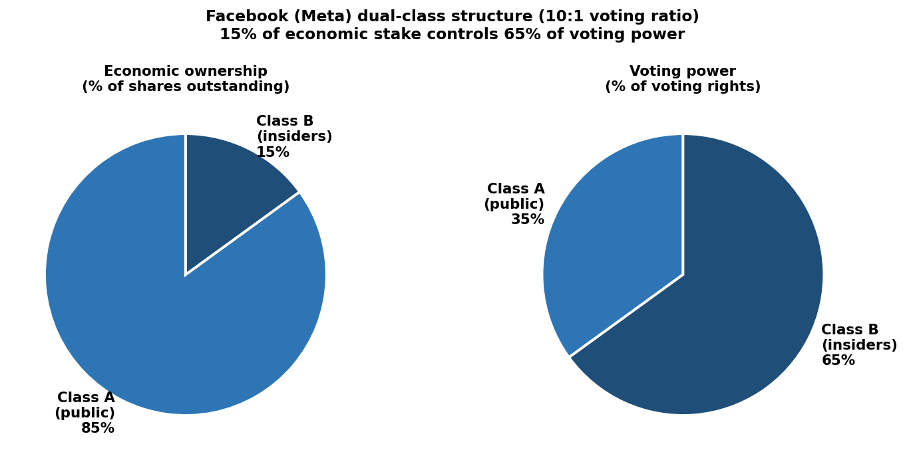
Figure 6.1 — Facebook (Meta) dual-class structure: 15% economic ownership controls 65% of voting rights.
In a dual-class structure, the firm issues two (or more) classes of common stock with identical economic claims but unequal voting rights.
- Class A — one share, one vote (the standard public-market share).
- Class B — one share, multiple votes (held by founders and insiders).
Three design parameters shape any dual-class structure:

Voting ratio
The number of votes that a Class B share carries relative to a Class A share. Common ratios are 10:1 (Facebook / Meta) and 20:1 (AirBnB). Some firms experiment with even higher ratios for specific holders.

Sunset
The period of time after which Class B shares convert to Class A. Sunset can be:
- Time-based — for example, ten years after the IPO.
- Event-based — for example, the death or departure of the founder.
- Indefinite — no automatic conversion.

Transferability
Some structures permit the original Class B holders to transfer their shares (keeping the multiple-vote privilege); others convert any transferred share to single-vote.

Facebook (Meta) — a worked example
Facebook uses a 10:1 voting ratio. Roughly 2.4 billion Class A shares and 440 million Class B shares are outstanding. So:
- B shares are 0.44 / (0.44 + 2.4) ≈ 15.5% of total shares.
- B shares are 0.44 × 10 / (0.44 × 10 + 2.4) ≈ 64.7% of voting power.
(Mark Zuckerberg owns most, but not all, of the Class B shares.) A small slice of equity controls majority voting — by design.

Debate: should dual-class structures be allowed?
Pros | Cons
Facilitates execution of a coherent long-term strategy. | Creates agency conflicts, especially when controlling holders have minimal economic exposure.
Encourages founders to publicly list rather than sell or stay private. | Creates an inferior class of shareholders with limited voice.
Insulates the firm from short-termism and quarterly noise. | Entrenches management or boards selected by the controlling holder.
Protects from activist shareholders, proxy battles and hostile takeovers. | Reduces accountability — fewer checks and balances.
Protects long-payoff capital expenditures from the pressure of short-horizon investors. | Increases the likelihood of related-party transactions.

The empirical record shows that the share of US IPOs using dual-class structures has trended sharply upward over the past two decades, especially among technology firms — consistent with the broader logic that intangible-heavy firms want to insulate founder-driven vision from market pressure.

6.3 Earn-outs
An earn-out is a payment from the buyer to the seller contingent on the target hitting some performance milestone after closing — for example, EBITDA in three years, or a specified product launch. Earn-outs are most common in private-firm transactions (especially those involving private equity), where the seller has private information about the target's future and the buyer wants to delay paying for unverifiable value.
The hardest part of writing an earn-out is making the milestone manipulation-proof. Once the deal is signed, both parties have an incentive to push the target's reported numbers in their preferred direction. Three principles help:
- Prefer EBITDA to net income — EBITDA is harder to manipulate (no discretion in tax planning, fewer one-off items, no D&A games).
- Prefer proportional formulas to thresholds — a discrete cliff at "EBITDA = $50m" creates pathological incentives, while a continuous schedule does not.
- Invest heavily in legal drafting — anticipate the gaming, define every term, lock down accounting policies.

6.4 Contingent Value Rights (CVRs)
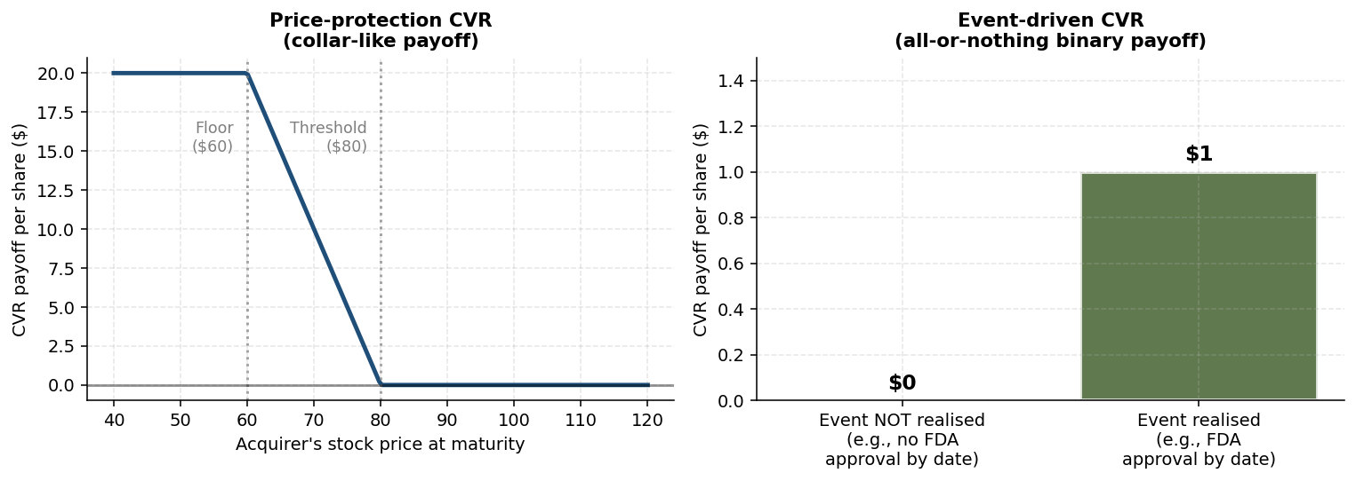
Figure 6.2 — Two CVR payoff types: price-protection (collar-like) and event-driven (binary).
A CVR is the public-market counterpart of an earn-out. It is a contractual right (often tradable on a public exchange) that pays out contingent on the occurrence of an event or the realization of a price. CVRs have become especially common in pharma deals, where the value of a target firm depends on regulatory outcomes years after closing.

A worked example: BMS / Celgene
When Bristol-Myers Squibb acquired Celgene in 2019 for $74 billion, the deal included a CVR. Each CVR was structured as an all-or-nothing payment: it paid in full if certain regulatory milestones were achieved on schedule, and nothing otherwise. Celgene shareholders received cash, BMS stock, and CVRs in the consideration mix.

Two main types of CVR

Price-protection CVRs
Typically used when the deal consideration is paid in the acquirer's stock. The CVR pays if the acquirer's stock falls below a defined threshold within a maturity (often three years), up to a cap. The payoff resembles a collar in option markets — long put plus short call.

Event-driven CVRs
Pay if a specified event occurs: an FDA approval, a sales target, the resolution of litigation. These are growing in popularity, particularly in pharma deals.

Litigation risk — the Sanofi / Lemtrada example
Sanofi negotiated for years with Genzyme in 2011, with a major sticking point being Genzyme's multiple-sclerosis drug Lemtrada. The deal settled at $74 per share in cash plus CVRs, one of which paid $1 if the FDA cleared Lemtrada by March 2014. The FDA missed the date, and the CVR did not pay. But the story did not end there — litigation followed, with payouts eventually arriving in 2019. The lesson: any honest CVR valuation must factor in the present value of potential litigation payoffs and the timing of those payoffs.

Pros and cons of CVRs
Pros | Cons
Bridge valuation gaps when parties disagree about a material contingency. | Execution risk — complex to negotiate, with many legal issues to resolve.
Increase deal certainty by letting parties close without waiting for the contingency to resolve. | Potential for dispute or litigation, particularly over whether the acquirer used "diligent efforts".
Provide financing benefits — reduce total upfront consideration, freeing time to capture synergies. | Can come with operational covenants that restrict the acquirer's freedom.
Easy to communicate to investors as a fairness mechanism. | Credit risk: CVRs are unsecured junior claims if the acquirer fails.
 | Valuation problem: target shareholders are often not natural CVR holders, so the instruments trade at a discount to fair value.

Worth memorizing
Three deal structures for intangible-heavy transactions: dual-class shares, earn-outs, CVRs.
Facebook B-share voting ratio: 10:1. AirBnB: 20:1.
Earn-out milestones: prefer EBITDA over NI; proportional over threshold.
Two types of CVR: price-protection (collar) and event-driven (e.g., FDA approval, sales targets).
CVRs typically trade at a discount to fair value because target shareholders are not natural holders.

6.5 Chapter recap
Intangible-heavy deals demand contract designs that align the human capital carrying the value, defer payments until verification, and concentrate decision rights with the people whose vision matters. Dual-class shares, earn-outs and CVRs are the three principal tools. Each comes with its own pitfalls — particularly around milestones that can be gamed, litigation that follows disputed events, and the awkward distribution of CVRs to investors who don't want them — but each is essential to the toolkit.

Quick check
- Why are dual-class share structures more common in tech and pharma than in utilities?
- If you were drafting an earn-out for a software-company target, which milestone would you prefer: EBITDA in three years, or revenue in three years? Why?
- Describe one risk that a price-protection CVR is designed to address.

Chapter 7 — Self-Test
This section assembles practice questions across all six chapters, formatted in the multiple-choice style of the actual exam. Solutions follow.

Section A — Multiple Choice
Q1. Under US GAAP, an internally developed brand name is most commonly:
A. Capitalized and amortized over its useful life
B. Capitalized as goodwill
C. Expensed as incurred
D. Disclosed in the notes only
Q2. Goodwill is best understood as:
A. The brand value of the target
B. Acquirer's stock value minus target stock value
C. Purchase price minus the fair value of identifiable net assets
D. The amount paid in cash
Q3. For a firm with stable annual R&D spending, capitalizing R&D for analytical purposes will most likely:
A. Sharply increase reported ROIC
B. Sharply decrease reported ROIC
C. Leave reported ROIC unchanged because the IRS tax basis doesn't change
D. Decrease ROIC modestly because invested capital rises faster than EBIT
Q4. The matching principle and the prudence principle are most likely to conflict over:
A. A purchased customer list
B. Internally generated R&D
C. A patent acquired in an acquisition
D. Land held for redevelopment
Q5. For an intangible-heavy tech firm, the capital-structure checklist most strongly points to:
A. Very high leverage to maximize the interest tax shield
B. Low or negative target leverage with large cash reserves
C. Asset-backed securitization of every receivable
D. Issuing convertible preferred stock
Q6. The three approaches to estimate the net orderly liquidation value (NOLV) of an intangible are:
A. Discounted cash flow, precedent transactions, and trading comparables
B. Market-based, cost-based, and income-based
C. Book value, fair value, and replacement value
D. Audit, appraisal, and arbitration
Q7. A price-protection CVR most closely resembles which option strategy?
A. Long straddle
B. Long call
C. Collar (long put plus short call)
D. Short put
Q8. A 10:1 voting ratio for Class B shares means:
A. Each Class B share carries one tenth of a vote
B. Class B holders receive 10× the dividend
C. Each Class B share carries 10 votes per share
D. Class B holders must hold for 10 years
Q9. The aggregate US corporate sector has, over the past 2-3 decades, become a net lender to the rest of the economy primarily because:
A. Of regulatory mandates to hold cash
B. Of a sustained rise in dividend payout ratios
C. Intangible-heavy firms accumulate cash as a self-financing buffer
D. Foreign exchange controls discourage offshore investment
Q10. Compared with a net-income-based earn-out, an EBITDA-based earn-out is preferred because:
A. EBITDA is always larger than NI
B. EBITDA is harder to manipulate via accounting choices
C. EBITDA includes cash interest, which is easier to verify
D. EBITDA is required by GAAP

Section B — Short Answer
S1. A firm spent €300M on R&D in year t with an amortizable life of 5 years. Compute its contribution to capitalized intangibles at end of years t, t+2, and t+5.
S2. Apply the capital-structure checklist to a global consumer-goods firm with strong brands (think Coca-Cola). On which dimensions do you reach a different conclusion from a software firm? On which dimensions do you reach the same conclusion?
S3. Explain why valuing a CVR ignoring potential litigation payoffs is too conservative. Reference the Sanofi/Lemtrada example.

Section A — Solutions
Q1: C
Internally generated intangibles are not capitalized under US GAAP — even an in-house brand name is expensed as incurred.
Q2: C
Goodwill is the residual: price paid minus fair value of identifiable net assets. The Whole Foods deal saw 70% of the price end up in goodwill.
Q3: D
With stable spend, EBIT changes little (investment ≈ amortization). IC grows by the capitalized base, so ROIC falls — but modestly.
Q4: B
Internally generated R&D is the canonical case: matching argues for capitalization, prudence argues for expensing. Prudence wins.
Q5: B
Weak tax shield, strong distress risk, strong investment needs, non-pledgeable assets, intense rivalry, human-capital reliance — all point to low or negative leverage.
Q6: B
NOLV approaches: market-based, cost-based, income-based (relief-from-royalty is the most common income-based variant).
Q7: C
A price-protection CVR pays when the stock falls below a threshold, capped at a maximum — long put plus short call, i.e., a collar.
Q8: C
10:1 voting ratio means each Class B share carries 10 votes; Class A holds one vote per share. Facebook's B shares are 15.5% of shares but 64.7% of votes.
Q9: C
Intangible-heavy firms accumulate cash to self-insure against cash-flow shocks they cannot otherwise hedge with debt.
Q10: B
EBITDA is more manipulation-resistant: it excludes tax, financing, and depreciation/amortization choices. Earn-outs prefer it for that reason.

Section B — Solutions
S1 — End of year t: contribution = (5+0)/5 × 300 = 300 (100% remaining, asset newly created). End of year t+2: (5−2)/5 × 300 = 180 (3/5 of useful life remains). End of year t+5: 0 — fully amortized at end of year t+4.
S2 — A global consumer-goods firm with strong brands shares the intangible-collateral problem (brands are hard to pledge), the rivals dimension (competition is real), and the customer dimension (long-run confidence matters). It differs on cyclicality (consumer staples are far less cyclical than tech), distress risk (lower), and tax-shield value (steady earnings → strong tax shield). The conclusion is therefore more nuanced: moderate leverage, not negative. The closest checklist match to negative leverage is youthful, highly cyclical, tech-style firms.
S3 — Sanofi's $1 CVR was triggered by FDA approval of Lemtrada by March 2014. The FDA missed the date — the CVR did not pay on schedule. But litigation followed, and payments arrived in 2019. A pure expected-value of the regulatory deadline would have missed the litigation pathway entirely. Honest valuation requires modelling the probability and timing of litigation outcomes, discounted back. Conservative valuations that ignore litigation systematically underprice CVRs.

Glossary
Amortizable life (n). The number of years over which an intangible would be amortized if capitalized. A modelling choice for analytical purposes.
CVR (Contingent Value Right). A publicly-traded payment right contingent on an event or stock-price outcome. Two main types: price-protection and event-driven.
Capital expenditure (CAPX). A spend that creates benefits over multiple years, capitalized to the balance sheet and depreciated over its useful life.
Capitalization (of intangibles). Analytical adjustment that moves intangible expense items into a balance-sheet asset and amortizes them over an assumed life.
Dual-class shares. Two (or more) classes of common stock with identical economic claims but different voting rights, e.g., 1:1 versus 10:1.
Earn-out. A contingent payment from buyer to seller based on a post-closing performance milestone (often EBITDA).
Event-driven CVR. A CVR paying out on a specific corporate event (e.g., FDA approval).
Goodwill. The residual of purchase price over fair value of identifiable net assets in an acquisition. Captures unrecognizable value paid for.
IAS 38. International accounting standard defining intangible assets. Sets the criteria for recognition, including identifiability, control, and probable future benefits.
Impairment test. An annual or event-driven check that an intangible's carrying value does not exceed its recoverable amount.
Matching principle. Accounting principle that costs should be recognized in the same period as the revenues they generate.
Net Orderly Liquidation Value (NOLV). The estimated net proceeds from selling an asset in an orderly manner, after costs.
Operating expense (OPEX). A spend whose benefit is consumed in the current period; reduces current income and creates no asset.
Price-protection CVR. A CVR paying out if the acquirer's stock falls below a threshold within a defined window.
Prudence principle. Accounting principle that uncertainty should be reflected with conservatism — assets not recognized until benefits are reasonably certain.
Purchase Price Allocation (PPA). Process by which an acquirer assigns the purchase price across identifiable assets and the residual to goodwill.
Relief-from-royalty. Income-based NOLV approach: present value of royalty payments a buyer would owe to commercialize the intangible.
Sunset clause. A provision in a dual-class structure converting Class B shares to Class A after a defined period or event.
Venture (VC) debt. Short-term loan to a high-growth firm, often with warrants and senior secured claims on assets and IP.
Warrants. Long-dated rights to buy equity at a fixed price, used to compensate VC debt lenders for risk.

End of textbook.

