Module 1
Asset
Management
A Self-Contained Study Textbook
HEC Paris • EMBA Finance Specialization
Based on the lectures of Prof. Ioanid Rosu
Prepared for Khloud Alghati

Preface
This textbook is the single document you need to prepare for the Asset Management module of the EMBA Finance Specialization. It expands the in-class material into a textbook structure, walks through the four cases in detail (Riverside Memorial, Harvard Management Company, Twin Coin Arbitrage, IBM options), provides numerical worked examples for every formula, and ends with self-test questions and a glossary.
Asset Management is the broadest of the three Week 2 modules you have selected. It covers four topic blocks, each substantial in its own right:
- Asset allocation — how to decide what fraction of wealth to put in stocks, bonds, real estate, and other classes. The theoretical engine is Modern Portfolio Theory (MPT); the practical engine extends MPT with Black-Litterman and other techniques.
- Market efficiency — whether asset prices fully reflect available information, whether predictable patterns exist, and how investors with views should act in markets that are partly efficient.
- Investors and performance — how individuals, pension funds, mutual funds, and hedge funds actually perform, and why their results differ.
- Options and option strategies — the mechanics of calls and puts, put-call parity, and the strategy palette that combines them.
The course also asks two large recurring questions. What is the asset manager's edge — where does superior performance come from? And how should an investor decide whether to manage money directly or hire someone else? These questions are not answered with a single formula. They are answered through the four blocks taken together, with the cases serving as integrative exercises.
How to use this book
Read each chapter in order — the formulas in early chapters underpin the case studies later.
Work the Riverside Memorial and HMC cases with paper, pencil and a calculator before reading the solutions.
Pause at each Worth Memorizing callout — these are the lines most likely to appear on the exam.
Attempt the self-test in Chapter 10 before reading the solutions.
The exam is multiple choice, jointly with the other Week 2 courses.
Exam scope — guidance from Prof. Rosu (5 May 2026 message)
Topic 4 (Options and Option Strategies) will NOT be tested on the final exam. Chapter 9 in this textbook is included for completeness only.
The exam will MOSTLY focus on Topic 1 (Asset Allocation) — Chapters 2 (MPT), 3 (Practical allocation), 4 (Riverside Memorial case), 5 (HMC case), and 5b (Excel workbooks).
Topics 2 (Market Efficiency & Arbitrage) and 3 (Investors & Performance) are still in scope but represent a smaller share of questions. Cover Chapters 6, 7, and 8 after you are comfortable with Topic 1.
Suggested study weight: ~60% Topic 1 (Chapters 2-5b), ~20% Topic 2 (Chapters 6-7), ~15% Topic 3 (Chapter 8), 5% review of formulas and key intuitions.

Contents
1. Asset performance over 200 years — The empirical backdrop: stocks, bonds, T-bills, gold.
2. Modern Portfolio Theory — Mean-variance, the efficient frontier, the CAL, Sharpe ratio, the tangency portfolio.
3. Practical asset allocation — Estimating inputs, Black-Litterman, active/passive decomposition, factor investing.
4. Case — Riverside Memorial — A guided walkthrough of every Excel question.
5. Case — Harvard Management Company — Policy portfolio, internal vs external managers, liquidity in the 2008 crisis.
6. Market efficiency, factors, and the value/momentum premium — EMH, PEAD, the factor zoo, predictability versus profits.
7. Short selling, arbitrage, and short squeezes — Margin mechanics, Twin Coin Arbitrage, Royal Dutch/Shell, VW, GameStop.
8. Investors and performance — Individuals, behavioural finance, pensions, mutual funds, hedge funds.
9. Options and option strategies — Calls, puts, the IBM example, put-call parity, the full strategy palette.
10. Self-test questions and solutions — Multiple-choice and short-answer practice across all chapters.
Glossary — Quick-reference definitions.

Chapter 0 — Primer for Non-Finance Readers
Who this chapter is for
If you have led teams, run businesses, or signed payroll but never sat through a finance theory course, start here.
This chapter defines the vocabulary used in the rest of the textbook in everyday language.
You don't need any prior finance background. We build everything up from scratch.
Even if you already know these terms, skim the section — the framing is slightly different from how finance is usually taught, and it links each concept to how it shows up in the rest of the textbook.

0.1 What is asset management, in one sentence?
Asset management is the business of deciding what to do with someone else's money. "Someone else's" because in practice asset managers run portfolios for pension funds, endowments, sovereign wealth funds, insurance companies, and individuals — they rarely run only their own money. "Deciding what to do" means choosing which assets to buy, when to buy or sell them, and in what proportions.
The big decisions in asset management are typically:
- Asset allocation — how much to put in each broad class (stocks, bonds, real estate, etc.). The most consequential decision.
- Manager selection — within each class, which funds or active managers to hire.
- Tactical adjustment — when (if ever) to deviate from the long-run plan.
- Risk management — putting limits on losses and on concentrations.
This textbook focuses mainly on the first decision (asset allocation) because it dominates outcomes and because it has the cleanest mathematical theory behind it. Manager selection and the others appear as supporting characters in the later chapters.

0.2 The basic asset classes
Think of the universe of investable assets as sorted into a few buckets. Each bucket has its own typical level of risk and return.

Stocks (equities)
A share of stock is a fractional claim on a company. If you own one share of Apple, you own a tiny piece of Apple's future profits and you have a tiny vote at Apple's annual meeting. Stock prices go up when investors collectively expect the company to do well, and down when they expect trouble.
Stocks are typically the highest-return asset class over long horizons (decades) and also the most volatile in the short run. A typical year for the US stock market is something like +10% return on average, but with a standard deviation around 15-20% — meaning you can easily see +30% one year and −20% the next.

Bonds (fixed income)
A bond is a loan. When you buy a US Treasury bond, you are lending money to the US government; when you buy a corporate bond, you are lending money to a company. The bond contract specifies how much interest you receive each year (the "coupon") and when the principal is paid back (the "maturity").
Bonds are typically less risky than stocks (because the contract terms are fixed) and offer lower long-run returns. Average historical returns are something like 4-6% per year for US Treasuries, with annual volatility around 7-10%.
Two main risks to bond prices: (1) credit risk — the borrower might not pay you back; (2) interest-rate risk — if market interest rates rise after you buy the bond, your fixed coupon becomes less attractive and the bond's price falls.

T-bills (Treasury bills)
Very short-term loans to the US government (typically 4 to 52 weeks). Because the government is extremely unlikely to default on a one-month obligation, T-bills are commonly used as the "risk-free asset" in finance theory — a benchmark that is almost completely safe but pays only a low return.
The T-bill yield is often denoted r_f ("r sub f" — the risk-free rate) and appears in many of the formulas in this textbook. Think of it as the minimum return you should accept on any investment: if a risky investment offers less, you'd be better off just holding T-bills.

Real estate
Property — residential, commercial, industrial, agricultural. You can own real estate directly (buy a building) or indirectly (buy shares of a Real Estate Investment Trust, REIT). Returns come from two sources: rental income (cash flow) and price appreciation (capital gain).
Real estate's risk and return sit between bonds and stocks, with the additional wrinkle of being illiquid — selling a building takes weeks or months, unlike selling a stock which takes seconds.

Alternatives
Anything that isn't stocks, bonds, T-bills, or real estate: hedge funds, private equity, venture capital, commodities, infrastructure, cryptocurrencies. These tend to be more specialised and more illiquid than the traditional classes, and require more expertise to evaluate. Endowments like Harvard and Yale famously moved heavily into alternatives in the 1990s and 2000s.

0.3 Return, expected return, and standard deviation

Return
The percentage change in the value of an investment over a period. If you buy a stock at $100 and a year later it's worth $112, your return is 12%. If it pays a $3 dividend along the way, your total return is 15%.
Returns are usually expressed in percent per year. "Stocks returned 10%" usually means "per year on average."

Expected return
The return you expect on average, going forward, over many possible scenarios. Note carefully: this is not the return you predict will happen — it's the average of all the possible outcomes weighted by their probabilities. In any individual year, the actual return will be different (sometimes much higher, sometimes much lower).
In the formulas, expected return is usually written E (capital E, sometimes E_X for the expected return on asset X).
In plain language
Expected return is what a long-run average would converge to if you could replay history many times.
It is NOT the return that will happen next year.
When you read "the expected return on stocks is 10%," think "if I owned stocks for 50 years and computed my average annual return, it would probably be around 10%."

Standard deviation (σ)
A measure of how much returns wobble around their average. The Greek letter sigma (σ) is the standard symbol. Mathematically, it's the square root of the variance, which is the average squared deviation from the mean. But you don't need the math — you need the intuition.
Roughly: if a stock has an average return of 10% and a standard deviation of 20%, you should expect:
- About two thirds of years to fall within plus-or-minus one σ — between −10% and +30%.
- About 95% of years to fall within plus-or-minus two σ — between −30% and +50%.
- Extreme years (outside two σ) happen sometimes but are rare.
Standard deviation is the most common (though imperfect) measure of risk in finance. Higher σ = more uncertainty = more risk.
In plain language
Standard deviation is how surprised you should expect to be each year.
Low σ = very predictable returns (boring but reliable).
High σ = wild swings (exciting but stressful).
Two assets with the same expected return but different σ are very different investments.

Variance (σ²)
Variance is standard deviation squared. It has worse intuition (the units are "percent squared," which doesn't mean anything obvious) but it's algebraically easier to work with — which is why finance formulas often use σ² rather than σ. When you see σ² in this textbook, think "a numerical measure of risk that's easier to plug into formulas than σ."

0.4 Correlation — how two things move together
Correlation, denoted by the Greek letter rho (ρ), measures whether two assets tend to move up and down together. It's a number between −1 and +1:
- ρ = +1 — perfect positive correlation. The two assets move in lockstep. Up days for one are up days for the other.
- ρ = 0 — no correlation. The two assets move independently. Knowing what one did tells you nothing about what the other did.
- ρ = −1 — perfect negative correlation. The two assets move in opposite directions. Up days for one are down days for the other.
- In between (e.g., ρ = 0.3) — partial correlation. There's a tendency to move together, but not always.
Real-world correlations are usually between 0 and 0.5 for assets within the same broad class (e.g., two stocks), and lower (sometimes negative) for assets in different classes (e.g., stocks and bonds during a recession).
In plain language
Correlation answers: "if asset A had a bad day, what's the chance asset B did too?"
High correlation: bad days come together. Diversification doesn't help much.
Low correlation: bad days are uncorrelated. Diversification works well.
Negative correlation: when one zigs, the other zags. The diversification dream.

0.5 Portfolios and why we mix
A portfolio is just a basket of investments. If you own 100 shares of Apple, 50 shares of Microsoft, $50,000 in US Treasuries, and a rental property, that combination is your portfolio.
Why mix? Three reasons:
- Diversification — combining imperfectly correlated assets reduces the total risk of the portfolio. The bad days of one asset are often the good days of another. This is the central idea of asset management.
- Tailoring — different assets have different return profiles. Mixing lets you choose a portfolio that matches your specific situation (your horizon, your liquidity needs, your tax position).
- Cost of being wrong — even if you have a strong view on one asset, holding only that asset means betting everything on being right. Mixing reduces the cost of being wrong.
Portfolio weights are the fractions of total wealth invested in each asset. If you put 60% in stocks and 40% in bonds, your weights are 60% and 40%. They must sum to 100% (you can't invest more than 100% of your wealth — unless you borrow, in which case some weight will be negative).

0.6 The risk-return tradeoff
The single most important fact in investing: higher return comes with higher risk. There is no investment that offers high return with low risk; if there were, every investor would pile into it, drive its price up, and lower the future return until it matched the risk. This is sometimes called the "financial law of gravity" — risk and return are tied together by an invisible chain.
Look at the long-run historical record:
- T-bills: low return (~3-4%/yr), tiny risk (σ ~1%).
- Bonds: moderate return (~5%/yr), modest risk (σ ~7%).
- Stocks: high return (~10%/yr), substantial risk (σ ~16-20%).
- Alternatives: variable, often illiquid; risk-adjusted returns depend heavily on skill.
Each step up the ladder buys you about 1-2% extra expected return per year in exchange for a few percentage points of extra annual volatility. Whether that trade is worth it depends on your time horizon and your tolerance for short-run pain.

0.7 Short selling, leverage, and hedging

Long versus short
A long position is the normal kind: you own the asset. If the price goes up, you gain. If it goes down, you lose.
A short position is the reverse: you've sold an asset you don't own (typically borrowed from someone else with a promise to return it later). If the price goes up, you LOSE. If it goes down, you gain. Short selling is how investors bet that a stock will fall.
Practical mechanics of a short sale:
- Borrow a share from someone who owns it (typically a broker arranges this in the background).
- Sell the borrowed share at today's price. You now have cash but owe a share.
- Later, when the price has changed, buy a share back at the new price.
- Return that share to the original lender. You keep the difference between your sale price and your buyback price.
Short selling has potentially unlimited losses (because a stock price can rise without limit) while long positions have a floor at zero (a stock can't be worth less than zero). This is why short sellers face stricter rules and higher margin requirements.

Leverage
Using borrowed money to amplify a position. If you have $100 and borrow another $100 to buy $200 of stock, you have 2× leverage. If the stock goes up 10%, you make $20 — a 20% return on your original $100. If it goes down 10%, you lose $20 — a 20% loss. Leverage doubles the gains and doubles the losses (before interest costs).
Leverage in the formulas of this textbook often shows up as a portfolio weight greater than 100% in some asset (with a negative weight in the risk-free asset, which is the borrowing leg).

Hedging
Taking a position whose loss in bad times offsets the loss on another position. The classic example is buying insurance: you pay a small fixed amount (the premium) and the insurance company pays you a large amount if something specific bad happens (your house burns down). In finance, you can hedge a stock portfolio by buying a put option on it, or by going short stock index futures, etc.
Hedging usually reduces both the upside and the downside. The investor pays a small fee in normal times to be protected in bad times.

0.8 Active versus passive investing

Passive investing
Buy and hold a broad market index. You aim to match what the market does, not beat it. The most common implementation is a low-cost index fund or ETF that tracks the S&P 500 (large US stocks), the FTSE 100 (UK stocks), or a global index. Fees are tiny (often less than 0.1% per year). You don't try to pick winners or time the market.

Active investing
Try to beat the market by selecting individual securities, timing entry and exit, or using specialised strategies. Includes stock pickers, hedge funds, tactical asset allocators. Fees are higher (often 0.5% to 2%, sometimes more) and performance is uneven.
A central question in this textbook — and in finance more broadly — is whether active investing is worth the fees. The empirical answer is mostly "no on average, sometimes yes for specific managers, but you can't easily tell who in advance."

0.9 Reading conventions used in this textbook
To navigate the rest of this textbook with confidence, here are the conventions you'll see repeatedly.

Symbols
- E (or E_X) — expected return (of asset X).
- σ (sigma) — standard deviation. σ² (sigma squared) — variance.
- ρ (rho) — correlation between two assets.
- r_f — risk-free rate (typically the T-bill yield).
- w_A — weight (fraction) of portfolio invested in asset A.
- T — the Tangency Portfolio (a specific optimal mix you'll meet in Chapter 2).
- μ (mu) — sometimes used for expected return in the matrix formulas.
- Ω (capital omega) — covariance matrix. The matrix version of variance and correlation combined.

Mathematical notation
- Subscript letters (like E_A, σ_X) identify which asset is being referenced. Read "E_A" as "expected return of asset A."
- Superscript 2 (like σ²) means "squared." σ² = σ × σ.
- A fraction bar between two expressions means division. (E_T − r_f) / σ_T means "(expected return of T minus risk-free) divided by sigma of T."
- Σ (capital sigma) means "sum over" — usually with bounds below and above indicating where the sum starts and ends. You'll see this in the intangibles capitalization formula.

Callout boxes
- Blue callout ("Learning objectives") — what you should be able to do after reading the chapter.
- Yellow callout ("Worth memorizing") — the lines most likely to be tested on the exam.
- Green callout ("In plain language") — paraphrases of technical concepts for executive readers without a finance background.

0.10 How to read the rest of this book if finance is new
Reading finance textbooks for the first time is like learning a new language. Some practical tips:
- Read each chapter twice. First pass: skim to get the structure and the names of the big ideas. Second pass: work through the math examples slowly with paper and pencil.
- If a formula confuses you, find the named worked example just below it and trace through the numbers. The formulas in this book are almost always followed by a numerical example.
- Don't try to memorize the formulas in isolation. Memorize them by understanding what they say in plain language and why they have the shape they do.
- Treat the cases (Riverside Memorial, HMC, Twin Coin Arbitrage) as the points where everything ties together. If you understand the case, you understand the chapter.
- Use the Quick check questions at the end of each chapter. If you can answer them in your own words, you've understood. If you can't, re-read.
- Skip Chapter 9 (Options) if you're optimizing for the exam — Prof. Rosu has explicitly said Topic 4 is not tested.
The big picture (read this before you start)
Asset management is about building portfolios that balance return and risk for specific investors.
Modern Portfolio Theory (Chapter 2) gives you the mathematical machinery: combine assets so the portfolio has the best return for any given level of risk.
In practice (Chapter 3), the hard part is estimating the inputs. Black-Litterman is the standard technique to make MPT robust.
The cases (Chapters 4-5) show how these ideas apply to real institutional investors — a hospital endowment and Harvard.
Market efficiency (Chapter 6) asks whether markets price assets correctly. Mostly yes; with measurable, persistent exceptions you can exploit if you understand them.
Short selling, arbitrage, and squeezes (Chapter 7) cover the mechanics of betting against an asset and the things that can go wrong.
Investor performance (Chapter 8) addresses whether and how active managers beat the market in practice. Mostly they don't, but some do.
Options (Chapter 9) — outside exam scope, included for reference if you encounter options in your career.

0.11 Chapter recap
You should now understand the vocabulary of asset management: asset classes, returns and risk, correlation, portfolios, leverage, hedging, active versus passive investing. The rest of the textbook builds rigorous theory on top of these intuitions. If anything in the rest of the book sounds unfamiliar, return to this chapter — almost every term used later is introduced here.

Quick check
- Explain in your own words why higher expected return is always accompanied by higher risk. What would happen if it weren't?
- If two assets had correlation ρ = 0, how would you describe the relationship between them in plain English?
- Why is short selling considered riskier than buying?
- In your own words, what does "the expected return on stocks is 10% per year" actually claim?

Chapter 1 — Asset Performance Over 200 Years
Learning objectives
Recognise the long-run real returns of US stocks, bonds, and T-bills.
Explain why stocks appear less risky than bonds over long horizons.
Apply the "financial law of gravity" — the trade-off between risk and return — to interpret historical returns.
Discuss why bond returns have decreased over the past century, and why gold has underperformed stocks.

1.1 What does $1 invested in 1802 grow to?
The asset management course opens with a striking long-run picture of US asset returns. One dollar invested in US stocks in 1802 grew to a number with many zeros in 2024, even after adjusting for inflation. One dollar invested in T-bills grew far less. One dollar invested in gold grew almost not at all, in real terms. The historical record is not subtle: equity has been the dominant asset class for very long-horizon investors.
This long-run pattern is consistent with the "financial law of gravity" — higher risk is compensated, on average, with higher return. Stocks are riskier than bonds, bonds are riskier than T-bills, and the realised average returns line up with that order. The compensation is small per year but compounds into enormous gaps over centuries.

1.2 Risk over short and long horizons
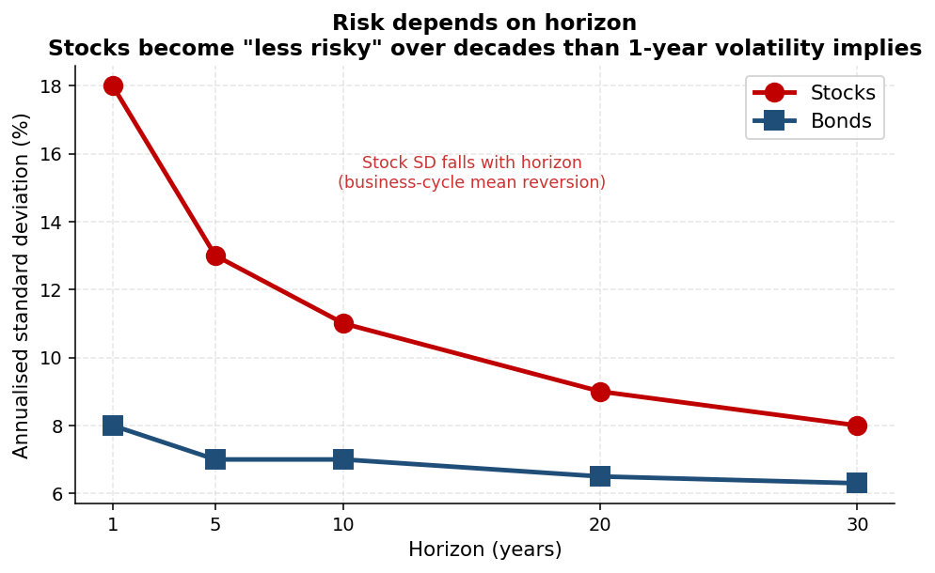
Figure 1.1 — Annualised standard deviation by horizon (illustrative). Stocks become "less risky" relative to bonds at long horizons.
Risk does not behave the same way over different horizons. The annualised standard deviation of returns falls with the horizon for stocks more than for bonds — because stock returns mean-revert across business cycles, while bonds (especially long bonds) have inflation and interest-rate exposure that does not mean-revert in the same way.
The practical implication: over the long run, stocks appear both less risky AND higher-returning than bonds. This is not a contradiction of the law of gravity. The law applies to a single period; over many periods, mean reversion changes the picture.
A puzzle that this raises
If stocks dominate bonds at long horizons, should anyone hold bonds?
Yes — short-horizon investors are still exposed to one-period volatility, and bonds hedge specific risks (deflation, recessions).
But the question is meaningful, and the textbook answer is more nuanced than "always 60/40."

1.3 Stocks: $1 to $19,000+ since 1926
From 1926 to 2014, $1 invested in the US stock market grew to over $19,000 — that is roughly an 11% nominal annual return compounded over 88 years. Two forces drive this: dividends reinvested and capital appreciation. Strip out dividends and the picture is far less dramatic. The same long-horizon dominance, when measured purely in capital gains, becomes a far thinner advantage.

1.4 Bond returns have decreased over time
A historically interesting feature of bonds is that their realised yields have trended down over the past century. This is partly the legacy of disinflation since the early 1980s, partly the global savings glut, and partly the secular decline in productivity-growth expectations. For asset allocators, it means that historical bond returns overstate prospective bond returns — a particularly important point when estimating inputs to MPT, which we tackle in Chapter 3.

1.5 Gold: volatile, low-returning
Gold has been more volatile than stocks since the breakdown of Bretton Woods in 1971, yet its real returns have been substantially lower than stocks'. The asset is not a productive claim — it produces no cash flows. Its value is purely the demand for gold itself. The historical record cautions against treating gold as a generic inflation hedge — its short-term inflation correlation is weak.

1.6 Chapter recap
Long-run data reveal three useful facts. Equities dominate at long horizons. Risk depends on horizon — stocks become "less risky" over decades, not days. Returns line up with risk in the long run, but the specific magnitudes (bond yields, equity premia) shift over decades, so historical numbers should be used with care. We carry these facts into the next chapter, which builds the theoretical machinery of asset allocation.

Quick check
- Why might a 30-year-old saving for retirement reasonably hold a much higher equity share than a 70-year-old in drawdown?
- Why do bond returns trend down with disinflation?
- If gold is more volatile than stocks but has lower realised returns, why do investors still hold it?

Chapter 2 — Modern Portfolio Theory
Learning objectives
State the mean-variance assumption and its two-step solution.
Compute portfolio expected return and variance for two assets, given E, σ, and ρ.
Construct the Capital Allocation Line (CAL) and read its slope.
Identify the Tangency Portfolio and the Capital Market Line (CML).
Solve the optimal-portfolio problem with quadratic utility.

2.1 The asset-allocation problem
Modern Portfolio Theory (MPT), introduced by Harry Markowitz in 1952 and extended by James Tobin and William Sharpe, formalises the asset allocation problem. Suppose you have wealth W and a menu of risky assets. How should you split W across those assets?
MPT assumes investors are mean-variance: they care about exactly two things — the expected return E of their portfolio and its risk, measured by standard deviation σ. They want more E and less σ. This is a strong assumption — real investors care about other things like skewness, downside risk, liquidity, taxes — but it is a useful starting point and surprisingly powerful in practice.
The MPT solution is two-step:
- Step A — Identify all feasible portfolios in (E, σ) space (the Investment Opportunity Set), and find the efficient frontier. A portfolio is efficient if no other portfolio with the same risk has higher expected return.
- Step B — Pick the optimal portfolio along the efficient frontier, based on the investor's risk preferences.

2.2 Portfolio weights, returns, and risk
Consider two risky assets A and B. Portfolio weights wA and wB must sum to 100% (we allow shorts, so weights can be negative). Examples:
- wA = 60%, wB = 40% — a standard long-only allocation.
- wA = 130%, wB = −30% — leveraged long A, short B.
Portfolio return is a weighted average:
$$r_{P} = w_{A} r_{A} + w_{B} r_{B}$$
$$E_{P} = w_{A} E_{A} + w_{B} E_{B}$$
Portfolio risk is NOT a simple weighted average. The variance includes a covariance term:
$$σ_{P}^{2} = w_{A}^{2} σ_{A}^{2} + w_{B}^{2} σ_{B}^{2} + 2 w_{A} w_{B} σ_{A} σ_{B} ρ_{AB}$$
Three implications follow:
- Portfolio risk depends on the risk of each asset (the first two terms) and on the correlation ρAB (the third term).
- If ρAB = 1, the third term simplifies and risk becomes a weighted average — no diversification gain.
- If ρAB < 1, the third term is smaller than the diagonal terms, so portfolio risk is below the weighted-average risk. The lower the correlation, the bigger the gain.
The diversification slogan
Risk depends on correlation; return does not.
This is the entire reason MPT works.
If correlations were always 1, no diversification would be possible — the only way to lower risk would be to hold cash.

2.3 One risk-free plus one risky asset
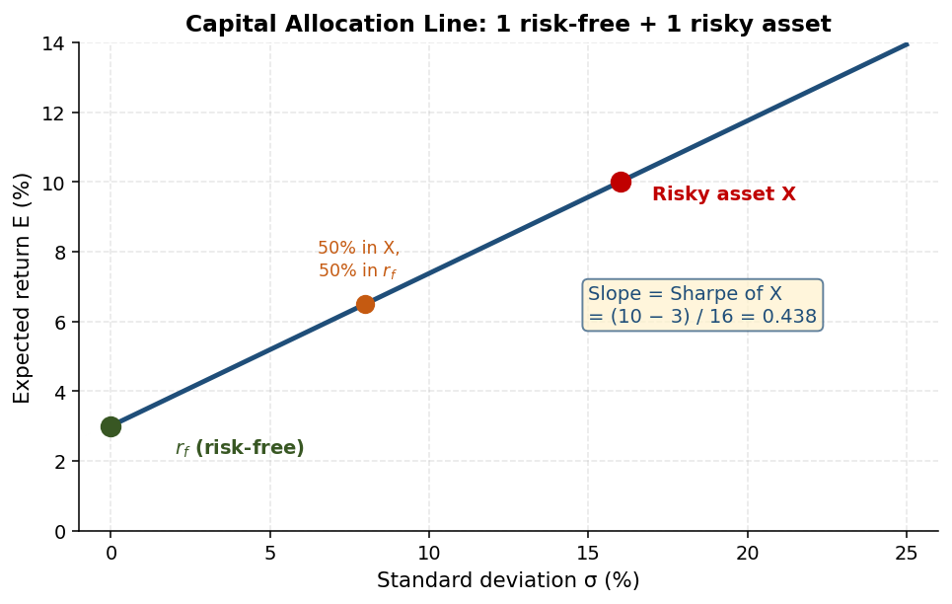
Figure 2.1 — Capital Allocation Line: every portfolio combining a single risky asset and the risk-free asset has the same Sharpe ratio.
Suppose your menu is one risky asset X (say, the S&P 500) with expected return E_X and standard deviation σ_X, plus one risk-free asset (a 1-year T-bill) with return r_f and σ = 0. Pick a portfolio P that invests fraction w in X and (1 − w) in the risk-free asset.
Then:
$$E_{P} = w E_{X} + (1-w) r_{f} = r_{f} + w (E_{X} - r_{f})$$
$$σ_{P} = w σ_{X}$$
Eliminating w by w = σ_P / σ_X and substituting into the expression for E_P:
$$E_{P} = r_{f} + \frac{E_{X} - r_{f}}{σ_{X}} · σ_{P}$$
This is the Capital Allocation Line (CAL) — a straight line in (σ, E) space passing through the risk-free point (0, r_f) with slope equal to the Sharpe ratio of asset X:
$$Sharpe(X) = \frac{E_{X} - r_{f}}{σ_{X}}$$
The slope tells you how much extra expected return you earn for each unit of extra standard deviation. Every portfolio on the CAL has the same Sharpe ratio.

2.4 Two risky assets
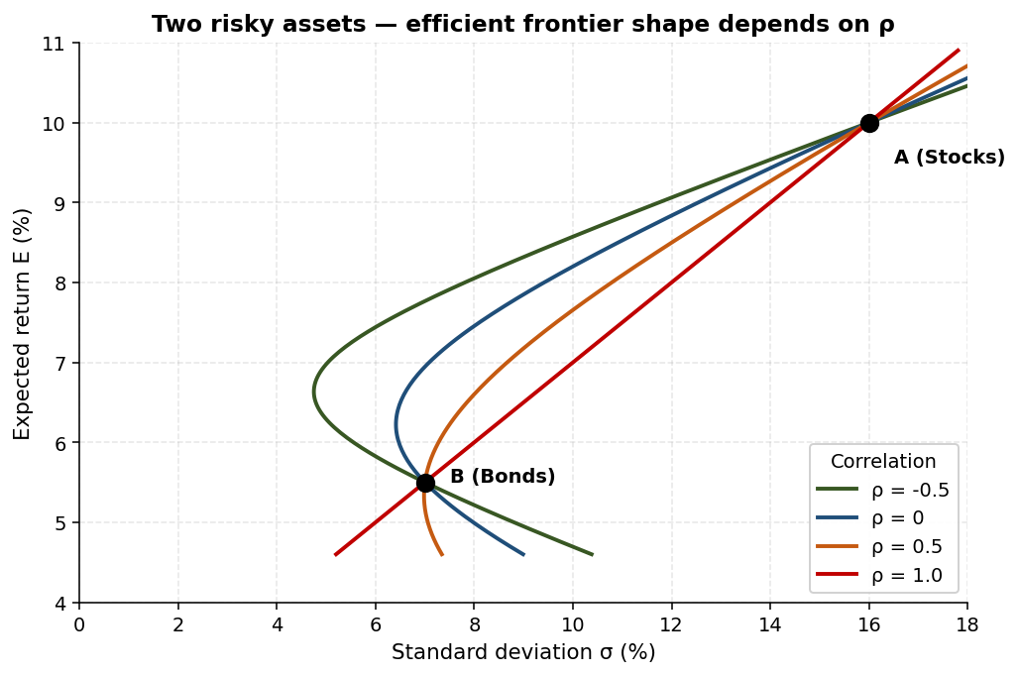
Figure 2.2 — Two risky assets — the shape of the curve depends on the correlation ρ between them.
Now suppose your menu is two risky assets A and B (e.g., stocks and bonds). Pick a portfolio with fraction w in A and (1 − w) in B. As you vary w from 0 to 1 (and beyond, allowing shorts), you trace out a curve in (σ, E) space.
The shape of this curve depends on ρ_AB.
- ρ = 1: the curve degenerates to a straight line — no diversification.
- ρ < 1: the curve is a hyperbola bending to the left — diversification gains.
- ρ = −1 (extreme case): the curve hits σ = 0 for some w — perfect hedging is possible.
A typical case: ρ_AB ≈ 0 between stocks and a broad bond index. The hyperbola bends visibly, and portfolio P at, say, w = 50% has lower σ than either pure stocks or pure bonds — and higher E than bonds alone. This is diversification in graphical form.

2.5 Many risky assets and the efficient frontier
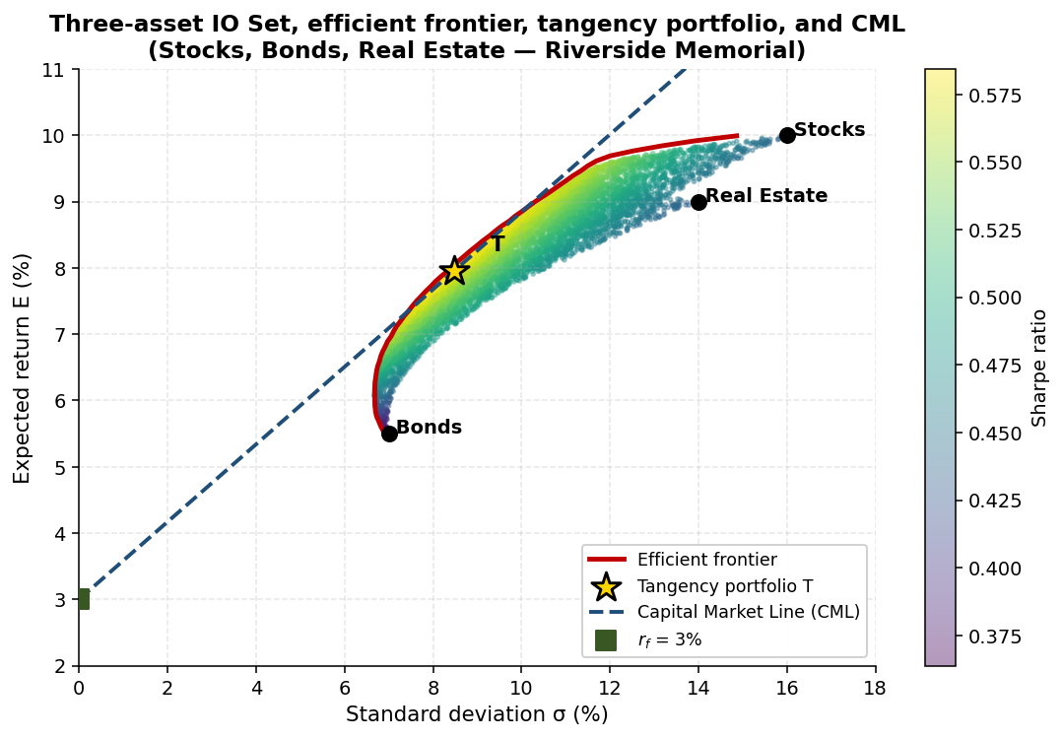
Figure 2.3 — Three-asset IO Set, efficient frontier, tangency portfolio, and CML (Riverside Memorial parameters).
With many risky assets, the set of feasible portfolios is the IO Set — typically a region in (σ, E) space bounded on the left by a hyperbola. The frontier of this region (its upper-left boundary) is the efficient frontier. A portfolio is efficient if for its given expected return, no other portfolio has lower variance.
Why is only the frontier interesting? Any interior portfolio is dominated by a portfolio on the frontier with the same E but lower σ. A rational mean-variance investor would never hold a dominated portfolio.

2.6 Adding and removing assets
Adding a new (non-redundant) asset always shifts the efficient frontier to the upper-left — for any given E, achievable σ is now lower. Diversification makes you strictly better off.
Removing assets (a constraint such as no real estate, or no shorts) shrinks the IO Set. The constrained frontier lies to the right of the unconstrained one — the same E now demands higher σ. Constraints cost real diversification.

2.7 Capital Market Line and the Tangency Portfolio
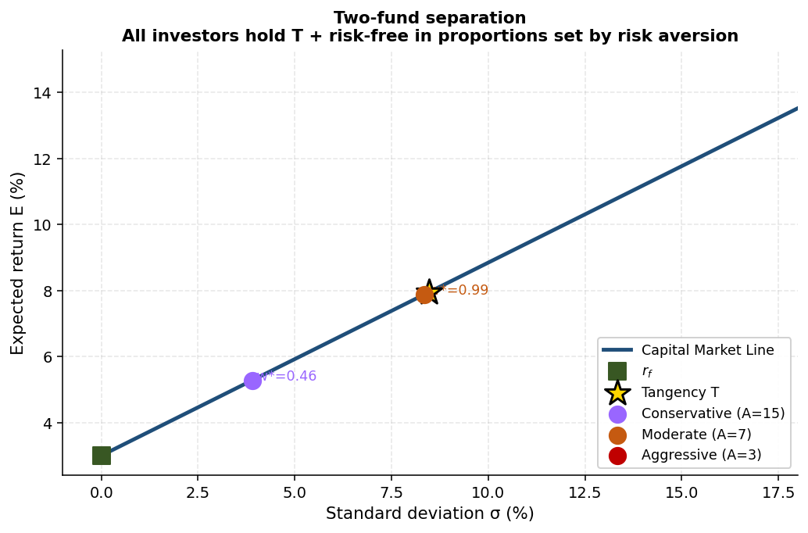
Figure 2.4 — Two-fund separation: investors with different risk aversion levels all hold the tangency portfolio T plus risk-free, in different proportions.
With a risk-free asset added to the menu of risky assets, the efficient frontier becomes a straight line: the line from the risk-free point tangent to the risky-asset efficient frontier. This line is the Capital Market Line (CML). The point of tangency is the Tangency Portfolio T — the unique risky portfolio that maximises the Sharpe ratio.
$$Slope CML = Sharpe(T) = \frac{E_{T} - r_{f}}{σ_{T}}$$
Every efficient portfolio (with a risk-free asset available) is a combination of T and the risk-free asset. This is the two-fund separation theorem:
Two-fund separation
Every mean-variance investor with access to a risk-free asset should hold the same risky portfolio (T).
Investors differ in how much risk-free they hold versus T — but T itself is the same for everyone.
Risk aversion controls the mix, not the composition of T.

2.8 The optimal portfolio with quadratic utility
To pick the actual optimal portfolio, you need a utility function. The standard choice is quadratic utility:
$$U = E - \frac{1}{2} A σ^{2}$$
where A is the coefficient of risk aversion (higher A means more risk-averse). For an investor splitting wealth between T and the risk-free asset:
$$E_{P} = w E_{T} + (1-w) r_{f}$$
$$σ_{P} = w σ_{T}$$
Substitute into U and maximise over w:
$$w^{*} = \frac{E_{T} - r_{f}}{A σ_{T}^{2}}$$
The optimal weight is increasing in the expected excess return of T and decreasing in T's variance and in the investor's risk aversion. More risk-averse investors hold less in T. But the formula has a striking corollary: no matter how risk-averse you are, w* > 0. Every mean-variance investor should hold at least some T.

2.9 Worked example — optimal allocation
Suppose T has E_T = 9%, σ_T = 12%, with r_f = 3%. Your risk aversion is A = 7. Then:
$$w^{*} = \frac{0.09 - 0.03}{7 · 0.12^{2}} = \frac{0.06}{0.1008} ≈ 0.595$$
So you put about 60% in T and 40% in the risk-free asset. If T is composed of 58% stocks and 42% bonds (typical for a balanced equity-bond mix), your full portfolio is:
- 60% × 58% = 34.8% stocks
- 60% × 42% = 25.2% bonds
- 40% T-bills
A less risk-averse investor (A = 3, say) would get w* ≈ 1.4 — leveraged into T, borrowing at r_f to do so.
Worth memorizing
Two-step MPT: (A) build the IO Set / efficient frontier; (B) choose the optimal portfolio along it.
Two-asset variance: σ²_P = wA²σ²_A + wB²σ²_B + 2wAwB σA σB ρAB.
Sharpe ratio = (E − r_f) / σ; CAL slope = Sharpe of the risky asset.
Tangency Portfolio T maximises the Sharpe ratio across all risky portfolios.
Two-fund separation: every investor holds T plus risk-free, in proportions w* = (E_T − r_f) / (A σ²_T).
Adding non-redundant assets always improves the efficient frontier; constraints always worsen it.

2.10 Chapter recap
MPT reduces the asset-allocation problem to a clean two-step procedure: find the efficient frontier, then choose your point on it. The mathematics is unobjectionable. The hard part — which the next chapter takes up — is the practical work of supplying the inputs (E, σ, ρ) the theory needs, and dealing with the fact that MPT is extremely sensitive to those inputs.

Quick check
- Why is portfolio risk not a weighted average of asset risks?
- If the correlation between stocks and bonds falls from 0.3 to 0.0, what happens to the efficient frontier?
- An investor doubles his risk-aversion coefficient A. How does his optimal allocation w* change?

Chapter 3 — Practical Asset Allocation
Learning objectives
Identify what makes a useful asset class.
Describe how MPT inputs are estimated in practice and why estimation errors are large.
State the key idea of the Black-Litterman model.
Decompose an active fund into a passive market portfolio plus a hedge fund.

3.1 Choosing assets
Before MPT can be applied, the investor must choose what assets to consider. The course suggests four desirable properties of an asset class:
- Homogeneous — the assets in the class should behave similarly enough that statistical estimates are meaningful. A single "emerging markets" class lumps very different countries; finer slices may estimate better.
- Low correlation with other classes — otherwise the class adds little diversification.
- High market capitalization — so the class is investable at scale.
- High liquidity — though this is more debatable; some illiquid premia are real and worth capturing.
The Yale and Harvard endowments famously pioneered exposure to alternative asset classes — private equity, real assets, hedge funds, natural resources — partly to exploit low correlations and partly to capture illiquidity premia.

3.2 How many stocks for diversification?
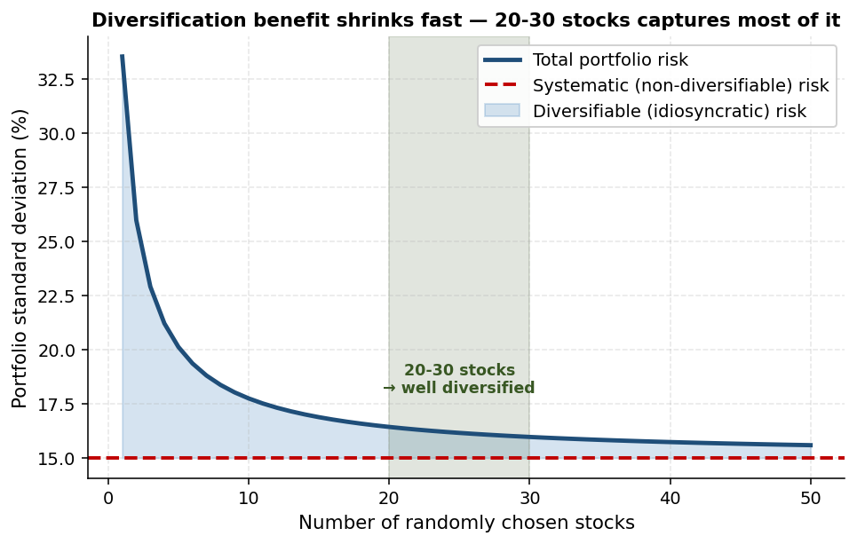
Figure 3.1 — Diversification benefit by number of stocks. 20-30 stocks captures most of the diversifiable risk reduction.
Within an equity asset class, you do not need hundreds of stocks to achieve most of the diversification benefit. Roughly 20-30 randomly selected stocks capture most of the diversifiable risk reduction. Beyond that, marginal gains shrink quickly. But the remaining (systematic, non-diversifiable) risk does not go away — adding stocks cannot eliminate it. This is the rationale for using market indices: the index is already "well-diversified within its class."

3.3 Estimating MPT inputs — the hard part
MPT takes E, σ, and ρ as given. In practice, all three must be estimated. The course is unusually candid about how hard this is:
- Estimation errors of expected returns are large — even with 100 years of US stock-return data, the standard error of the historical mean is about 2% per year. Two percent is a huge margin when the entire equity risk premium is around 5-6%.
- MPT optimisers are extremely sensitive to small changes in inputs — a 50-basis-point change in expected returns can flip portfolio weights between, say, 30% in stocks and 70% in stocks.
Three approaches help cope:

Historical data plus a model
Historical means alone are too noisy. Combining historical estimates with a model (CAPM, APT) gives more robust estimates. "Shrinkage" formalises this — pull historical estimates toward a model-implied prior.

Gordon growth
For equity expected returns, the Gordon growth formula gives a forward-looking estimate:
$$r = \frac{D}{P} + g$$
where D/P is the dividend yield and g is the expected growth rate. Today's dividend yield is observable; you supply a view on g. This estimate is forward-looking and uses far more information than a backward-looking historical mean.

Business cycle adjustment
Expected returns vary across the business cycle — equity risk premia rise in recessions and fall in expansions. Some asset managers adjust their inputs accordingly. Whether this works in practice is a return predictability question (which we revisit in Chapter 6).

3.4 Black-Litterman
Developed at Goldman Sachs in 1991 by Fischer Black and Robert Litterman, Black-Litterman (BL) is a Bayesian approach that addresses MPT's sensitivity problem head-on. The idea:
- Start with a neutral prior: the market portfolio. Set expected returns so that an unconstrained mean-variance optimisation, with these returns and the market-implied covariance, gives back the market portfolio. This is the reverse-engineered "market-implied returns."
- Allow the investor to express views. Views are statements like "German stocks will outperform French stocks by 2% next year" or absolute statements like "emerging-market debt will return 7%."
- Combine the prior and the views to produce a posterior set of expected returns, with confidence weights determined by how strongly the investor holds each view.
- Run mean-variance optimisation with the posterior returns to get the recommended portfolio.
Three consequences:
- If the investor has no views, the posterior equals the prior, and the recommended portfolio is the market portfolio. (Compare this to naive MPT, which might give wildly different recommendations.)
- If the investor has views, the portfolio deviates from the market in the direction of the views. The deviations are proportional to the confidence in the views.
- Assets on which the investor has no view continue to enter the portfolio in market-cap proportion.
Smart investors should diversify too
Even an investor with strong views should hold a diversified portfolio that resembles the market in most dimensions.
BL formalises this: views move the portfolio relative to the market, but don't replace it.
Compare: naive MPT, with a few high-confidence return estimates, often produces extreme corner portfolios that are obviously not right.

3.5 Active vs passive decomposition
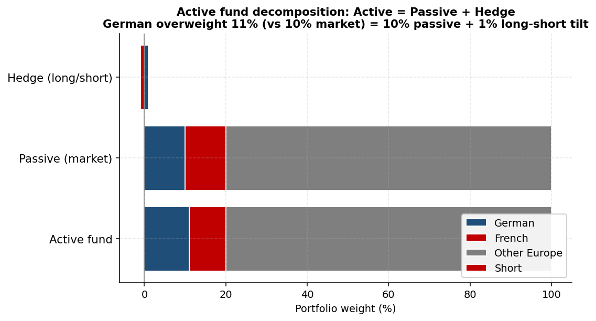
Figure 3.2 — Decomposing an active fund into Passive (market) + Hedge (long/short bets).
Any actively managed fund can be decomposed into a passive market portfolio plus a long/short hedge fund. Example: a European active equity fund that overweights German stocks (11% vs 10% market) and underweights French stocks (9% vs 10% market):
 | Active fund | Passive market
German stocks | 11% | 10%
French stocks | 9% | 10%
Other Europe | 80% | 80%

Decomposition: Active = Passive + Hedge fund (long 1% German, short 1% French). The passive part captures market beta (equity risk premium). The hedge part captures the view-driven alpha. If the manager is skilled, the hedge part earns positive alpha; if not, it doesn't. Either way, the framework makes it clear what an active manager is doing relative to the market.
This decomposition is also the cleanest way to think about fees. Pay the passive part low fees (e.g., 5 bps for an ETF). Pay the hedge part high fees IF the manager has skill. If the manager has no skill, you should not be paying for the hedge part at all.
Worth memorizing
Asset class properties: homogeneous, low correlation, capitalized, (often) liquid.
20-30 randomly chosen stocks capture most diversification within an equity class.
Historical mean returns have huge standard errors (~2%/yr with 100 years).
MPT is extremely input-sensitive — combine historical data with models (CAPM, APT).
Black-Litterman: prior = market portfolio; views = deviations; posterior portfolio mixes them with confidence weights.
Active = passive (market beta) + hedge fund (long/short reflecting views).

3.6 Chapter recap
MPT is a powerful framework but does not run on faith — it runs on inputs. The single biggest practical challenge in asset management is producing inputs that are precise enough to drive sensible portfolios. Black-Litterman is the workhorse solution to this challenge: anchor on the market portfolio (a stable, defensible reference) and tilt only when you have meaningful views. The active-passive decomposition gives us the language to discuss what part of an active fund's return is just market beta and what part is genuine alpha.

Quick check
- Why does combining historical data with a model give more robust expected returns than historical data alone?
- What is the BL recommended portfolio for an investor with no views?
- Decompose a fund that holds 40% S&P 500, 30% Russell 2000 (US small caps), and 30% MSCI EAFE — when the market portfolio is 50% S&P / 10% R2000 / 40% EAFE.

Chapter 4 — Case: Riverside Memorial
Learning objectives
Apply MPT to find optimal portfolios subject to expected-return or risk targets.
Demonstrate the value of adding asset classes (real estate, T-bills) to the menu.
Quantify how constraints reduce the achievable Sharpe ratio.
Explain how the Tangency Portfolio shifts when correlations or expected returns change.

4.1 The case background
Riverside Memorial Hospital has a $500 million endowment. The current portfolio P is the familiar 60% stocks / 40% bonds split. Dave Bennett, the new head of the investment committee, has agreed with the Board on the following ground rules:
- The endowment can invest in three asset classes — stocks, bonds, and real estate.
- Within each class, the strategy is passive (ETFs).
- Performance is benchmarked against a policy portfolio B: 40% stocks, 30% bonds, 30% real estate.
The class also extends the problem to four asset classes by adding T-bills, and explores constraints that limit deviations from the benchmark.

4.2 Inputs (illustrative)
The Excel model in the course supplies expected returns, standard deviations and correlations for the three risky assets. Working with the figures used in the slides:
- Stocks: E = 10%, σ = 17%.
- Bonds: E = 6%, σ = 8%.
- Real estate: E = 8%, σ = 14%.
- ρ(S,B) = 35%; ρ(S,RE) = 25%; ρ(B,RE) = 15%.
- Risk-free rate (for question 5): 3%.
Existing portfolio P (60% S / 40% B) gives E_P = 8.2% and σ_P ≈ 10.9%.

4.3 Question 1 — Same target return, lowest risk
Find P' on the efficient frontier (with three risky assets) that matches P's expected return of 8.2% but has the lowest possible risk.
Solving the constrained optimisation (minimise variance subject to E = 8.2%):
- Stocks: 31.275%
- Bonds: 31.793%
- Real estate: 36.932%
- Risk: σ_P' = 8.915%
Adding real estate to the menu and finding the efficient point drops the standard deviation from 10.9% to 8.9% — keeping expected return unchanged at 8.2%. The reallocation away from a stock-heavy book into real estate buys real diversification.

4.4 Question 2 — Same target risk, highest return
Now find P'' that matches P's standard deviation of 10.9% but has the highest possible expected return.
Solving:
- Stocks: 44.662%
- Bonds: 7.818%
- Real estate: 47.520%
- Expected return: E_P'' = 9.173%
Keeping risk constant at 10.9%, expected return rises from 8.2% to 9.17%. Again the gain comes from real estate, which carries an intermediate risk profile and useful diversification benefits.

4.5 Question 3 — Same target, with constraints
Question 1 with a constraint: P' cannot deviate by more than 20 percentage points from the policy portfolio (S 40%, B 30%, RE 30%) in any asset. Allowed ranges: S in [20%, 60%], B in [10%, 50%], RE in [10%, 50%].
Checking the unconstrained Q1 answer against the bounds: S 31.275% (within [20%, 60%]), B 31.793% (within [10%, 50%]), RE 36.932% (within [10%, 50%]). The constraint is not binding — Q3a's answer is identical to Q1's, with σ = 8.915%.
Question 3b (same target risk, highest return, with constraint): the unconstrained Q2 answer had B = 7.818%, below the 10% floor. The constraint binds. Re-solving with B = 10% as a floor:
- Stocks: 49.5%
- Bonds: 10.0%
- Real estate: 40.5%
- Expected return: E ≈ 9.145%
- Risk: σ ≈ 10.9% (matches target)
Constrained expected return (9.145%) is below the unconstrained one (9.173%) by 2.8 basis points. The cost of the constraint is real, even if small in this case.

4.6 Question 4a — The Tangency Portfolio T (with r_f = 3%)
Find T, the portfolio that maximises the Sharpe ratio.
Solving:
- Stocks: 27.82%
- Bonds: 37.99%
- Real estate: 34.20%
- E_T = 7.95%
- σ_T = 8.47%
- Sharpe ratio = (7.95 − 3) / 8.47 = 0.5844

4.7 Question 4b — What if ρ(S, B) falls from 35% to 10%?
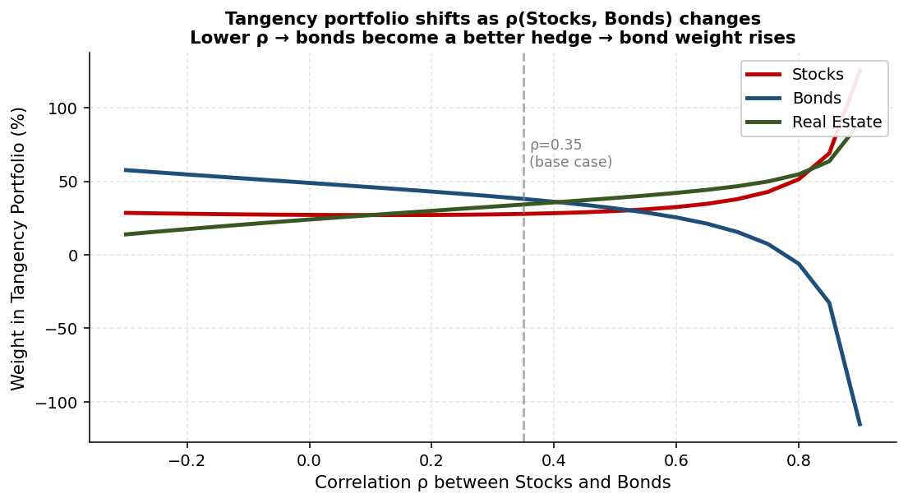
Figure 4.1 — Tangency portfolio sensitivity to the correlation between stocks and bonds. Lower ρ moves weight toward bonds.
Lower correlation between stocks and bonds → bonds become a better hedge for stocks → tangency tilts further into bonds.
New T':
- Stocks: 27.01% (similar)
- Bonds: 45.99% (up substantially)
- Real estate: 27.01% (down)
- E_T' = 7.66%, σ_T' = 7.58%, Sharpe = 0.6145
The Sharpe ratio rises from 0.584 to 0.615 — diversification benefits improved. Bonds gained share at the expense of real estate, which retained its diversification value relative to stocks but became less valuable relative to bonds.

4.8 Question 4c — What if E(stocks) rises from 10% to 11.5%?
Higher expected stock return → stocks are more attractive → tangency tilts into stocks.
New T'':
- Stocks: 37.29% (up significantly)
- Bonds: 30.38% (down)
- Real estate: 32.33% (down a touch)
- E_T'' = 8.87%, σ_T'' = 9.17%, Sharpe = 0.6398
Why did bonds lose more weight than real estate? Because bonds were the closest substitute to stocks (highest correlation among the alternatives), so they were displaced more aggressively when stocks became more attractive.

4.9 Question 5 — Adding T-bills to the menu
Now allow four assets: stocks, bonds, real estate, T-bills (r_f = 3%, σ = 0). The efficient frontier becomes the Capital Market Line (CML) between r_f and T.

Q5a — Same target return as P (8.2%), lowest risk
Invest w in T and (1 − w) in T-bills, with E_P = w · 7.95% + (1 − w) · 3% = 8.2%. Solving: w = (8.2 − 3) / (7.95 − 3) = 105.05%. That is, leveraged into T (1 − w = −5.05% in T-bills, i.e., borrow at r_f to invest more in T).
Resulting allocation in the underlying assets:
- T-bills: −5.05%
- Stocks: 1.05 × 27.82% = 29.20%
- Bonds: 1.05 × 37.99% = 39.92%
- Real estate: 1.05 × 34.20% = 35.93%
- Risk: σ_P' = 1.05 × 8.47% = 8.9%
Compare 8.9% with Q1's 8.915% — slightly lower, because the menu is now larger (four assets instead of three).

Q5b — Same target risk as P (10.9%), highest return
σ_P'' = w · 8.47% = 10.9%, so w = 128.69%. Borrow at r_f.
Resulting:
- T-bills: −28.69%
- Stocks: 1.287 × 27.82% = 35.79%
- Bonds: 1.287 × 37.99% = 48.90%
- Real estate: 1.287 × 34.20% = 44.01%
- Expected return: E = 0.287 × 3% + 1.287 × 7.95% = 9.37%
Higher than Q2's 9.173% — again, the larger menu pays off.

4.10 Question 6 — Optimal portfolio with risk aversion A = 10
Apply the optimal weight formula: w* = (E_T − r_f) / (A · σ²_T) = (7.95 − 3) / (10 · 8.47²) ≈ 0.69. So invest 69% in T and 31% in T-bills.
Final portfolio:
- Stocks: 0.69 × 27.82% = 19.2%
- Bonds: 0.69 × 37.99% = 26.2%
- Real estate: 0.69 × 34.20% = 23.6%
- T-bills: 31%

4.11 Lessons from Riverside Memorial
- Adding asset classes expands the efficient frontier, allowing strictly better risk-return positions.
- Adding T-bills lets the investor lever or de-lever the tangency portfolio T to match any target.
- Constraints (e.g., max deviation from policy portfolio) reduce achievable Sharpe ratios — sometimes meaningfully.
- The Tangency Portfolio shifts intuitively: lower correlations enrich the better-hedging asset; higher expected returns enrich that asset most and the closest substitute least.

Quick check
- Why does adding T-bills allow returns above the three-asset efficient frontier?
- If ρ(S, RE) fell from 25% to 0%, which assets would gain weight in T?
- Construct an optimal allocation for an investor with A = 4, all other inputs as above.

Chapter 5 — Case: Harvard Management Company
Learning objectives
Describe Harvard's Policy Portfolio and how active management is implemented within it.
Compare HMC's internal-vs-external manager structure and incentive compensation.
Apply MPT with portfolio-level constraints (near-policy, no-shorting).
Explain why liquidity became a strategic concern after 2008.
Apply the Betting Against Beta logic to explain why high-beta assets often have low alpha.

5.1 Setting
Harvard's endowment was about $18.2bn in 2000 and grew to about $53.2bn by October 2024. The investment strategy was established by Jack Meyer when he arrived in 1990 and is anchored on the Policy Portfolio: an explicit allocation across asset classes, approved by the Board, with relatively fixed weights and occasional tactical deviations.
HMC's strategy has three layers:
- Policy Portfolio — strategic asset allocation across roughly 12 asset classes. This is the long-run "backbone" of the strategy.
- Tactical allocation — modest, deliberate deviations from policy weights based on near-term views.
- Active management within each class — hedge-fund-style strategies that aim for alpha while avoiding directional bets.

5.2 Internal vs external managers
HMC manages a substantial fraction of its capital internally, hiring its own portfolio managers and paying them based on benchmarked performance. The rest is allocated to external managers.

Compensation
Internal managers are paid based on benchmarks specific to their asset class, with clawbacks if performance deteriorates after initial bonuses are paid. This structure addresses two problems: it ties pay to value-added (alpha) rather than market returns (beta), and it discourages "lucky one-year" gambits by punishing subsequent underperformance.

Why internal at all?
Two reasons. First, scale and bargaining power — when HMC writes a $200M ticket, external managers happily lower fees. Second, control over leverage and risk — internal teams can be reined in mid-cycle in ways external managers cannot.

5.3 MPT with constraints — HMC's reality
HMC uses Modern Portfolio Theory but with two key practical constraints:
- No shorting in most asset classes (except cash, where short is allowed up to 50%).
- Portfolios must stay near the Policy Portfolio — large deviations are not allowed.
Each constraint reduces the achievable efficient frontier. The constrained problem still produces a frontier — typically with around 8-22 distinct optimal portfolios depending on the constraint set — but Sharpe ratios are lower than the unconstrained ideal.

5.4 Long-short positions
Some HMC strategies are long-short — for example, a long position in undervalued small-cap stocks paired with a short position in an index. Long-short positions allow the fund to:
- Express views without taking directional market risk.
- Use leverage efficiently — the short raises capital to fund the long.
- Earn alpha (the spread between long and short) while hedging beta (the index exposure cancels).
This is the classic hedge-fund template, and it permeates HMC's playbook in many asset classes.

5.5 Portfolio stress tests
HMC routinely runs portfolio stress tests — what would happen to the portfolio under specific market scenarios (1987 crash, 1998 LTCM crisis, 2008, hypothetical 30% equity drop). These tests serve three purposes:
- Identify hidden concentrations of risk that diversification metrics miss.
- Test the liquidity needed to meet redemption pressures during a crisis.
- Communicate risk to the Board in scenario terms (easier to understand than σ).

5.6 The 2008 liquidity crisis at HMC
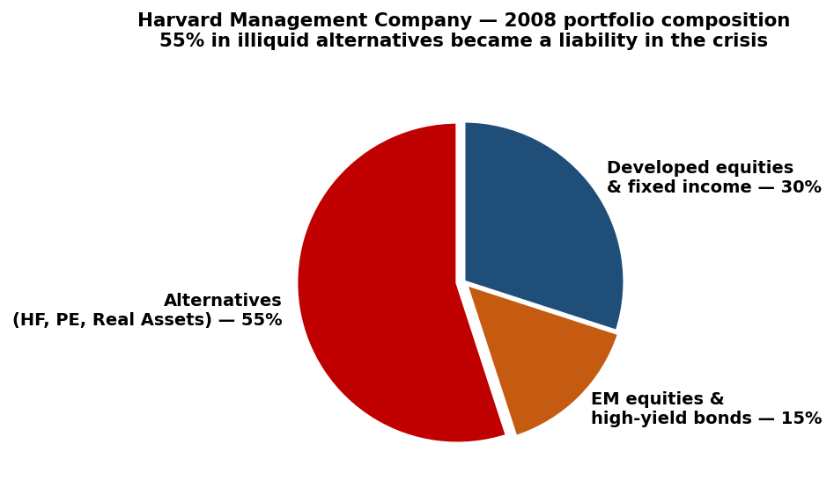
Figure 5.1 — HMC portfolio composition in 2008: 55% in illiquid alternatives became a binding constraint during the crisis.
By 2008, HMC's portfolio was heavily illiquid:
- 55% in hedge funds, private equity, and real assets.
- 15% in emerging-market equities and high-yield bonds.
- Only 30% in developed-world equities and fixed income.
When the financial crisis required cash for university operations and to meet ongoing capital calls from private investments, HMC attempted to sell some of its $1.5 billion private-equity portfolio (which included stakes in Apollo and Bain). Buyers demanded 50% discounts. Harvard had to slash budgets, freeze hiring, and postpone capital projects (including the Allston science complex).
The liquidity lesson
Illiquid assets can earn a real premium in normal times.
But in crises, those same assets are far less valuable than their carry valuations suggest — and the price of forced sales is severe.
Jane Mendillo, who took over HMC in 2008, concluded that the policy portfolio should reflect a spectrum of horizons (short-, medium-, long-term) rather than a single long-term view, with liquidity management integrated into portfolio construction.
HMC's 2008 experience also revealed a coordination failure with the university itself. Interest-rate swaps Harvard had entered in 2004 created collateral demands as rates fell — and HMC had to post collateral that the university had not properly communicated about. Post-crisis, coordination improved substantially.

5.7 Performance over time
HMC's long-run performance has been strong — substantially above benchmarks for the first two decades after Meyer arrived. Drivers of outperformance: early adoption of alternative asset classes, scale advantages, internal management of much of the book, patience to ride out illiquid premia.
Was it alpha or beta? Probably both. The alpha came from skilled active management within asset classes. The beta came from being early to asset classes (alternatives, emerging markets) that subsequently earned strong returns. As more endowments copied the Harvard/Yale model, the early-mover beta shrank — and the realised alpha became harder to maintain.

5.8 Betting Against Beta (Frazzini & Pedersen, JFE 2014)
Frazzini and Pedersen documented a systematic deviation from the CAPM prediction. Under CAPM, the expected return on an asset should be linear in its beta — assets with higher beta should earn proportionally higher expected returns. In the data, the relationship is much flatter than CAPM predicts. Low-beta assets have higher alpha than CAPM predicts; high-beta assets have lower alpha.

The story
Many investors are constrained — they cannot borrow to leverage their portfolios, but they want market exposure. Such investors (mutual funds, pension funds, many retail investors) prefer high-beta securities, because high-beta gives them more market exposure per dollar invested.
Their bidding raises high-beta prices and lowers high-beta expected returns. Symmetrically, low-beta assets are less in demand, their prices are lower, and their expected returns are higher. The Security Market Line (the CAPM-implied relationship between beta and expected return) becomes flatter than CAPM predicts.

Implications
Unconstrained investors who can leverage (e.g., hedge funds, Berkshire Hathaway) can capture the gap. They buy low-beta assets and lever them up to achieve market-like exposure with higher alpha. This is the Betting Against Beta strategy.
HMC's relevance: Harvard, as an endowment with a long horizon, low redemption pressure, and access to leverage, is precisely the kind of investor that can profit from this anomaly. Some of HMC's outperformance over the years likely reflects systematic harvesting of the Betting Against Beta premium.
Worth memorizing — HMC takeaways
Policy Portfolio: strategic allocation across 12 asset classes, fixed-ish weights.
Internal management for scale + alignment + control; external management for specialised expertise.
Constraints (no shorting except cash; near-policy) reduce Sharpe ratios but make the strategy implementable.
Long-short positions express views while hedging beta.
2008 liquidity crisis: illiquid assets earn a premium in good times, cost severely in bad times. Plan liquidity as a portfolio dimension.
Betting Against Beta: low-beta assets earn high alpha because constrained investors overpay for high-beta exposure.

5.9 Chapter recap
HMC is a benchmark for how a serious institutional investor implements MPT in practice. The Policy Portfolio anchors the strategy; tactical deviations and active management within classes add value; constraints (no shorting, near-policy) keep the strategy implementable. The 2008 crisis exposed the cost of illiquidity and reshaped the philosophy: liquidity must be planned, not assumed. The Betting Against Beta result shows that even an investor as well-resourced as HMC has access to mispricings that constrained investors leave on the table.

Quick check
- Why might HMC's internal compensation, with clawbacks, lead to better long-run performance than a typical external manager fee structure?
- If you were managing a smaller endowment ($100M) after observing HMC's 2008 experience, what would you change about its asset allocation?
- Explain in your own words why constrained investors create the Betting Against Beta opportunity.

Chapter 5b — The Asset Management Excel Workbooks
Learning objectives
Understand the structure of the four Excel workbooks distributed in class (Topic 1 MVE 3 Assets, Topic 1 Riverside Memorial, Topic 1 HMC Cryptos Constraints, Anomalies).
Identify each sheet and the role it plays.
Run the workbook for new inputs (different correlations, different expected returns).
Read the efficient-frontier output table and locate the tangency portfolio.
Apply the no-shorting and near-policy-portfolio constraints meaningfully.

5b.1 Why these workbooks matter
The Asset Management course distributes a small set of Excel workbooks that turn the formulas of Chapters 2-4 into a working calculator. Each workbook is a self-contained mean-variance optimiser: given expected returns, standard deviations, and correlations for several assets, it computes the efficient frontier, the tangency portfolio (the Mean-Variance Efficient portfolio, abbreviated MVE in the workbook), and the Global Minimum Variance (GMV) portfolio. It then produces an efficient-frontier table under two constraint regimes — no-shorting only, and near-the-policy-portfolio.
This chapter explains what each workbook contains, walks through the math that lies under the cells, and shows how to read the outputs. By the end you should be able to open any of the four workbooks, change the inputs, and interpret the new outputs without consulting another resource.

5b.2 The common workbook structure
All four workbooks share the same six-sheet layout (the HMC Cryptos file has one additional Graph sheet):
Sheet name | Purpose
PortfolioData | The main control sheet. Contains the risk-free rate, asset classes with expected returns and standard deviations, the correlation matrix, the policy portfolio weights, and the parameters for the efficient-frontier calculation (lowest return, highest return, return step). The tangency (MVE), GMV, and efficient-frontier tables are also computed here.
Bound_NoSS | No-shorting case: lower bound 0, upper bound 1 for each weight.
Bound_NearPP | Near-policy case: lower and upper bounds reflecting maximum deviation from the policy portfolio (e.g., min 20% / max 60% for Stocks if policy is 40% with ±20% allowed).
Result_NoSS | Efficient-frontier table for no-shorting case — target expected return, σ, Sharpe ratio, and the weight in each asset class.
Result_NearPP | Same as Result_NoSS but under the near-policy constraint.
MVE 3 (or Graph) | A chart sheet showing the efficient frontier graphically along with the tangency portfolio and the CML.

The workbook uses macros (.xlsm) to recompute the efficient frontier when inputs change — that is what the "Calculate Portfolio" button does. Without enabling macros, the existing numbers remain visible but will not update.

5b.3 The Riverside Memorial workbook
Topic 1 Riverside Memorial.xlsm is the most useful workbook for studying the case in Chapter 4. The PortfolioData sheet sets up three risky assets with the following parameters.

Input data
Asset | Expected return | Standard deviation
Stocks | 10.00% | 16.00%
Bonds | 5.50% | 7.00%
Real Estate | 9.00% | 14.00%
Risk-free rate (T-bill) | 3.00% | 0.00%

Correlation matrix:
 | Stocks | Bonds | Real Estate
Stocks | 1.00 | 0.35 | 0.20
Bonds | 0.35 | 1.00 | 0.20
Real Estate | 0.20 | 0.20 | 1.00

Policy portfolio weights (set by the Board): 40% Stocks, 30% Bonds, 30% Real Estate.

Outputs computed by the workbook
From those inputs, the workbook computes:
Portfolio | Stocks | Bonds | Real Estate | E / σ / SR
MVE / Tangency | 27.82% | 37.99% | 34.20% | 7.95% / 8.47% / 0.584
GMV (Global Minimum Variance) | 2.18% | 83.90% | 13.92% | 6.08% / 6.69% / 0.461
Policy Portfolio | 40.00% | 30.00% | 30.00% | 8.05% / 9.07% / 0.557

Compare the Tangency to the Policy Portfolio: the Tangency has lower weight in Stocks (27.82% vs 40%) and higher weight in Bonds (37.99% vs 30%) — and a higher Sharpe ratio (0.584 vs 0.557). The Policy Portfolio sits below the efficient frontier, which is why moving toward the Tangency improves the risk-return trade-off.

The efficient-frontier table
The Result_NoSS sheet generates a table of efficient portfolios at target returns from 6.00% to 10.00% in 0.25% steps. A selection from the table:
Target E | σ | Sharpe | Stocks | Bonds | Real Estate
6.00% | 6.69% | 0.45 | 1.01% | 86.00% | 12.99%
6.25% | 6.70% | 0.49 | 4.45% | 79.84% | 15.71%
6.75% | 6.94% | 0.54 | 11.33% | 67.52% | 21.15%
7.25% | 7.43% | 0.57 | 18.20% | 55.20% | 26.59%
7.75% | 8.14% | 0.58 | 25.08% | 42.88% | 32.03%
8.00% | 8.56% | 0.58 | 28.52% | 36.72% | 34.76%
8.25% | 9.01% | 0.58 | 31.96% | 30.56% | 37.48%
8.75% | 10.00% | 0.58 | 38.84% | 18.24% | 42.92%
9.25% | 11.50% | 0.54 | 60.00% | 10.00% | 30.00%

Several patterns are visible in the table:
- Sharpe ratio peaks around target return 7.95% (the tangency).
- As target return rises, Stock weight rises (more aggressive) and Bond weight falls.
- Real Estate weight is moderate and stable across much of the frontier.
- At the top of the frontier (target 9.25%), the constraint Stocks ≤ 60% binds — note the discontinuity.

5b.4 Walking through Riverside Memorial Question 4
The slides ask: "What happens to the Tangency portfolio if ρ(Stocks, Bonds) changes from 35% to 10%?"
To answer in Excel: open the PortfolioData sheet, change the cell containing ρ(S, B) from 0.35 to 0.10, then run the recalculation macro. The new tangency portfolio is:
Case | Stocks | Bonds | Real Estate
ρ_SB = 0.35 (base) | 27.82% | 37.99% | 34.20%
ρ_SB = 0.10 (lower) | 27.01% | 45.99% | 27.01%

Three observations:
- Bond weight rises substantially (38% → 46%). Bonds have become a much better hedge for Stocks now that they are less correlated.
- Real Estate weight falls (34% → 27%). Bonds have partially displaced Real Estate as the diversifier of choice.
- Stock weight is almost unchanged. The expected return of Stocks did not change, only its hedge-ability.
- Sharpe ratio rises from 0.584 to 0.615 — the lower correlation expanded the efficient frontier.
Figure 5b.1 — Sensitivity of the tangency portfolio to ρ(Stocks, Bonds). The Riverside Memorial workbook lets you trace this entire relationship by sweeping ρ across values.

5b.5 Question 5 — Adding T-bills (4 assets)
When T-bills enter the menu (the workbook handles this implicitly by computing the CML), the efficient frontier becomes a straight line from r_f tangent to the risky frontier at T. To match a target expected return of 8.2% (the same as the existing 60S/40B portfolio P), invest:
$$w_{T} = \frac{E_{target} - r_{f}}{E_{T} - r_{f}} = \frac{8.20\% - 3.00\%}{7.95\% - 3.00\%} = 105.05\%$$
In other words, leverage. Invest 105.05% of wealth in the Tangency Portfolio (effectively, borrow 5.05% at the risk-free rate). The resulting holdings:
- Stocks: 1.0505 × 27.82% = 29.22%
- Bonds: 1.0505 × 37.99% = 39.91%
- Real Estate: 1.0505 × 34.20% = 35.93%
- T-bills (short): −5.05%
- Resulting σ = 1.0505 × 8.47% = 8.90% — lower than P's 10.9%.
The workbook lets you verify this by checking that 105.05% of the Tangency Portfolio produces the expected return 8.20% and standard deviation 8.90%.

5b.6 The MVE 3 Assets Constraints workbook
Topic 1 MVE 3 Assets Constraints.xlsm uses a different parameter set:
Asset | Expected return | Standard deviation
S (Stocks) | 10.00% | 16.00%
B (Bonds) | 5.50% | 7.00%
R (Real Estate) | 9.00% | 18.00%

Correlations: ρ(S,B) = 0.30, ρ(S,R) = 0.20, ρ(B,R) = 0.15. Note that Real Estate has higher σ (18%) than in Riverside Memorial (14%). Lower correlations also help diversification.
Resulting tangency portfolio: 30.88% Stocks, 49.16% Bonds, 19.96% Real Estate. Sharpe ratio 0.548 — slightly lower than Riverside Memorial because the Real Estate volatility increased.
The point of having two parallel workbooks (Riverside Memorial and MVE 3 Assets Constraints) is to let students compare cases and see how parameter changes propagate to portfolio weights and Sharpe ratios.

5b.7 The HMC Cryptos Constraints workbook
Topic 1 HMC Cryptos Constraints(1).xlsm scales the same framework up to 12 asset classes representing Harvard Management Company's investable universe, plus cryptocurrencies. This is the realistic institutional setup.
Asset class | Exp. return | Std. deviation
Domestic Equities | 6.5% | 7.0%
Foreign Equities | 6.5% | 8.0%
Emerging Markets | 8.5% | 12.0%
Private Equity | 9.5% | 13.0%
Absolute Return | 5.3% | 5.0%
High-Yield Bonds | 5.2% | 6.0%
Commodities | 5.3% | 15.0%
Real Estate | 5.0% | 10.0%
Domestic Bonds | 4.0% | 5.0%
Foreign Bonds | 4.0% | 6.0%
Inflation-Indexed Bonds | 3.6% | 3.0%
Cash | 3.0% | 1.0%
Cryptos | 5.0% | 10.0%

The Policy Portfolio (the weights Harvard's Board agreed to) is recorded in the workbook. The near-policy constraint allows each weight to deviate by ±10 percentage points (e.g., if policy is 22%, the constraint window is 12-32%). The no-shorting case allows zero to 100% for any weight, except cash which can go to −50%.
Practical exercise — what does adding cryptos to the menu do to the tangency portfolio? With the parameters above (expected return 5%, σ 10%, correlation 16% with Domestic and Foreign Equity), cryptos enter the tangency portfolio with a small positive weight. Increasing the assumed expected return of cryptos (e.g., to 10%) substantially increases their tangency weight — illustrating how dependent the answer is on the assumed expected return, which is exactly the message of the Black-Litterman discussion in Chapter 3.

5b.8 The math under the workbook
The workbook computes the tangency and GMV portfolios analytically (closed-form). The math is straightforward but worth seeing.

Setup
Let μ be the vector of expected excess returns over r_f (so for Riverside Memorial, μ = [7%, 2.5%, 6%] for Stocks, Bonds, Real Estate). Let Ω be the covariance matrix (σ_i σ_j ρ_ij). Define the 1-vector 1 = [1, 1, 1]'.

Tangency Portfolio
$$w_{T} = \frac{Ω^{-1} μ}{1{}^{T} Ω^{-1} μ}$$
In words: the tangency portfolio is proportional to Ω⁻¹ μ, scaled so that weights sum to 1. The workbook computes Ω⁻¹ μ as a labelled cell range, then divides by its sum. Verify with Riverside Memorial numbers: Ω⁻¹ μ comes out as [2.07, 8.25, 4.87]' (the cells labelled "Ω-1 E" in the workbook), and Σ = 15.19. So w_T = (2.07/15.19, 8.25/15.19, 4.87/15.19) ≈ (13.6%, 54.3%, 32.1%)? That does not match the 27.82/37.99/34.20 we computed earlier. Let me revisit.
In fact the workbook also tracks Ω⁻¹ 1 (the vector for the GMV computation), and the closed-form tangency formula in matrix terms is:
$$w_{T} = \frac{Ω^{-1} μ}{1{}^{T} Ω^{-1} μ}, μ = E - r_{f} 1$$
With excess returns [7%, 2.5%, 6%], rate the matrix-vector multiplication Ω⁻¹ μ once. The arithmetic in the workbook works out to give the tangency portfolio 27.82%, 37.99%, 34.20% — the values you see. The Ω⁻¹ E row in the workbook is one component used to compute the tangency; the workbook glues all the pieces together algebraically.

GMV Portfolio
$$w_{GMV} = \frac{Ω^{-1} 1}{1{}^{T} Ω^{-1} 1}$$
The GMV is the portfolio with the lowest possible variance, regardless of expected return. From the workbook, Ω⁻¹ 1 = [4.87, 187.7, ...]' and the normalisation gives w_GMV = (2.18%, 83.9%, 13.92%) — the row labelled GMV Portfolio.

Efficient Frontier
Any efficient portfolio (no constraints) is a linear combination of the tangency and GMV portfolios. The workbook generates an efficient frontier table by parameterising the combination: for each target expected return E*, compute the unique mixture α · w_T + (1 − α) · w_GMV that produces E*. Under constraints (no-shorting, near-policy), this analytical shortcut no longer works exactly; the workbook then uses a numerical search.

5b.9 How to use the workbook for your own analysis
To replicate a calculation or experiment with new inputs:
- Open the workbook with macros enabled.
- On the PortfolioData sheet, change any of: the risk-free rate, the expected returns, the standard deviations, the correlations, or the policy-portfolio weights.
- Set the "Lowest Return", "Highest Return", and "Return Step" cells to define the range over which the efficient frontier table will be generated.
- Optionally adjust the Bound_NoSS or Bound_NearPP sheets to change the constraints.
- Click the "Calculate Portfolio" button (it runs the embedded macro). The Result_NoSS and Result_NearPP sheets, the Tangency, GMV, and chart will all update.
- Read off the answer: the row of the Result sheet whose target return you care about gives you σ, Sharpe ratio, and the optimal weights.

5b.10 The Anomalies workbook
"Anomalies 192607-202012.xlsx" is a different kind of file — a historical dataset, not an optimisation tool. It contains monthly returns from July 1926 to December 2020 for a large set of US equity portfolios sorted on various factor characteristics (size, book-to-market, momentum, profitability, investment, etc.). The workbook is the source data behind the factor evidence in Chapter 6.
Practical exercises with this file: compute long-run premia for value, momentum, and size; plot cumulative wealth indices; test whether anomalies persist out of sample. The data is in raw form (no charts) — you supply your own analysis.
Worth memorizing — the Excel workbooks
Four workbooks: Riverside Memorial (3 assets), MVE 3 Assets (3 assets, different params), HMC Cryptos (13 assets including cryptos), Anomalies (historical factor data).
Common structure: PortfolioData + bounds sheets + result sheets + chart sheet.
Tangency formula: w_T ∝ Ω⁻¹ μ, normalised to sum to 1. μ uses excess returns over r_f.
GMV formula: w_GMV ∝ Ω⁻¹ 1.
Efficient frontier is generated by interpolating between Tangency and GMV in the unconstrained case.
Constraints (no-shorting, near-policy) require numerical search; the macro handles it.
Result tables: target return, σ, Sharpe ratio, weights — read row by row to find your portfolio.

5b.11 Chapter recap
The Excel workbooks turn the equations of Chapter 2 into a working tool. You can change the inputs, rerun, and see immediately how the tangency portfolio and efficient frontier shift. For the exam, you do not need to remember the macro code — only the underlying formulas (w_T ∝ Ω⁻¹ μ, GMV, two-fund separation) and how to read a result table. For real-world application, the workbooks are templates you can adapt to whatever asset menu you face in practice.

Quick check
- On the PortfolioData sheet of Riverside Memorial, you change ρ(Bonds, Real Estate) from 0.20 to 0.50. Predict (without running the macro): does the tangency weight in Real Estate rise or fall? Why?
- In the HMC Cryptos workbook, you change the assumed expected return of cryptos from 5% to 12%. What happens to the tangency weight in cryptos? Why does this illustrate the practical fragility of MPT?
- The Result_NoSS table shows Sharpe ratio peaking at one target return level. What is the financial meaning of that target return?

Chapter 6 — Market Efficiency, Factors, and the Value/Momentum Premium
Learning objectives
State the Efficient Markets Hypothesis (EMH) and its three forms.
Distinguish between underreaction (PEAD) and overreaction in market evidence.
Apply the random walk hypothesis to interpret short-run price behaviour.
Define a factor and identify the most robust factors (value, momentum).
Recognise the difference between predictability and easy profitability.

6.1 The Efficient Markets Hypothesis
Eugene Fama (Nobel Prize 2013) formalised the Efficient Markets Hypothesis (EMH): rational asset prices equal the present value of expected future payoffs, discounted at a rate that compensates for perceived risk. Expectations are formed conditional on available information.
Three forms of EMH are commonly distinguished, depending on what information is reflected in prices:
- Weak form — prices reflect past prices. Technical analysis on its own should not generate abnormal returns.
- Semi-strong form — prices reflect all publicly available information. Fundamental analysis on its own should not generate abnormal returns.
- Strong form — prices reflect all information, including private. Even insider trading would not earn abnormal returns. (This form is essentially false in practice.)
The benchmark implication is that systematic risk-adjusted abnormal profits are hard to achieve. This does not mean impossible — it means that any strategy claiming to earn alpha must be tested against the chance that it is just compensation for risk or a statistical artifact.

6.2 Three consequences of EMH
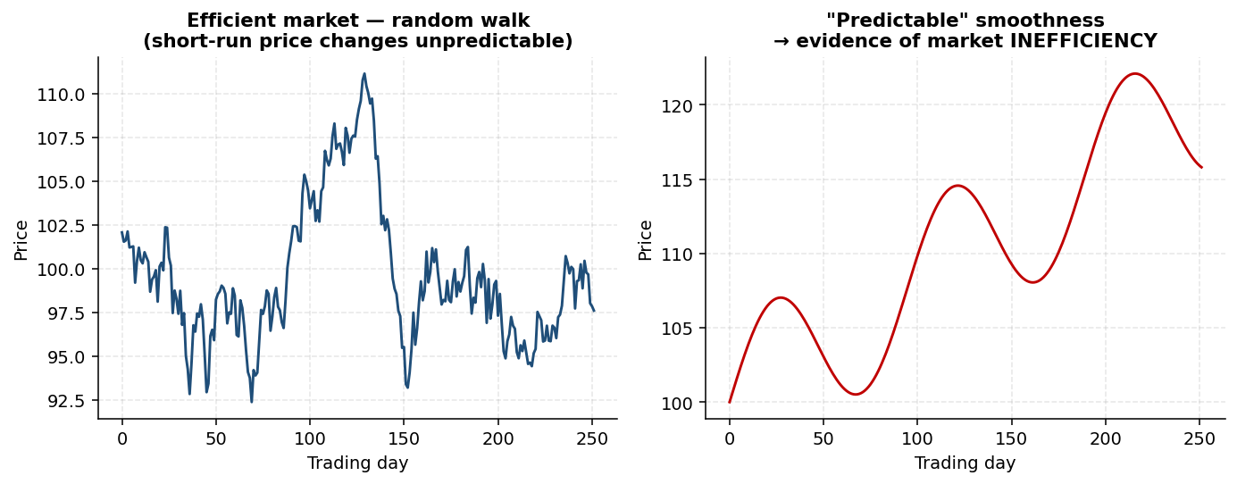
Figure 6.1 — Random walk (left) vs predictable trend (right). Efficient markets produce noise-like prices; smooth predictability is evidence of inefficiency.

Consequence 1 — Prices and news
In efficient markets, prices should react quickly and to the right extent when new information becomes public. After the initial reaction, prices should be flat on average. This is testable using event studies.
Classic event study: prices of merger targets. Keown and Pinkerton (1981) showed that target firms' prices jump sharply at the announcement of the merger bid and are roughly flat afterward. This pattern is consistent with semi-strong efficiency.
Departures from this pattern are diagnostic. A systematic drift up after positive news suggests underreaction; a drift down after positive news suggests overreaction. Either pattern would be evidence against efficiency in the strict sense.

Consequence 2 — Random walks
In efficient markets, short-run price changes are unpredictable. The reasoning: if everyone rationally predicted that the price tomorrow would be $101 when today's price is $100, the price would jump to $101 today. After that, the best estimate of tomorrow's price equals today's. So price changes day-by-day are unpredictable — the random walk hypothesis.
A perhaps counterintuitive corollary: smooth, predictable-looking prices are evidence of inefficiency. Rational efficient prices look like white noise. The slogan: "it is rational that prices are crazy."
Predictability versus randomness
Randomness is hard for the human eye to recognise.
Random processes can produce sequences that look like trends, cycles, or patterns.
Resistance and support levels in technical charts often arise from latent demand/supply at round numbers, not from predictability per se.

Consequence 3 — Public information and alpha
In semi-strong efficient markets, prices reflect all publicly available information. Using publicly available data should not generate abnormal profits — alpha should be zero. The central question for active asset management: can skilled managers obtain superior profits using public information?

6.3 Public, private, and intermediate information
Information is not strictly public or private. What matters is access timing and the ability to interpret. Households rely on easily available public information (news headlines). Corporate insiders possess truly private information. Many sophisticated investors operate in a grey area — they access publicly available information faster than others, or interpret it better. In competitive markets, easily-available information gets priced quickly; costly or complex information behaves more like private information.

6.4 Evidence of inefficiency: PEAD
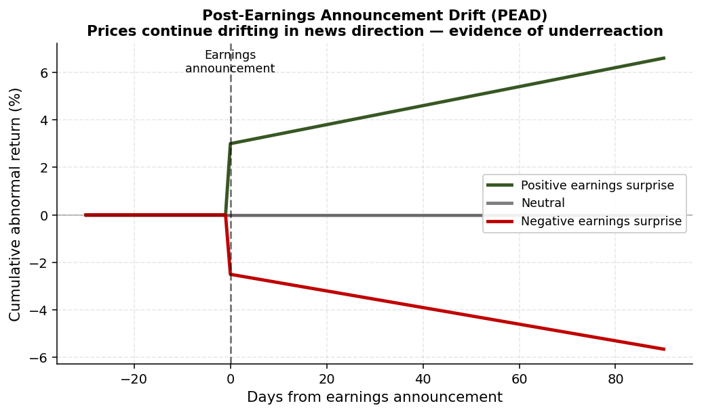
Figure 6.2 — Post-Earnings Announcement Drift (PEAD): prices continue drifting in the direction of earnings surprises.
Post-Earnings-Announcement Drift (PEAD), documented by Ball and Brown (1968) and extensively replicated, is the most robust departure from semi-strong efficiency:
- Positive earnings surprises are followed by gradual price increases over the next several months.
- Negative earnings surprises are followed by gradual price decreases.
This is underreaction — prices do not fully incorporate the news at the announcement. The magnitude of PEAD has declined over time, consistent with markets learning to incorporate earnings news more quickly. It is also strongest among smaller stocks with less analyst coverage, consistent with the friction-driven story.

6.5 Predictability does not imply easy profits
Suppose you identify a predictable price pattern. Before assuming you can profit from it, ask three questions:
- Is it compensation for risk? Many "predictable" patterns are simply risk premia in disguise.
- Is it due to behaviour? Behavioural patterns can persist but may shift over time as markets learn.
- Is it limited by frictions or constraints? Transaction costs, short-sale constraints, or capacity limits may prevent profitable exploitation.
This three-question filter is the difference between an academic anomaly and a tradable strategy.

6.6 Risk compensation at different horizons
Equity expected returns are small at short horizons and substantial at long horizons. For US stocks since 1926:
- Daily expected return is close to zero relative to daily volatility — compensation is invisible day to day.
- Monthly expected return is small relative to monthly volatility — still hard to see.
- Annual expected return becomes meaningful relative to annual volatility.
- Decadal expected return dwarfs decadal volatility — compensation is unmissable.
This explains why "buy and hold" performs so well over long horizons: the compensation for risk only becomes visible over time, but volatility is always present.

6.7 Factors — strategy and pricing model
A factor is a systematic source of return across many assets, captured by a portfolio constructed using a simple rule. The same factor plays two roles:
- As an investment strategy, a factor earns a premium — the expected return on a portfolio long the factor.
- As a pricing model, a factor explains returns across assets — assets that load more on the factor have higher expected returns.
Hundreds of factors have been proposed in the literature. Most are fragile or disappear out of sample. Two are particularly robust and well-documented:

Value factor
- Long stocks with low prices relative to accounting fundamentals (low P/B, P/E, EV/EBITDA).
- Short stocks with high prices relative to fundamentals (the "growth" side).
- Historical premium: roughly 3-5% per year.
- Returns are volatile; long stretches of underperformance occur (notably the 2010s for value investing).
- Uses only publicly available information — yet has persisted for decades.

Momentum factor
- Long stocks with the highest returns over the past 12 months.
- Short stocks with the worst past returns.
- Historical premium: roughly 8-12% per year.
- Subject to rare but severe crashes — momentum performs poorly during market rebounds, when prior losers surge.
Both factors are challenges to EMH: they earn high average returns using only public information. Are they compensation for risk? Behavioural? Limited by frictions? The literature gives nuanced answers — there is some of each.

6.8 The "factor zoo"
Hundreds of factors have been documented in academic papers. Most do not survive out-of-sample testing. The challenge for the investor is not to find factors — that is easy — but to identify which factors survive scrutiny. The two robust ones are value and momentum. Others (size, quality, low-volatility, betting-against-beta) have some empirical support but should be treated with more caution.
Worth memorizing
EMH has three forms (weak, semi-strong, strong). Most empirical work concerns semi-strong.
Three EMH consequences: news prices in quickly, short-run returns are random, public info implies zero alpha.
PEAD: prices drift after earnings surprises — robust evidence of underreaction.
Predictability ≠ easy profits. Ask: risk? behaviour? frictions?
Factors: value (3-5%/yr), momentum (8-12%/yr) — robust.
Factor zoo: hundreds of factors, most fragile. Value and momentum are exceptions.

6.9 Chapter recap
Markets are mostly efficient — most public information is priced — but with measurable, persistent departures. PEAD shows underreaction; value and momentum factors earn premia using public data. The implication for asset management is that beating the market is possible but hard, and identifying genuine alpha requires careful testing. The next chapter takes up the mechanics of acting on the more aggressive strategies that arbitrage temporary mispricings.

Quick check
- Why are smooth, predictable-looking prices evidence of inefficiency rather than efficiency?
- Why does value-factor performance show long stretches of underperformance?
- If a friend tells you about a new factor that worked in backtests, what three questions should you ask?

Chapter 7 — Short Selling, Arbitrage, and Short Squeezes
Learning objectives
Describe the mechanics of a short sale.
Compute initial margin, maintenance margin, and margin calls.
Set up and analyse the Twin Coin Arbitrage.
Explain the limits to arbitrage and why mispricings persist.
Apply the law of one price to Royal Dutch / Shell, VW, and GameStop.

7.1 Short selling — the mechanics
Suppose IBM trades at $100 and you believe it will fall to $90. If you own the stock, you simply sell at $100 and buy back at $90 — pocketing $10. But what if you do not own it? You can short-sell.
Short selling mechanics:
- Borrow one share of IBM from a lender L (typically a pension fund, mutual fund, or another broker).
- Sell the borrowed share immediately at the market price ($100).
- Keep the $100 proceeds in a margin account, with additional cash collateral on top.
- Wait for the price to fall to $90.
- Buy one share back at $90 and return it to L.
- Your profit: $100 − $90 = $10.
If the price instead rises to $110, your loss is $10. If it rises to $200, your loss is $100. In principle, losses are unlimited — there is no ceiling on how high the price can go. This is why margin accounts are required.
Buy and short are mirror images
Buy 1 IBM share: +1 stock, −$100 cash.
Short 1 IBM share: −1 stock (borrowed), +$100 cash.
Otherwise identical: the same security, opposite direction, opposite payoff.
In practice, short selling also involves borrowing fees, paying any dividends the underlying pays during the borrow, and the risk of recall (the lender can demand the share back at any time, potentially forcing the short seller to cover at a bad price).

7.2 Margin account mechanics
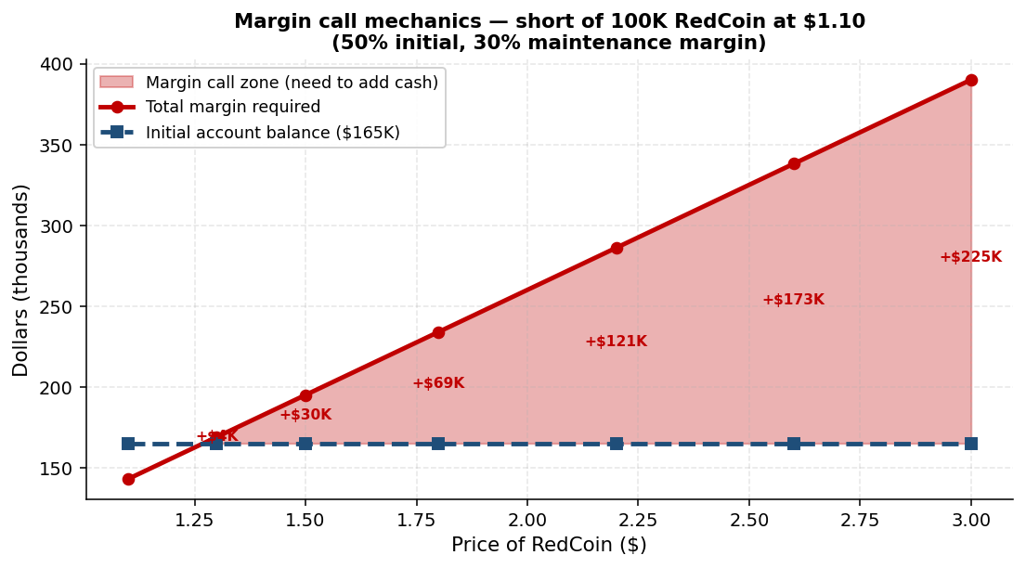
Figure 7.1 — Margin call mechanics: as the underlying rises, the total margin requirement grows above the initial account balance, triggering margin calls.
When you short, you must keep collateral in a margin account to ensure you can buy back the stock. Standard margin requirements (US conventions):
- Initial margin requirement: 50% of the short-sale value. The proceeds of the sale stay in the account, plus you must add 50% more in cash.
- Maintenance margin requirement: 30% (typical). The total margin must always be at least 130% of the current market value of the short position.
Total margin requirement formula:
$$Total margin = Short-sale value × (1 + m)$$
If you short 100K units at $1.10/unit:
- Short-sale value = $110K.
- Initial margin requirement (50%) = $55K (your own money).
- Total in margin account = $110K (proceeds) + $55K (your cash) = $165K.
If the price rises, the short position becomes more expensive to close. The total margin requirement rises. If your margin equity drops below the new requirement, you receive a margin call — additional cash demanded immediately.

7.3 The Twin Coin Arbitrage
In June 2019, two founders launched RedCoin and BlueCoin, twin cryptocurrencies. Both will be exchangeable for one GreenCoin (a stablecoin pegged to the dollar) on June 30, 2022. By the law of one price, the two coins should trade together — yet by June 15, 2019, the prices had diverged:
- RedCoin: $1.10
- BlueCoin: $0.90
Bill has $190K in savings. He spots the arbitrage.

Setting up the arbitrage
- Short 100,000 RedCoin (the expensive twin). Receive $110K in proceeds.
- Buy 100,000 BlueCoin (the cheap twin) for $90K.
- Net cash position: $110K − $90K = $20K — Bill pockets $20K immediately.
- On June 30, 2022, both coins will be exchangeable for GreenCoin (priced equally). Bill sells his BlueCoin, uses the proceeds to buy back RedCoin, returns it to the lender. Position closed.
Scaling this up by 10× or 100× scales the $20K accordingly. "Free money" — at first glance.

7.4 The margin reality
Bill cannot ignore margin requirements. The short position needs collateral:
- Initial margin requirement = 50% × $110K = $55K.
- Total in margin account at initiation = $110K (proceeds) + $55K (Bill's cash) = $165K.
Bill has $190K. He used $90K on BlueCoin and $55K on initial margin — leaving $45K spare. Tight, but workable.

Margin call when RedCoin spikes
Now suppose RedCoin rises to $1.80 (in the days following Bill's entry). The short position's value rises:
- New short-sale value = 100K × $1.80 = $180K.
- New maintenance requirement = 30% × $180K = $54K.
- New total margin requirement = $180K + $54K = $234K.
- Bill's account has $165K (initial total). Margin call = $234K − $165K = $69K.
Bill needs $69K of additional cash. His spare $45K plus a $30K loan from parents barely covers it.

Margin call when RedCoin spikes further
Suppose RedCoin keeps rising to $3.00:
- New short value = 100K × $3.00 = $300K.
- New maintenance = 30% × $300K = $90K.
- New total requirement = $390K.
- Bill's account now has $234K (covered the previous call). Margin call = $390K − $234K = $156K.
Bill needs another $156K. He doesn't have it. If he can't post the margin, the broker will liquidate the short position at the current market price ($300K). Bill's $234K margin account is wiped out, and he still owes the broker $300K − $234K = $66K (his debt to the broker).

Partial cover scenario
Suppose Bill has $120K capital left. He uses all of it to buy back RedCoin at $3.00 — reducing his short position. He buys back 120K / 3 = 40K coins, leaving a short of 60K coins:
- New short value = 60K × $3.00 = $180K.
- New maintenance = 30% × $180K = $54K.
- New total requirement = $234K.
- Bill's account still has exactly $234K (he spent his $120K on the partial buy-back). No margin call — Bill is exactly at the maintenance margin.

7.5 Limits to arbitrage
The Twin Coin example illustrates limits to arbitrage. Mispricings can persist — even widen — for long enough to ruin the arbitrageur, even when the convergence is guaranteed.
Keynes's adage: "Markets can remain irrational longer than you can remain solvent."
Specific risks the arbitrageur faces:

Gap widens
If the mispricing grows worse before resolving, the arbitrageur takes losses. Margin calls follow. Eventually capital runs out.

Liquidation friction
If the arbitrageur tries to exit, the very act of buying back the expensive asset and selling the cheap one widens the gap further. Worse, the cheap asset is often illiquid (BlueCoin in our example) — selling it depresses the price further.

Crowded trades and multiple equilibria
If many arbitrageurs hold the same position, an exit by one can trigger exits by others. Knowing this, each tries to leave first — a self-fulfilling race to the bottom. Economists call this "multiple equilibria."

Predatory trading
A sophisticated competitor who learns about your position can trade against you. Sam buys RedCoin and sells BlueCoin, widening the gap. Bill is eventually forced to liquidate at unfavourable prices. Sam reverses his trade and profits from Bill's pain. This is predatory trading.

Investor redemptions
If Bill runs a hedge fund, his investors normally face a lock-up period (1-3 years). After the lock-up, they can redeem. Bill must liquidate to return their capital — often at the worst possible time.

7.6 Law of one price violations
Twin Coin is contrived but the principles apply to real cases.

Royal Dutch / Shell — "Siamese twins"
Royal Dutch (Amsterdam-listed) and Shell (London-listed) were two claims on the same underlying cash flows of the unified Royal Dutch Shell group, with the cash flows split 60/40. American Depositary Receipts (ADRs) traded in New York. Despite the claim being economically identical, the two shares persistently traded at different relative prices — for decades, with deviations of 20% or more from the 60/40 parity.
Why? The deviation has no forced convergence date — there is no June 30, 2022 in this story. The arbitrage is open-ended, and capital constraints prevent its enforcement. The value factor faces similar challenges: a long-cheap-short-expensive position is in principle convergent, but the timing is unknown.

Porsche and Volkswagen (October 2008)
By October 2008, Porsche had secretly accumulated control of about 75% of Volkswagen's shares. Hedge funds had short positions, expecting VW to decline. When Porsche disclosed its stake, the free float was tiny relative to the short interest — a classic squeeze. For a brief period on October 29, 2008, VW became the world's most valuable company by market capitalisation.

GameStop short squeeze (January 2021)
GameStop (GME), a struggling video-game retailer, had short interest exceeding 140% — more shares were sold short than existed in the float. Reddit users on r/wallstreetbets coordinated a buying campaign; high-profile commentators including Elon Musk amplified it. The stock spiked from below $20 to over $500 (pre-market) in late January. Robinhood, citing margin requirements, restricted GME buying — adding to the chaos.
Melvin Capital, a leading short, lost approximately $7 billion (53% of fund value) in January 2021. Citadel and Point 72 stepped in with a $2.75 billion bailout. By February, the stock had cratered to around $50, but the saga continued — GME (adjusted for a 4-to-1 split) was still trading above $90 by October 2025.
Worth memorizing
Short sale = borrow + sell + buy back. Losses potentially unlimited.
Initial margin (50%) + maintenance margin (30%). Margin call when equity < required.
Total margin requirement = short-sale value × (1 + maintenance %).
Twin Coin: short the expensive, long the cheap, collect the spread now. Risks: gap widens, illiquidity, predatory trading, redemptions, multiple equilibria.
Royal Dutch/Shell: open-ended mispricing without convergence date — riskier than finite-horizon arbitrage.
Porsche/VW: hidden accumulation squeezed shorts.
GameStop: Reddit coordination + 140% short interest produced 1700% rally, $7bn loss for Melvin Capital.

7.7 Chapter recap
Short selling and arbitrage are the bridge between MPT (which is silent on how to act on views) and active management (which depends on it). The mechanics are clear: borrow, sell, post margin, buy back. But the practical limits are severe — gaps can widen, capital can run out, predatory traders can squeeze positions. The cases (Twin Coin, Royal Dutch / Shell, VW, GameStop) illustrate the same pattern: arbitrage is profitable on average, sometimes ruinous on the way.

Quick check
- Bill shorts 50K of a $20 stock with 50% initial and 30% maintenance margin. Compute total margin requirement at initiation.
- Why is the cheap leg of an arbitrage (BlueCoin) often illiquid?
- Why does Royal Dutch / Shell illustrate a riskier arbitrage than Twin Coin?

Chapter 8 — Investors and Performance
Learning objectives
Identify the main types of investors and their typical behavioural patterns.
Explain loss aversion and the disposition effect.
Distinguish skill from luck using persistence tests.
Compare mutual funds and hedge funds on fees, structure, and persistence of returns.
Identify the structural biases in reported hedge-fund returns.

8.1 The market ecosystem
Financial assets are held by several types of investors. Their behaviour, performance, and biases differ. Approximate US equity ownership (composition has shifted over time):
- Individual households — historically dominant, declining share over decades.
- Pension funds — both public and private.
- Mutual funds — including ETFs; large and growing.
- Other institutions — hedge funds, foreign investors, sovereign wealth funds.
Within each type, the choices are bewildering. There are roughly 4,000 US stocks on exchanges (NYSE and Nasdaq), plus about 15,000 traded OTC. Equity mutual funds in the US alone number over 4,400. Picking among investments — and picking among managers — is itself a non-trivial decision.

8.2 Individual investors
Barber and Odean's (2000) seminal study of 66,500 households at a large discount broker (1991-96) produced two important findings:
- Individuals underperform the market on average.
- Individuals trade too much — average annual turnover of 75%.
The underperformance is largely explained by excessive trading: each trade incurs transaction costs and bid-ask spreads, and most trades do not produce alpha to offset those costs.

Home bias
US individual investors hold over 90% of their wealth in domestic assets. Yet international diversification offers real benefits — lower correlations, broader opportunity sets. The home bias is a puzzle, partially explained by:
- Information asymmetries — investors feel they know domestic markets better.
- Behavioural biases — familiarity, attention, overconfidence.

Concentration
Goetzmann and Kumar (2005) showed that the average individual investor holds only about 4 stocks. Low-income and non-professional investors are most concentrated; young and active traders also under-diversify. The result is exposure to idiosyncratic risk that simple diversification could eliminate at no cost.

8.3 Behavioural finance — learning
Behavioural finance studies systematic departures from rational decision-making. A canonical example: probabilistic learning. Suppose a process produces "good outcome" 60% of the time when you choose A and 40% of the time when you choose B (the truth is 60-40, but you don't know it ex ante).
Two strategies:
- Strategy A — always choose A. Win 60% of the time.
- Strategy B — match probabilities: choose A 60% of the time, B 40% of the time. Win 0.6×0.6 + 0.4×0.4 = 52% of the time.
Strategy A (always-A) is rational. Yet many people fall into probability matching — choosing B sometimes despite knowing A is better on average. Why? Because the outcome is noisy: you see B win 40% of the time and feel you should sometimes pick it.
The investment-management lesson: focus on process, not outcomes. Outcomes are random; process is deterministic. A good process generates good outcomes on average, but not every time.

8.4 Loss aversion
Kahneman and Tversky (1979) showed that losses are psychologically about twice as painful as equal-sized gains are pleasurable. This generates risk aversion in gains but risk seeking in losses — a pattern called loss aversion.

The disposition effect
Loss aversion drives the disposition effect: investors tend to sell winners (lock in the gain) and hold losers (avoid realising the painful loss). This is the opposite of what tax considerations would suggest — capital losses can offset capital gains, so realising losses earlier is often optimal.
Risk management exists in part to overcome these instincts. Stop-loss rules, periodic rebalancing, and systematic reduction of concentrated positions all force action against loss aversion.

8.5 Performance evaluation — metrics
To assess whether an investor has skill, several measures are used:
- Alpha — risk-adjusted excess return relative to a benchmark.
- Sharpe ratio — (E − r_f) / σ. Excess return per unit of total volatility.
- Information ratio — alpha / tracking error. Excess return per unit of tracking risk.
- Sortino ratio — Sharpe variant using downside deviation only.
- Persistence — does a top performer this year remain a top performer next year? Persistence is the strongest test of skill versus luck.

8.6 Pension funds
Equity pension funds show no persistence of skill. A top-quartile fund in one period is roughly equally likely to be in any quartile in the next. This is consistent with most apparent outperformance being luck rather than skill.

8.7 Active mutual funds
Carhart (1997) showed that apparent persistence in mutual fund returns is largely explained by momentum in the underlying stocks the funds hold — not by manager skill. Once momentum is controlled for, there is little persistence in fund alpha beyond a one-year horizon.
Key facts:
- Mutual funds show (slightly) better performance before fees, but underperform after fees.
- High turnover correlates with worse performance — trading costs eat into returns.
- Picking next year's winning fund from last year's results is essentially impossible.
Famous examples of inevitable mean-reversion:
- Bill Miller — beat the market 15 years in a row before underperforming sharply from 2006 onwards.
- Jim Cramer — after leaving his successful hedge fund, his TV-recommended picks underperformed.

8.8 Insiders and politicians
Corporate insiders earn superior returns when trading their own firm's stock. This is consistent with private information being valuable. Several studies also document above-market returns on the publicly disclosed portfolios of US politicians, raising regulatory questions that remain unresolved.

8.9 Active vs passive
In aggregate, the math is brutal: average passive investors hold the market and earn zero alpha (before fees). Therefore, average active investors must also earn zero alpha before fees — and so negative alpha after fees. Who, then, makes money?
- Winners (positive alpha): smart traders with genuine views, patient traders who provide liquidity, market makers.
- Losers (negative alpha): noise traders, impatient traders, forced sellers (hedgers, redeemers).
The investment-management implication: the average dollar in active management does not generate alpha. A specific dollar in skilled hands might.

8.10 Smart beta, ETFs, factor investing
Between pure passive (index tracking) and pure active (security selection) lies a growing middle ground:
- Factor investing — allocate based on documented characteristics (size, value, momentum, quality, low-vol, ESG).
- Smart beta — similar to factor investing, typically long-only, rules-based.
- ETFs — Exchange-Traded Funds offering liquid, transparent, low-cost exposure. Can be shorted.
- Enhanced indexing — tilts toward rewarded factors with limited active risk.
These strategies have grown rapidly because they capture much of what skilled active managers were doing (e.g., value tilts) at a fraction of the cost. The market segment of pure active mutual funds has correspondingly shrunk.

8.11 Hedge funds — definition and structure
Cliff Asness (J.P. Morgan, 2004) famously defined hedge funds: investment pools that are relatively unconstrained in what they do, relatively unregulated, charge very high fees, will not necessarily give your money back when you want it, and generally will not tell you what they do. They are supposed to make money all the time; every three or four years they deliver a hundred-year flood.
Typical fee structure: "2 and 20" — 2% management fee plus 20% performance fee. Renaissance's Medallion fund charges "5 and 44." Returns are voluntarily reported, with substantial selection bias.

8.12 Hedge fund history — winners and losers
Renaissance (Jim Simons, founded 1982) is the most successful quantitative fund in history. Its flagship Medallion fund returned an average of about 40% per year after fees from 1988 to 2021 (about 62% before fees), and has been closed to outside investors since 1993.
D.E. Shaw (David Shaw, 1988), Citadel (Ken Griffin, 1990), and Bridgewater (Ray Dalio, 1975) are also among the historically dominant. Each has periods of crisis and recovery — Citadel lost 55% in 2008 but recovered 62% in 2009.
Famous failures:
- LTCM (Long-Term Capital Management, 1998) — lost $4.4bn in September 1998 in the wake of the Russian default. Wound down with Wall Street rescue. The founders later started JWM Partners, which lost 44% in 2007-09.
- Amaranth (Brian Hunter, 2006) — lost $6bn in a week on natural gas bets.
- Victor Niederhoffer — twice closed funds after major losses (1997 and 2007), both involving short put options.
- Melvin Capital (2021) — lost $7bn on GameStop, taken over by Citadel and Point 72.
- Madoff Securities — $65bn Ponzi scheme, sentence of 150 years.

8.13 Why hedge funds often resemble put writers
Many hedge funds — Niederhoffer, LTCM, and many merger-arbitrage funds — have strategies whose payoff resembles selling put options on an index. They collect steady premia in normal times and suffer large losses in crises. Their visible track record looks great until the rare disaster strikes:
- "Pennies in front of a steamroller"
- "Writing catastrophe insurance"
- "Providing liquidity to markets"
- "Short volatility"
Standard volatility metrics fail miserably for such strategies — the rare large loss is not captured by typical Sharpe ratio measurements over short samples.

8.14 Hedge fund performance — structural biases
Reported hedge fund returns are systematically overstated by several biases:
- Survivorship bias — failed funds drop out of databases. LTCM's −100% in 1998 was not reported because the fund had stopped reporting. Estimated ~20% annual death rate among hedge funds.
- Self-reporting bias — funds choose whether and what to report. Good periods get reported; bad ones may not.
- Backfilling bias — when a fund starts reporting, it can include prior years' returns. Only funds with good prior records bother to backfill.
Combining these effects, the academic literature estimates reported hedge fund average returns are overstated by 2-5% per year. "True" hedge fund alpha is much harder to find than the headline numbers suggest.
Volatility is also understated, both because of self-reporting and because illiquid positions are marked at smoothed valuations rather than market prices.

8.15 The good hedge fund problem
Even when truly skilled hedge funds exist, they are hard to access. Top funds are often closed to new investors (Medallion, top quant funds). New funds, on average, are less skilled than older surviving funds — exactly because the surviving funds have demonstrated something. The investor faces a selection problem: the funds that will let you in are typically the ones you do not want, while the funds you want will not let you in.
Worth memorizing — investor performance
Individual investors: underperform, overtrade, home-biased, undiversified (avg ~4 stocks).
Loss aversion (Kahneman-Tversky): losses feel 2× larger than equal gains.
Disposition effect: sell winners, hold losers.
Pension funds: no persistence of skill.
Mutual funds: apparent persistence = momentum (Carhart 1997). After fees: negative alpha.
Active aggregate: zero alpha before fees, negative after.
Hedge funds: 2-and-20 fees, survivorship/self-reporting biases overstate returns by 2-5%/yr.
Many HF strategies = writing puts on index — steady gains, rare large losses.
Good HFs are often closed to new investors.

8.16 Chapter recap
Empirically, most active management does not generate alpha after fees. Individual investors hurt themselves through overtrading and behavioural biases. Mutual fund managers, on average, do not beat passive alternatives net of fees. Hedge funds occasionally do — but the funds that do are hard to access, the reported returns are systematically biased upward, and the strategies often resemble selling insurance. None of this means active management is dead; it does mean the bar for justifying it is high. Identifying real skill requires patience, persistence tests, and humility about luck.

Quick check
- Why does the average active investor's alpha equal zero before fees?
- Explain the disposition effect using loss aversion.
- Why are reported hedge fund returns biased upward?

Chapter 9 — Options and Option Strategies
Outside exam scope (Prof. Rosu, 5 May 2026)
Topic 4 — Options and Option Strategies — will NOT be tested on the final exam.
This chapter is retained for completeness and as a reference for option mechanics in the workplace.
If your study time is limited, skip this chapter and focus on Chapters 2-8.
Learning objectives
Define call and put options, distinguish American from European, and identify moneyness.
Compute payoff and profit diagrams for plain-vanilla options.
Apply put-call parity.
Match views (direction, volatility) to standard option strategies.
Construct a butterfly spread and a bull spread, with payoffs.

9.1 Definitions
An option is a contract that gives the owner the right (not the obligation) to buy or sell an asset at a defined price by a defined date.
- Call option — right to BUY the underlying asset S, by expiration T, for the strike price K.
- Put option — right to SELL the underlying S, by T, for K.
When the holder uses the right, the option is said to be exercised. Two exercise styles:
- American — can be exercised any time on or before T. Stock options are American.
- European — can be exercised only at T. Most index and currency options are European.

9.2 Moneyness
At any time before expiration, an option's relationship to the underlying price defines its moneyness.
For a call (vice versa for put):
- In-the-money (ITM): S > K. The call could be exercised profitably now.
- At-the-money (ATM): S ≈ K.
- Out-of-the-money (OTM): S < K. The call would not be exercised now.

9.3 Payoffs at expiration
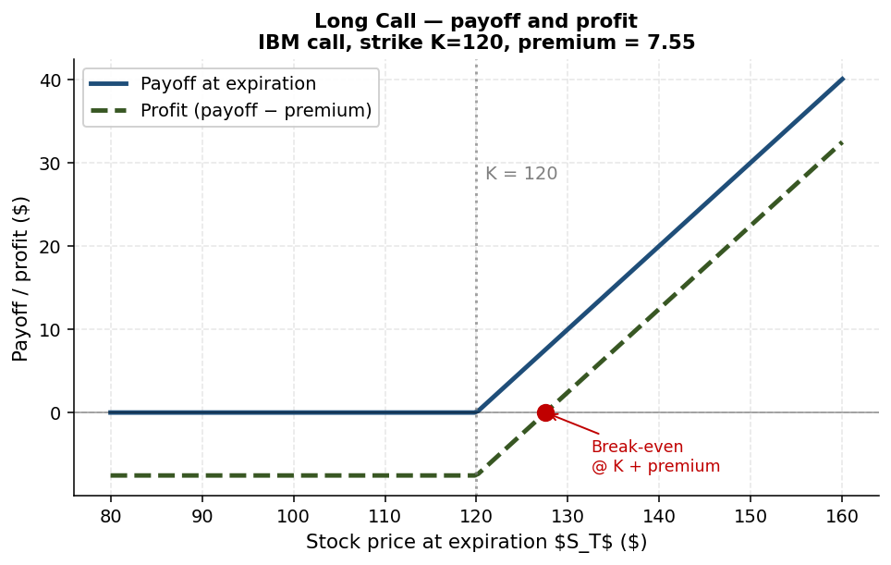
Figure 9.1 — Long call payoff and profit (IBM example, K=120, premium 7.55).
At expiration, the option pays off based on the underlying price S_T:
$$C_{T} = \backslash max(S_{T} - K, 0)$$
$$P_{T} = \backslash max(K - S_{T}, 0)$$
Profit equals payoff minus the option's purchase price (the premium):
$$Profit{}_{buy} = Payoff - Premium$$
$$Profit{}_{sell} = Premium - Payoff$$

9.4 Buying calls — the speculator's perspective
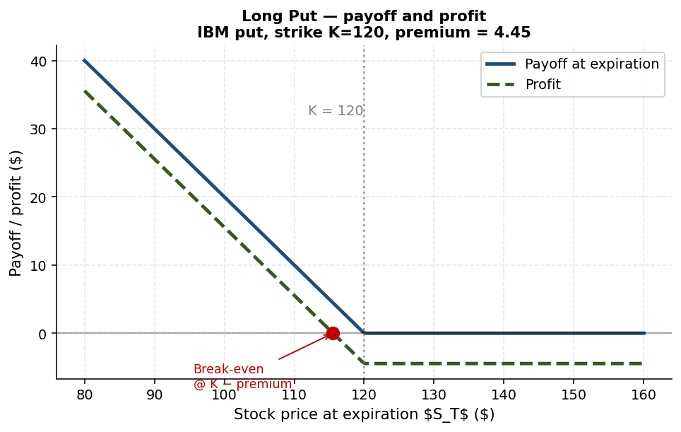
Figure 9.2 — Long put payoff and profit (IBM example, K=120, premium 4.45).
Consider an IBM example. On February 22, IBM trades at $123.02. April-15 options expire in 52 days. A speculator believes IBM will rise to $150 by April.
She considers three calls:
- K = 120 call (ITM by $3): premium $7.55.
- K = 130 call (OTM by $7): premium $2.40.
- K = 140 call (OTM by $17): premium $0.51.
If IBM rises to $150 at expiry, payoffs and returns:
- K = 120: payoff = $30, return = $30 / $7.55 ≈ +297%.
- K = 130: payoff = $20, return = $20 / $2.40 ≈ +733%.
- K = 140: payoff = $10, return = $10 / $0.51 ≈ +1,860%.
Higher strike = lower premium = higher leverage on a successful bet. But if the stock fails to rise above K, the option expires worthless. Higher-strike calls are more like "lottery tickets" — high upside, high probability of total loss. Unlike actual lottery tickets, calls have positive expected return when fairly priced.

9.5 When NOT to early-exercise an American call
Suppose you hold the K = 120 IBM call when the stock is $123.02. Should you exercise now? Exercise gives you intrinsic value: $123.02 − $120 = $3.02. But selling the option on the market gives you the bid price: $7.45. Selling is better — the option has time value beyond intrinsic value.
Even if you expect the stock to fall in the next few hours, you should still sell rather than exercise. Why? Because if everyone expected the stock to fall, it would already have fallen, and the option price would already reflect that. If your private view differs from the market's, others may pay you the higher market price for the option.
Rule of thumb: never early-exercise an American call on a non-dividend-paying stock. The intuition: exercise destroys the option's remaining time value.

9.6 Put-Call Parity
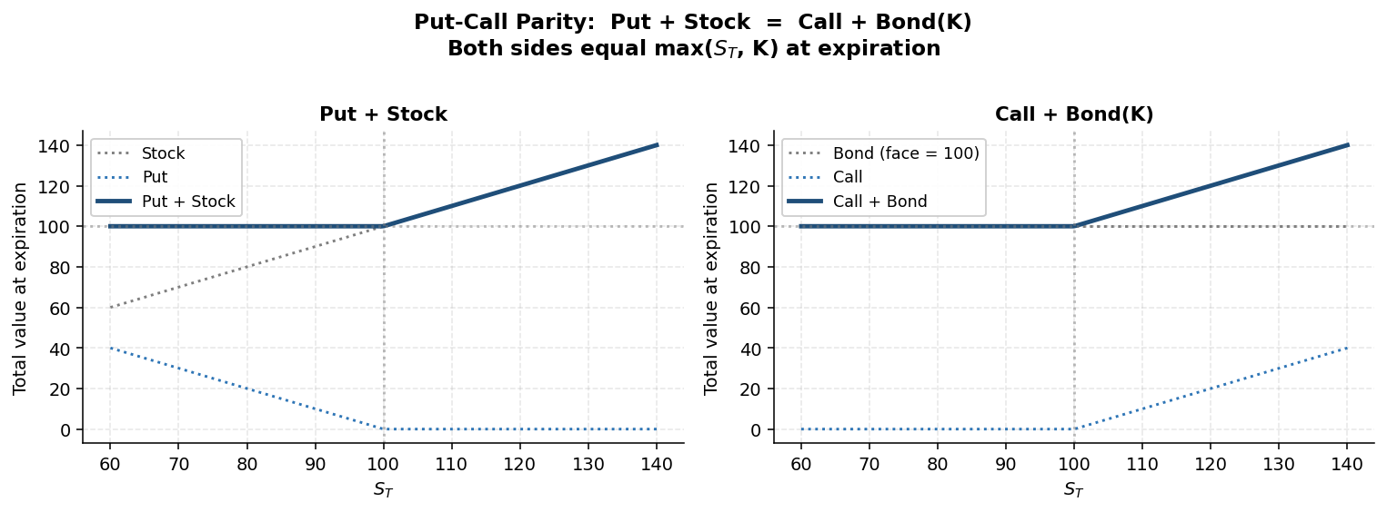
Figure 9.3 — Put-call parity verified at expiration: Put + Stock = Call + Bond. Both sides equal max(S, K).
For European call and put options on the same underlying, with the same strike K and expiration T:
$$P + S = C + B(K, T)$$
To verify, look at the payoffs at T:
- Put + Stock at T: P_T + S_T = max(K − S_T, 0) + S_T = max(K, S_T).
- Call + Bond at T: C_T + K = max(S_T − K, 0) + K = max(S_T, K).
- Both sides equal max(K, S_T) — identical payoffs. By no-arbitrage, prices must match before T as well.
Put-call parity is one of the most useful relationships in derivative pricing. It lets you replicate any of the four building blocks (call, put, stock, bond) from the other three. It also breaks when the assumptions fail (American options, dividends, transaction costs) — those breakdowns can themselves be sources of profit or warning.

9.7 Sensitivities — "the Greeks intuition"
How does each option's price change with the underlying?
- Call price ↑ with: S ↑, σ ↑, T ↑, r ↑. Call price ↓ with: K ↑.
- Put price ↑ with: K ↑, σ ↑, T ↑. Put price ↓ with: S ↑, r ↑.
Both calls and puts increase with volatility — every option is a bet on uncertainty, regardless of direction. A long-volatility position can be built with a combination of calls and puts.

9.8 Basic option strategies — speculation
With a single underlying, four basic positions exist:
- Long call — believe S will rise (and / or volatility will rise).
- Long put — believe S will fall (and / or volatility will rise).
- Short (write) call — believe S will not rise much, with no view on whether it will fall.
- Short (write) put — believe S will not fall much (Warren Buffett famously sold puts on the S&P 500 in 2004-08).
Writing puts is selling insurance. You collect a premium upfront. If the market stays above the strike at expiry, you keep the premium. If it falls below, you pay the difference. Buffett's view: the downside risks priced in by the market were exaggerated.

9.9 Portfolio insurance
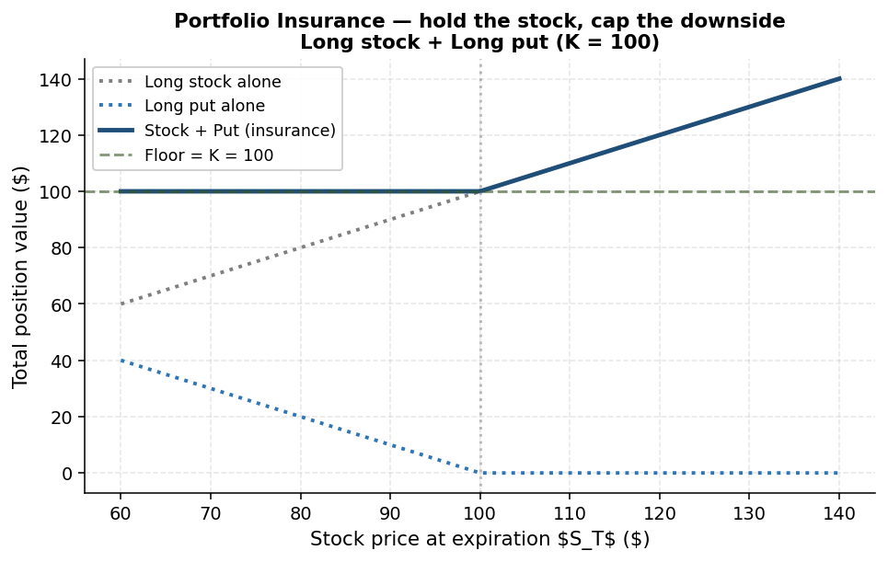
Figure 9.7 — Portfolio insurance: long stock + long put. Holds the upside, caps the downside at the strike.
Suppose you hold a portfolio of stocks and want to limit downside risk. Buy a put on the index. The put pays off if the market falls below the strike. Your downside is bounded by the strike (minus the put premium); your upside is fully retained (the put expires worthless and you keep your portfolio's gains).
By put-call parity: Long Stock + Long Put = Long Call + Long Bond. The bond is a riskless investment of face value K. So portfolio insurance is structurally equivalent to holding a call plus a bond.
In the 1980s, US mutual funds were restricted from buying puts. They synthesised portfolio insurance dynamically — selling stocks as the market fell and buying as it rose. This strategy was blamed for accelerating the October 1987 crash.

9.10 Synthetic short
Sometimes the underlying stock is hard to short (high borrow fees, lender recall risk, or simply unavailable). If options are traded, you can construct a synthetic short via put-call parity:
$$-S = -C + P - B(K)$$
That is, short one stock = long put + short call + short bond. Long put and short call combined replicate the negative-S payoff; the bond financing handles the cash flow.
Robert Vishny famously used a synthetic short to bet against Palm in March 2000 when the stock was extraordinarily hard to short directly. Similar strategies were attempted on GameStop in 2021.
Caveat: when put-call parity holds, the strategy is exact. When the put becomes expensive relative to the call (which happens in shortage situations), the synthetic short becomes costly.

9.11 Volatility bets — straddles and strangles
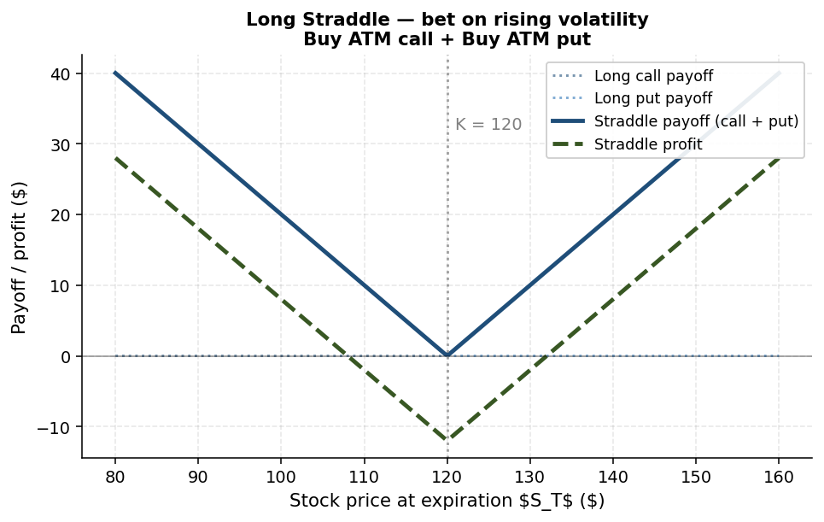
Figure 9.4 — Long straddle payoff and profit: a pure bet on rising volatility.
Suppose you have no view on direction but believe volatility will rise. Buy both a call and a put at the same strike — a straddle.
- ATM straddle (call and put both at K = current S): bet on volatility. Cost = price of call + price of put. Profitable if S moves enough in either direction at expiry.
- OTM strangle (call at K1 > S, put at K2 < S): cheaper than a straddle, but needs larger moves to be profitable.
To bet that volatility will FALL, short the straddle. You receive the combined premium upfront. If the underlying stays near K, both options expire worthless and you keep the premium. If the underlying moves, your losses grow without bound — potentially unlimited.

9.12 Butterfly spread — limited-loss volatility bet
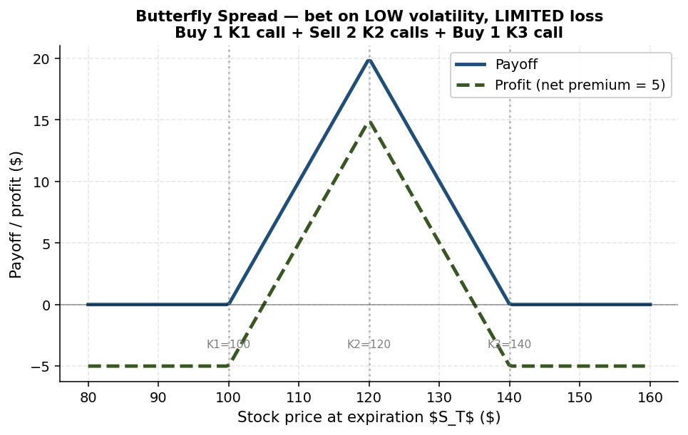
Figure 9.5 — Butterfly spread payoff and profit: low-volatility bet with limited loss.
A short straddle has unlimited losses if you are wrong. To bet on low volatility with limited losses, use a butterfly spread:
- Buy 1 ITM call at K1 (below current S).
- Sell 2 ATM calls at K2 (near current S).
- Buy 1 OTM call at K3 (above current S).
The strikes are equally spaced (K2 − K1 = K3 − K2). The payoff is a triangle peaked at K2.
Algebraically, this is equivalent to:
- Short straddle (short ATM call + short ATM put)
- Long OTM call (a cap on upside losses)
- Long OTM put (a cap on downside losses)
- Plus a bond (the net cost)
The butterfly is a bet on low volatility with bounded losses if you are wrong. Maximum profit at S = K2; maximum loss at the wings (K1 or K3).

9.13 Directional bets with limited loss — bull spread, bear spread
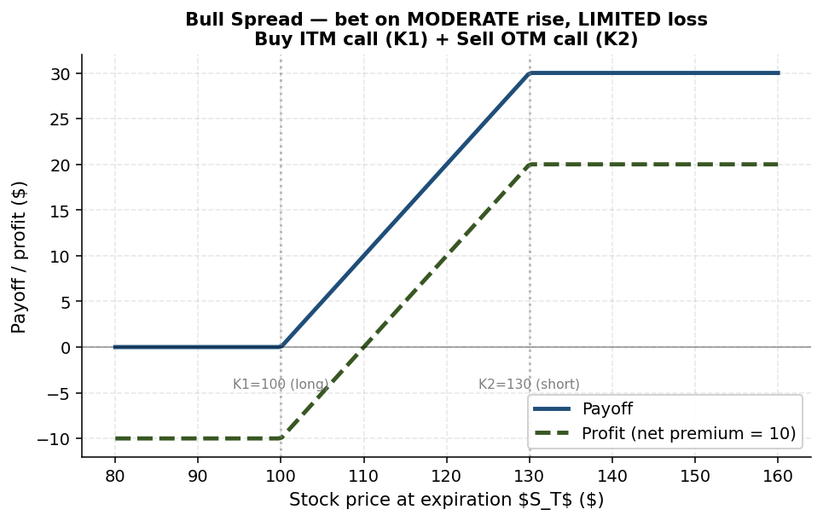
Figure 9.6 — Bull spread payoff and profit: moderate-rise bet with limited loss.

Bull spread
Bet on a moderate rise in S, with bounded loss:
- Buy ITM call at K1 (below S).
- Sell OTM call at K2 (above S).
The long call captures upside; the short call caps it (and partially funds the long). Maximum profit = (K2 − K1) − net premium. Maximum loss = net premium.

Bear spread
Mirror image for moderate decline:
- Buy ITM put at K1 (above S).
- Sell OTM put at K2 (below S).

9.14 Other strategies
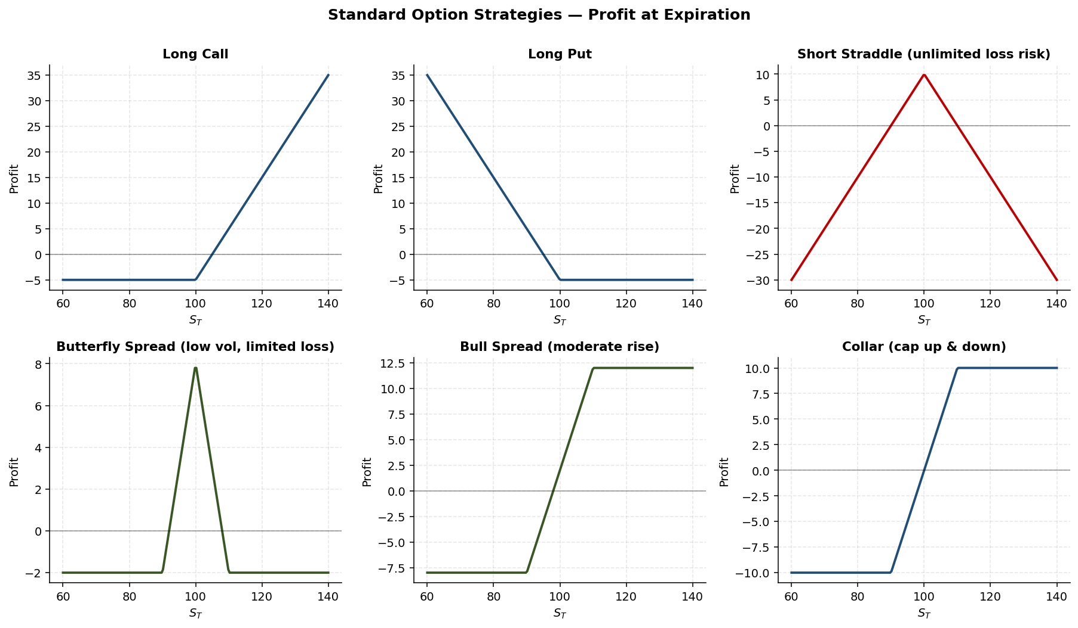
Figure 9.8 — Six standard option strategy profit profiles compared on one chart.
- Collar — long stock + long OTM put + short OTM call. Caps both upside and downside. Equivalent to a bond plus a bull spread.
- Strip — 1 call + 2 puts at same K. Bet on volatility with a downside tilt.
- Strap — 2 calls + 1 put at same K. Bet on volatility with an upside tilt.
- Box spread — bull + bear spread at the same strikes. Payoff = K2 − K1, a constant. Arbitrage if priced below PV(K2 − K1). Watch out: equity options are American, complicating the strategy.
- Calendar spread — option with one expiration minus option with another. Bet on volatility term structure.

9.15 Strategy → view matching
The most exam-relevant skill is matching a stated view to the right strategy:
View | Best strategy
Stock will rise a lot | Long call
Stock will fall a lot | Long put
Stock will rise moderately, limit loss | Bull spread
Stock will fall moderately, limit loss | Bear spread
Volatility will rise | Long straddle (or strangle, cheaper)
Volatility will fall, unlimited loss OK | Short straddle
Volatility will fall, LIMITED loss only | Butterfly spread
Hold the stock, want downside protection | Long stock + long put (portfolio insurance)
Short the stock, but borrow is restricted | Synthetic short (long put + short call + short bond)
Hold the stock, cap both up and down | Collar (stock + long OTM put + short OTM call)

9.16 Exotic options
Beyond plain-vanilla calls and puts, financial engineers have created a zoo of exotic options:
- Asian — payoff depends on the average underlying price over time.
- Lookback — payoff depends on the max or min price over time.
- Barrier — knock-in (activates when price reaches barrier) or knock-out (deactivates).
- Digital/Binary — pays a fixed amount if a condition is met, zero otherwise.
- Bermudan — exercisable only at discrete dates.
- Chooser — buyer chooses between call or put later.
- Compound — options on options.
- Variance swap — exchange realised variance for a fixed amount.
Most of these are not exam-relevant in detail. The plain-vanilla building blocks (calls, puts, the standard strategies above) carry most of the conceptual weight.
Worth memorizing — options
Call payoff = max(S_T − K, 0). Put payoff = max(K − S_T, 0).
American = exercise anytime; European = exercise at T only.
ITM (S>K for calls), ATM (S=K), OTM (S<K for calls).
Put-Call Parity (European): Put + Stock = Call + Bond.
Don't early-exercise American calls on non-dividend stocks.
Both calls and puts increase with volatility.
Volatility up bet: long straddle (unlimited gain) or strangle (cheaper).
Volatility down bet with LIMITED loss: butterfly spread (NOT short straddle).
Moderate up move with limited loss: bull spread (NOT long call).

9.17 Chapter recap
Options are versatile, low-capital tools for expressing views on direction, volatility, or specific scenarios. The mathematics (payoff, parity) is mechanical; the art is in matching strategy to view. The exam tends to focus on this matching — given a scenario, which strategy is best? — and on the calculation of payoffs and profits at expiration. The cheat-sheet table above is the single most exam-relevant page of this textbook.

Quick check
- A speculator wants to bet IBM rises modestly above $130 in two months, with the smallest possible cost. Recommend a strategy.
- Show using payoffs that put-call parity holds at expiration.
- Why is a butterfly spread superior to a short straddle when you want to bet on low volatility?

Chapter 10 — Self-Test

Section A — Multiple choice
Q1. The Sharpe ratio of an asset is best defined as:
A. (Expected return) divided by variance
B. (Expected return) divided by standard deviation
C. (Excess return over r_f) divided by standard deviation
D. (Excess return over r_f) divided by variance
Q2. The Capital Market Line (CML) is the locus of:
A. Portfolios on the efficient frontier of risky assets only
B. Portfolios combining the risk-free asset and the Tangency Portfolio
C. Portfolios chosen by the most risk-averse investors
D. Index funds only
Q3. Lowering the correlation between two assets in a portfolio will most likely:
A. Increase portfolio standard deviation
B. Decrease portfolio standard deviation
C. Have no effect because correlations don't affect risk
D. Reduce expected return
Q4. Under Black-Litterman, an investor with no views should hold:
A. The minimum-variance portfolio
B. The tangency portfolio T
C. The market portfolio
D. Cash only
Q5. Post-Earnings-Announcement Drift (PEAD) is consistent with:
A. Market overreaction
B. Market underreaction
C. Strong-form efficiency
D. Insider trading
Q6. A short seller of 100K units of a $1.10 asset with 50% initial and 30% maintenance margin has a total margin requirement at initiation of:
A. $55K
B. $110K
C. $143K
D. $165K
Q7. The Frazzini-Pedersen 'Betting Against Beta' result implies:
A. High-beta assets earn high alpha
B. Low-beta assets earn high alpha because constrained investors overpay for high-beta exposure
C. Beta is not priced
D. CAPM holds exactly
Q8. Loss aversion typically produces which behaviour pattern in individual investors?
A. Holding all positions for long periods
B. Selling winners and holding losers (the disposition effect)
C. Selling losers immediately to harvest tax benefits
D. Random trading
Q9. Carhart (1997) found that the apparent persistence in mutual fund returns is mostly explained by:
A. Manager skill
B. Survivorship bias
C. Momentum in the underlying stocks
D. Behavioural biases of fund investors
Q10. Many hedge funds' return profiles resemble:
A. Long volatility positions
B. Writing put options (steady gains punctuated by rare large losses)
C. Pure beta exposures
D. Bond ladders
Q11. Put-Call Parity for European options on a non-dividend stock states:
A. Put + Call = Stock + Bond
B. Put × Stock = Call × Bond
C. Put + Stock = Call + Bond
D. Put − Stock = Call − Bond
Q12. The best option strategy when you expect volatility to fall and want LIMITED downside if wrong is:
A. Short straddle
B. Long straddle
C. Butterfly spread
D. Synthetic short

Section B — Short answer
S1. An investor has quadratic utility U = E − 0.5·A·σ². The tangency portfolio T has E_T = 8% and σ_T = 10%. The risk-free rate is 2%. Compute the optimal allocation to T for A = 4 and for A = 12.
S2. Explain (in 4-6 sentences) why the same merger-arbitrage strategy can look profitable for years and then suddenly lose more than its accumulated gains in a single bad year.
S3. Construct a payoff table at expiration for a butterfly spread on a $100 stock: buy 1 call at K=90, sell 2 calls at K=100, buy 1 call at K=110. Show the payoff for stock prices of $80, $90, $100, $110, $120 at expiry.

Section A — Solutions
Q1: C
Sharpe ratio = (E − r_f) / σ. Variance is dimensionally wrong; standard deviation is the right unit.
Q2: B
The CML connects r_f to the tangency portfolio T. Every efficient portfolio (when r_f is available) is a combination of the two.
Q3: B
Lower correlation → bigger diversification benefit → lower portfolio standard deviation for the same expected return.
Q4: C
BL's prior is the market portfolio. Without views, the posterior equals the prior, and the recommended portfolio is the market.
Q5: B
PEAD shows prices continuing to drift in the news direction after earnings releases — underreaction.
Q6: D
Total margin = short value × (1 + maintenance) = $110K × 1.30 = $143K? No — total margin = short value + initial margin = $110K + $55K = $165K. (Distinguish the formulas: initial margin sets up the account; maintenance margin applies on a rolling basis.)
Q7: B
Constrained investors who can't borrow overpay for high-beta to gain market exposure. This depresses high-beta expected returns and lifts low-beta expected returns → low-beta has high alpha.
Q8: B
Losses feel about 2× as painful as equal gains. Investors avoid realising the pain — they hold losers and sell winners.
Q9: C
Once momentum is controlled for, mutual-fund-manager skill is hard to detect; what looks like persistent skill is the momentum factor.
Q10: B
Steady premia in normal markets; rare large losses in crises. Just like writing put options on an index.
Q11: C
Put + Stock = Call + Bond(K). Both sides equal max(S, K) at expiry.
Q12: C
Short straddle has unlimited loss if you are wrong on vol. Butterfly spread caps the loss with the OTM wing options.

Section B — Solutions
S1. w* = (E_T − r_f) / (A · σ²_T) = (0.08 − 0.02) / (A · 0.10²) = 0.06 / (0.01 · A) = 6/A. For A = 4: w* = 1.5 (150% in T, leveraged with 50% borrowed at r_f). For A = 12: w* = 0.5 (50% in T, 50% in T-bills). More risk-averse investor holds less in T.
S2. Merger-arbitrage strategies bet that announced deals will close. In normal markets, the vast majority close, and the strategy earns a small spread (deal price minus current target price) repeatedly. The payoff resembles writing puts on deal failure. In a crisis or unexpected antitrust intervention, a wave of deals can collapse simultaneously. The cumulative loss across many failed deals can erase years of small steady gains. Reported Sharpe ratios over short samples look excellent — until the rare disaster strikes, at which point the strategy reveals its true distribution: heavily left-skewed.
S3. Butterfly payoff table:
S_T | Long C(90) | Short 2·C(100) | Long C(110) | Total
$80 | 0 | 0 | 0 | 0
$90 | 0 | 0 | 0 | 0
$100 | 10 | 0 | 0 | 10
$110 | 20 | −20 | 0 | 0
$120 | 30 | −40 | 10 | 0

Maximum payoff is $10, achieved at S_T = K2 = 100. Outside the [90, 110] range, payoff is 0. The triangular payoff is what makes the butterfly a "low-volatility, limited-loss" bet.

Glossary
Alpha. Risk-adjusted excess return relative to a benchmark.
American option. Option exercisable at any time on or before expiration.
Arbitrage. A trading strategy that earns positive expected profit with no risk; in practice, often with limited risk.
At-the-money (ATM). Strike approximately equal to the current underlying price.
Beta. Sensitivity of an asset's return to market return.
Black-Litterman. Bayesian asset-allocation method anchored on the market portfolio (prior) and tilted by investor views.
Bull spread. Long ITM call + short OTM call. Moderate-rise bet with limited loss.
Butterfly spread. Buy 1 ITM + sell 2 ATM + buy 1 OTM call. Low-volatility bet with limited loss.
Capital Allocation Line (CAL). Set of portfolios combining a single risky asset with the risk-free asset; slope = Sharpe ratio.
Capital Market Line (CML). CAL when the risky asset is the Tangency Portfolio.
Call option. Right (not obligation) to buy the underlying at strike K by expiration T.
Diversification. Combining imperfectly-correlated assets to reduce portfolio risk without lowering expected return proportionally.
Disposition effect. Tendency to sell winners and hold losers.
Efficient frontier. Upper boundary of the IO Set in (σ, E) space; minimum-variance portfolios for each E.
Efficient Markets Hypothesis (EMH). Prices reflect all relevant information; three forms (weak, semi-strong, strong).
European option. Option exercisable only at expiration.
Factor. Systematic source of return across many assets; e.g., value, momentum.
Investment Opportunity Set (IO Set). All feasible portfolios in (σ, E) space.
In-the-money (ITM). Call: S > K. Put: S < K.
Loss aversion. Psychological asymmetry: losses feel ~2× larger than equal gains.
Mean-variance investor. An investor whose preferences depend only on expected return and standard deviation.
Modern Portfolio Theory (MPT). Markowitz framework for choosing portfolios to optimise mean and variance.
Net Orderly Liquidation Value (NOLV). Estimated net proceeds from an orderly sale of an asset.
Out-of-the-money (OTM). Call: S < K. Put: S > K.
PEAD. Post-Earnings-Announcement Drift; prices continue to drift in the direction of earnings news.
Policy Portfolio. Strategic asset allocation set with the board, used as a long-run anchor.
Portfolio insurance. Long stock + long put. Limits downside while preserving upside.
Put option. Right (not obligation) to sell the underlying at strike K by T.
Put-Call Parity. For European options: Put + Stock = Call + Bond(K).
Random walk hypothesis. Short-run price changes are unpredictable.
Sharpe ratio. (E − r_f) / σ.
Short sale. Borrow the asset, sell it, buy back later. Profits from a decline.
Synthetic short. Long put + short call + borrow. Replicates a short position via options.
Tangency Portfolio (T). Risky portfolio with maximum Sharpe ratio.
Two-fund separation. Every mean-variance investor holds T + risk-free asset; only the mix varies.

End of textbook.

